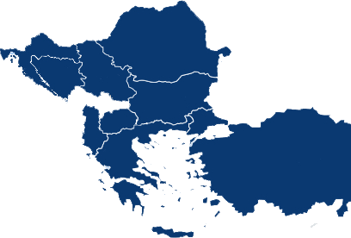
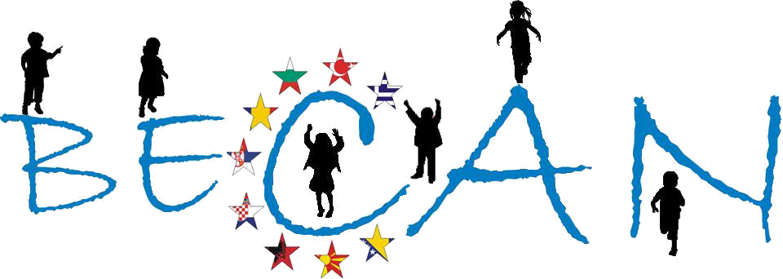


BECAN
Epidemiological Survey on Child Abuse and Neglect (CAN) in Croatia
FP7 DG-RESEARCH [Contract No: HEALTH-F2-2009-223478]

The work leading to this document has received funding from the European Community’s 7th Framework Programme (FP7/2007-2013) under the Grant Agreement no HEALTH-F2-2009-223478
Athens, January 2012
Balkan Epidemiological Study on Child Abuse & Neglect (BECAN)

SHORT INTRODUCTION
The Project “Balkan Epidemiological Study on Child Abuse and Neglect” (B.E.C.A.N.) run from September 2009 until January 2013 in 9 Balkan countries and was co-funded by the EU’s 7th Framework Programme for Research and Innovation (FP7/2007-2013) and the participating partner Organizations. The project’s coordinator was the Institute of Child Health, Department of Mental Health and Social Welfare, Centre for the Study and Prevention of Child Abuse and Neglect (ICH-MHSW), in Athens (Greece), while the national coordinators for each of the participating countries were the following Organizations:
• Children's Human Rights Centre of Albania (Albania)
• Department of Medical Social Sciences, South-West University “Neofit Rilski” (Bulgaria)
• Faculty of Political Sciences, University of Sarajevo (Bosnia & Herzegovina)
• Department of Social Work, Faculty of Law, University of Zagreb (Croatia)
• University Clinic of Psychiatry, University of Skopje (F.Y.R. of Macedonia)
• Social Work Department, Faculty of Sociology and Social Work, Babes-Bolyai University (Romania)
• Faculty for Special Education and Rehabilitation, University of Belgrade (Serbia)
• Association of Emergency Ambulance Physicians (Turkey)

The project’s evaluation was conducted by Istituto degli Innocenti (Italy) and the project’s external scientific supervision was undertaken by Prof. Kevin Browne, Head of the W.H.O. Collaborating Centre for Child Care and Protection (United Kingdom) and Chair of Forensic Psychology and Child Health, Institute of Work, Health & Organisations, University of Nottingham.

The BECAN project included the design and realization of an Epidemiological field survey and a Case-Based Surveillance study in 9 Balkan countries (Albania, Bosnia & Herzegovina, Bulgaria, Croatia, F.Y.R. of Macedonia, Greece, Romania, Serbia and Turkey).

The 9 Epidemiological Surveys that were conducted aimed at investigating the prevalence and incidence of child abuse and neglect (CAN) in representative randomized samples of the general population of pupils attending three grades (the grades attended mainly by children 11, 13 and 16 year-olds). In addition, supplementary surveys were conducted to convenience samples of children that have dropped-out of school in countries where the drop-out rates are high for producing estimates of respectful CAN indicators at national level. Data were collected by two sources, namely by matched pairs of children and their parents, by using two of the ICAST Questionnaires (the ICAST-CH and the ICAST-P) modified for the purposes of the BECAN project.

The Case-Based Surveillance Study (CBSS) aimed at identifying CAN incidence rates based on already existing data extracted from the archives of agencies involved in the handling of CAN cases (such as child protection, health, judicial and police-services and NGOs) in the same geographical areas and for the same time period as the epidemiological field survey. The collected data were related to the characteristics of individual cases such as child, incident, perpetrator(s), caregiver(s), and information concerning the family. At the same time, the CBSS targeted to map the existing surveillance mechanisms, where available, and to outline the characteristics of the surveillance practices in each participating country. Moreover, comparison at national level between incidence rates of CAN as found in field survey in one hand and in case based surveillance study on the other would produce evidence based estimates of the instantiation of the “iceberg” phenomenon regarding CAN, viz. that actual rates of the phenomenon are substantially higher than the number of cases actually known or provided for by services in the participant countries.

In addition, in the context of the BECAN Project were built National Networks of agencies (governmental and non-governmental) working in the fields of child protection from the areas of welfare, health, justice, education and public order. In total, 9 National Networks were developed in the participating countries, having more than 430 agencies-members. Last but not least, a wide range of dissemination activities were conducted which included the organization of National Conferences and one International Conference, scientific papers, announcements to scientific conferences and meetings, publications in press/media, publication of Reports, etc (more information about the project’s activities can be found at the project’s website: www.becan.eu).

Finally, BECAN aimed to include all aforementioned outcomes in terms of evidence produced, experience gained and networking of resources into comprehensive consolidated reports at national and Balkan level that could facilitate evidence based social policy design and implementation for improving child protection services and overall provisos.

The current Report describes in detail the methodology and the main results of the epidemiological survey conducted in Croatia to the samples of pupils attending the 5th and 7th grade of primary and 2nd grade of secondary school and their parents.

A. GENERAL INFORMATION
In Croatia preparation of the survey in schools began in December 2010., and the data collection lasted from January to May 2011. The research took place simultaneously in all parts of Croatia.

The study was conducted by the Department of Social Work, Faculty of Law, University of Zagreb. The project leader is Marina Ajduković, PhD and team members who participated ​​in the organization and supervision of the research are Ivan Rimac, PhD, Miroslav Rajter and Nika Sušac. Regional research coordinators in different parts of Croatia were Danijel Antunović, Danijela Didić, Ana Miljenović, Miroslav Rajter, Silvija Ručević and Nika Sušac.

B. ORGANIZATION OF THE STUDY
1. Permission(s) to access schools
Permission to conduct research in primary schools was requested from the Ministry of Science, Education and Sports on 8th July 2010 and received 4th August 2010. Permission to conduct research in secondary schools was requested on 20th September 2010 and received 30th September 2010, also from the Ministry of Science, Education and Sports. Written explanation was sent to the principals of all schools that were selected in the sample and they were further explained all the details of the implementation of the study by telephone, after which a written consent for their school to participate in research was requested. No additional ethical clearance was needed because the Ministry, in making a decision on granting their approval, also examined the ethical aspects of the research and the appropriateness of its implementation with children.

2. Field Researchers’ Training
73 persons have applied to participate in the Field Researchers’ Training, out of which 72 did participate and finish the training. Participants were psychologists, social workers, social pedagogues, sociologists and teachers.

The training consisted of several parts. The first was the “Introduction and familiarization with the project”, and included project description, aims, sample, methodology and methods of data collection. Then followed the “Getting acquainted with the instruments” part, where participants self-completed the questionnaires, after which there was a discussion on any questions they might have regarding certain items in the questionnaires and their administration. In this part of the Training, standardized responses that should be used if children ask something during the completion of the questionnaires were explained to the participants. This procedure was repeated separately for the ICAST-P and ICAST-CH. The third part of the training was “Description of field researchers’ duties at every stage of the research”, where participants were explained the research procedure and their tasks in detail, according to the content provided in the “Guidelines for Researchers”. The last part of the training, “Ethical principles and legal obligations”, was aimed at complying with the ethical principles of research with children and procedures followed in the case of CAN detection. At the end of the training, participants had the opportunity to ask questions about any of the contents of the training and anonymously completed an evaluation questionnaire. Each participant was given a copy of “Guidelines for Researchers”. The only post-workshop obligation of the participants was to study the manual in detail and clarify all potential ambiguities with their regional coordinator before the commencement of the research.

In total, four such trainings, lasting one or two days, were conducted in different parts of Croatia, in order to separately coach several regional teams of researchers. The trainers were Marina Ajduković, PhD, Miroslav Rajter and Nika Sušac, and training sessions were held on 23rd and 24th November 2010 (Osijek), 10th and 11th December 2010 (Split), 7th December 2010 (Rijeka) and 18th December 2010 (Zagreb).

The evaluation questionnaire consisted of 8 questions to which the participants gave their estimates from 1 to 5, with questions focusing on the quality of the training and its adequacy in preparing the participants for specific aspects of fieldwork. The mean ratings were very high and ranged from 4.79 to 4.93 on specific items. Three additional open-ended questions about the contents of the training that they considered redundant or inadequately covered and their suggestions for its improvement were asked. Responses of participants showed that the training was adequately prepared and implemented, and that it prepared the participants for the fieldwork very well.

C. METHODOLOGY

1. Sampling Method – Sample
A probabilistic stratified cluster sample of 2% of children, regular school attendees, aged 11, 13 and 16 years was planned to be used in this study. Pupils of 5th and 7th grade of primary and 2nd grade of secondary school were selected as age-equivalent group of the planned sample. Planned research coverage for Croatia was a sample of at least 3000 children, 1000 per generation.

A two-stage probability sample of each of the defined age populations of pupils in Croatia was used, where for every age group the school was selected in the first stage, and whole class divisions were selected in the second stage using a PPS random selection method. PPS (proportional per size) is a group of random selection methods which control the selection of clusters in stage-wise sampling based on the information about the number of final sampling units, in this case pupils. In this study, the cumulative size method was used. The final selection of the last stage of sampling represents a cluster sample in which all members of selected class divisions are included in the survey sample. Starting from this sampling procedure, the study included 40 primary schools (76 fifth grade and 77 seventh grade class divisions) and 29 secondary schools in all counties of the Republic of Croatia. The number of pupils enrolled in the selected classes was 1744 for 5th grade, 1771 for 7th grade and 1492 for 2nd grade of secondary school, which makes a total of 5007 pupils.

The final realized sample of the survey consisted of a total of 3689 children. Of the children who were included in the study 98.78% were retained in the data analysis, while 45 questionnaires were excluded from the analysis because of mistakes in the completion of the questionnaire. Therefore, the final sample on which the analyses were performed consisted of 3644 children and all three age groups were equally represented in the sample: 5th grade of primary school with 33.56% (N = 1223), 7th grade of primary school with 32.60% (N = 1188) and 2nd grade of secondary school with 33.84% (N = 1233). As the subsamples consist of pupils attending 5th and 7th grade of primary school and 2nd grade of secondary school, after the data gathering it was checked how the children in the sample correspond with the planned age groups and it was found that the class that the child attends is a good equivalent of the anticipated age of the sample.

The sample is composed of 51.13% (N = 1863) of girls and 48.87% (N = 1781) of boys. Most of the children in the sample come from urban areas (72.55%, N = 2556), while 27.45% (N = 967) of children who participated in the study live in a rural area.

2. Response rates
When the schools were contacted regarding their participation in the research, principals of two primary schools and one secondary school have refused to participate. One primary school refused to participate because the Parents’ Council disagreed with the implementation of research on this topic with their children, while two schools refused to participate due to technical reasons, namely lack of qualified staff who would organize parent-teacher meetings and dates of data collection and the lack of space due to the renovation of the school building.
Average response rate of participants in this study was 70.1% in 5th, 67.1% in 7th, and 82.6% in 2nd grades of secondary schools. This is a very high response rate, which was probably in part a result of organising parents-teacher meetings where parents had the opportunity to hear all the important information on the planned procedure of the study and to ask the researchers all that they were interested in and thus reduce their fears about their child's participation in the study. For children younger than 14 years, that is the children attending primary school, an active written parental consent was requested for their participation in the study. According to the Croatian Code of Ethics of Conducting Research with Children (Ajduković and Kolesarić, 2003), for children older than 14 years it is not necessary to ask for their parents’ consent, but the parents need to be informed about the study, which was done. Primary school children who had parental consent and all children of secondary school age were explained the purpose of the study and the implementation procedure, and they decided for themselves whether they wanted to participate.
The response rate of children in secondary schools was slightly higher because no parental consent was required for their participation. In 5th grades 11.01% of the parents refused their child’s participation in the study, while 11.93% did not return the completed consent forms, so their children were also not able to participate in the study. In 7th grades these percentages were slightly higher and amounted to 12.70% and 13.83%. Some children who had parental consent were not involved in the study, because they were not in school on the day of the survey or they themselves refused to fill out the questionnaire. In primary schools only 4.87% of the children in 5th and 4.63% of the children in 7th grades was absent from school, while 1.20% in 5th and 1.36% in 7th grades refused to participate. These percentages, as expected, were slightly higher for children in 2nd grade secondary school, where 11.53% were absent from school on the day of the data collection and 4.29% refused to participate. Although the percentage of refusals in total was very low, it is observed that the refusal rate is slightly higher for boys than for girls at both primary and secondary schools.

Table C.2.1. Number of schools, classrooms, pupils and their parents in the samples, by grade group

Grade group |  | Pupils’ sample |  |  |  |  |  | Parents’ Sample
Grade group |  | Schools |  | Classrooms |  | Pupils |  | Parents’ Sample
11-year olds |  | 40 |  | 77 |  | 1744 |  | 1259
13-year olds |  | 40 |  | 78 |  | 1771 |  | 1204
16-year olds |  | 29 |  | 58 |  | 1492 |  | 1291
TOTAL |  | 69 |  | 213 |  | 5007 |  | 1291

Table C.2.2. Pupils’ and parents’ samples, participation/response rates and reasons for samples’ losses
 | Grade group |  |  |  |  |  | TOTAL
 | 11-year olds |  | 13-year olds |  | 16- year olds
Pupils | N | % | N | % | N | % | N | %
Sample size (registered pupils)¹ | 1744 | 100 | 1771 | 100 | 1492 | 100 | 5007 | 100
Absent from school | 85 | 4,87 | 82 | 4,63 | 172 | 11,53 | 339 | 6,77
Negative parental consent form | 400 | 22,94 | 470 | 26,54 | 0 | N/A | 870 | 17,38
Child's refusal | 21 | 1,20 | 24 | 1,36 | 64 | 4,29 | 109 | 2,18
Completed ICAST-CH (valid & invalid) | 1238 |  | 1195 |  | 1256 |  | 3689
Excluded ICAST-CH due to invalid completion | 15 | 0,86 | 7 | 0,40 | 23 | 1,54 | 45 | 0,90
Participation rate (valid ICAST-CH) | 1223 | 70,13 | 1188 | 67,08 | 1233 | 82,64 | 3644 | 72,78
Parents | N | % | N | % | N | % | N | %
Sample size | 1259 |  | 1204 |  | 1291 |  | 3754
Completed ICAST-P (valid & invalid) | 1048 | 83,24 | 1004 | 83,39 | 779 | 60,34 | 2831 | 75,41
Excluded ICAST-P due to invalid completion | 6 | 0,57 | 6 | 0,50 | 11 | 0,85 | 23 | 0,61
Response rate (valid ICAST-CH) | 1042 | 82,76 | 998 | 82,89 | 768 | 59,49 | 2808 | 74,80
Pupils registered to school

Table C.2.3. Children and parents paired samples, by children’s grade group
Grade group |  | Valid questionnaires |  |  |  | Valid ICAST CH-P pairs
Grade group |  | ICAST-CH |  | ICAST-P |  | Valid ICAST CH-P pairs
11-year olds |  | 1223 |  | 1042 |  | 1027
13-year olds |  | 1188 |  | 998 |  | 987
16-year olds |  | 1233 |  | 768 |  | 755
TOTAL |  | 3644 |  | 2808 |  | 2769

3. Research Tools
In this study, the international instruments for assessing the incidence and prevalence of CAN, that were created by ISPCAN (International Society for Prevention of Child Abuse and Neglect) and UNICEF, were used. These instruments were translated into Croatian for the purposes of this research and focus groups and a pilot study with children of the appropriate age and their parents were conducted. The purpose of these procedures in the preliminary study was to increase the cultural appropriateness of the translation, and gain insight into the reactions of potential participants to the content of the questionnaire, on what basis modifications in the questionnaires, described in the International report, were carried out on the level of the whole project.

Validation of the questionnaires
For the purposes of the validation of the instruments 10 focus groups (7 focus groups with children and 3 focus groups with parents) were conducted in Croatia. Two focus groups for children were conducted with 5th graders, two with pupils from 7th grade and two with pupils of 2nd grade of secondary school, and one focus group with pupils aged 16 who participate in the program of the Institution for Education of Children and Juveniles. A total of 64 children participated in the focus groups. Schools form the city of Zagreb area participated in the research and they were selected in a way for one primary school to be from an urban area and the other from a rural area. Secondary schools were chosen so that one of them was vocational and the other one general secondary school. There were three focus groups with parents in which a total of 16 parents participated. When it was possible, parents of students who participated in the focus groups for children were included in these parents’ focus groups, and the remaining participants were parents who have children of the appropriate age to participate in the study. Focus groups with parents were organized so that one was conducted with parents of primary school children from urban areas, one with parents from rural areas and one with parents of pupils who attend secondary school.

Focus group participants were first given the questionnaires to fill out, and then a guided discussion followed, where they had the opportunity to give their comments and suggestions related to the content of the questionnaire, its adequacy and comprehensiveness, the filling out process and procedure of the research. The aim of these focus groups was to get the answers to the following questions:
- Is the questionnaire developmentally appropriate for pupils of different age?
- Is the content of the questions in the questionnaire for children appropriate?
- Is the content of the questions in the questionnaire for parents appropriate?
- How long does it take to fill out the questionnaire?
- Do the questionnaires cover the phenomenon of CAN good enough?
- What are the difficulties faced by children and parents when filling out the questionnaire?
- Do the children and parents support conducting this research and what benefits do they see from it?

The implementation of the focus groups lasted between 90 and 120 minutes. In every focus group, besides the moderator, one co-moderator and one note-taker were present. The moderators and co-moderators were members of the research team, professional psychologists and social workers by profession, and note-takers were graduates of social work. After each group a transcript was made, and, based on that, the analyses and the reports. In the end, all of the reports were summarized in two final reports (one for the parents’ focus groups, and the other for the children’s) according to the template that was the same in all participating countries.

After finalizing the questionnaire a pilot study was conducted in two primary schools, one of which was in an urban area and the other one in a rural area, and one secondary school. In each school two class divisions participated, with one class division of general and one class division of vocational orientation participating in the secondary school. Research procedure was the same as in the main study, and questionnaires were collected from 111 children and 27 of their parents. Researchers who were in the classroom during the data collection recorded all the questions and comments from children who participated in the pilot study. They also recorded all the unforeseen situations and the difficulties they had encountered during implementation, so that the procedure in the main research could be improved. Parents were also asked two additional questions related to the amount of time that they needed to fill out the questionnaire and any suggestions they might have related to the process of obtaining consent for participation in the study.

All results, obtained in the focus groups and the pilot study, were used to improve various aspects of the study both on international and national level.

Based on the comments of participants in the focus groups related to the content of the questions and the entire procedure, the study in Croatia was expanded, among other things, by adding questions on non-violent methods of upbringing, attitudes toward punishing children, stressors that parents are exposed to and peer violence experienced or perpetrated by children. Separate questionnaires have been prepared for boys and girls that use the same questions, but their formulation was adapted for each gender. Questions that were added in the Croatian version of the questionnaire for children will be described below.

Questionnaire for children

Socio-demographic and general questions
Among the socio-demographic and general questions about the participant additionally collected data related to the religiosity of the child, employment status of parents, information on school performance and absence from school, frequency of certain Internet services, such as social networks, usage, and financial situation of the child's family.

Self-assessment of experienced violence
This questionnaire consists of 5 questions in which participants mark whether they believe they have experienced corporal punishment, physical abuse, psychological abuse, sexual abuse and neglect in the family. Possible answers are “No”, “Yes, in a less severe form”, and “Yes, in the more severe form”.

Peer violence questionnaire
Peer violence questionnaire was designed specifically for this study and consists of 34 items covering various manifestations of peer violence. The questionnaire is divided into two parts, with the first 17 ​​items asking about experienced, and the other 17 items about perpetrated peer violence. Items used in these two sections of the questionnaire are identical and differ only with respect to whether experienced or committed behaviour was examined. Types of violence covered by the items include physical, psychological, material and sexual violence, as well as cyber-violence. Participants had to mark how often in the past year they had experienced/perpetrated certain behaviour on a following scale: “Never”, “Once”, “Several times a year”, “Once a month”, “Once a week” or “Several times a week”. At the end of both parts of the questionnaire one open-ended question was added asking about other experienced/perpetrated forms of peer violence that were not included in previous items.

Additional questions
Beside the described components, questionnaire for children includes a few additional questions. One relates to the police coming to the child's household during the last year due to family violence, while the remaining 4 additional questions relate to child's knowledge of the Brave phone and similar telephone lines and organizations for helping children and the child's experience with using such services.

Questionnaire for parents
Based on the results of the preliminary study some questions were also added in the questionnaires for parents and they will be described in more detail below.

Socio-demographic and general questions
Among the socio-demographic and general questions additionally collected data related to the average monthly household income and receiving financial support from the Centres for Social Care, and the person who filled out the questionnaire also assessed the financial situation and poverty of his/her family during childhood, and gave information on his/her housing situation, number of square meters and rooms in his/her home, his/her religion and religiosity, and the program under which the child attends school (regular, individualized or adapted).

Questionnaire for child's characteristics assessment
Questionnaire for child's characteristics’ assessment consists of 10 pairs of mutually opposite adjectives that can be used to describe a child about whom the parent is filling out the questionnaire, such as “hardworking-lazy”. Parent’s task was to first pick which one of the two adjectives better describes his/her child and then mark how well does this adjective describe the child: “Somewhat”, “Good” or “Completely”. If they could not assess which adjective describes their child better, they were supposed to mark the answer “I cannot decide”.

Social support questionnaire
This questionnaire consists of 3 questions on satisfaction of participants with the help and support they receive in the upbringing of the child from their partner, other family members and friends. Parents answer these questions on a scale from 1 (Not satisfied at all) to 5 (I'm completely satisfied).

Attitudes toward punishing children
Attitudes toward punishing children questionnaire consists of 10 statements regarding psychological and corporal punishment of children, and the respondent indicates the extent to which he/she agrees with each statement on a scale of 5 points, from “I completely disagree” to “I completely agree”. One of the items is “A child should sometimes get beaten in order to learn his/her lesson”.

Witnessing violence between parents
This questionnaire comprises of 6 questions from the international version of the questionnaire related to the experiences of witnessing violence between their parents that the participants had in childhood, specifically psychological, physical and sexual abuse by their father against their mother, and vice versa. Participants answer these questions by selecting one of the answers that indicate the frequency of experiencing such events: “Many times”, “Sometimes”, “Once or twice” or “Never”. Along with the aforementioned, answers “I don’t know/I don’t remember” and “I don’t want to answer” were offered.
Experience with domestic violence
This questionnaire includes 15 questions about experienced psychological, physical and sexual abuse and neglect by their parents, as well as psychological, physical and sexual violence experienced or perpetrated in the current marital/partner relationship. For each of the listed behaviours participants indicate whether they have experienced/perpetrated it by selecting one of the answers: “No, never”, “Yes, in a less severe form”, or “Yes, in a more severe form”.

Everyday stress and stressors questionnaire
Everyday stress and stressors questionnaire is composed of two parts, with the first part consisting of 3 questions about the presence of stress in daily life, distress of participants because of daily stress and assessment of own success in coping with stress, to which the participants give their assessments on a scale from 1 to 5. The second part consists of 16 listed stressful events for which the parents first have to indicate whether they have experienced them in the previous three years, and then, if they have, how upset it made them on a scale from 1 (This event did not upset me at all) to 5 (This event upset me severely). At the end an open-ended question about experiencing a stressful event that is not listed in the previous list was asked, and the participants had to assess how upset they were by that event.

Illnesses and health problems questionnaires
Questionnaire for parents also includes four questionnaires relating to mental and physical illnesses and difficulties of family members. In the questionnaire of mental illnesses and difficulties 6 diagnoses are listed, along with one open-ended question, and the participants have to mark whether one of the family members (mother/stepmother of the child, father/stepfather of the child, other family members or no one) has any of these diagnoses. In the questionnaire of chronic illnesses 4 most common groups of chronic diseases in Croatia (cardiovascular diseases, cancer, chronic respiratory diseases and chronic diseases of the digestive system) are listed, along with one open-ended question, and parents indicate family members who have some of these health problems. Possible answers are: “Mother/stepmother of the child”, “Father/stepfather of the child”, “The child who I am answering about”, “Other family members” and “No one in the family”. The next questionnaire relates to difficulties that can occur in childhood and consists of 2 offered diagnoses: diagnosed hyperactivity disorder (ADHD) and diagnosed learning difficulties, and parents have to indicate which children in the family (if any) have a certain diagnosis: the child who they are answering about, brother/sister of the child or another child who lives in the same household. The last is the questionnaire of impairments that can affect the physical, mental and social functioning, where 5 such impairments are listed: sight, hearing and speech impairment, mobility difficulties or limb impairment and mental retardation, as well as one open-ended question, with the task of participants being to indicate the family members who are diagnosed with one or more of these impairments or conditions. Provided answers that parents can choose from are: “Mother/stepmother of the child”, “Father/stepfather of the child”, “The child who I am answering about”, “Other family members” and “No one in the family”.

Additional questions on family violence
Questionnaires for parents also include 3 additional questions regarding the parent’s reasons for hitting the child last time he/she did so, knowledge on the existence of laws prohibiting corporal punishment of children (which is used in the international version of the questionnaire), and whether the police came in their household in the past year because of family violence.

4. Data Collection & Fieldwork process
Before the implementation of the survey the approval of the Ministry of Science, Education and Sports was sought and obtained. Schools that were selected in the sample were informed in writing about the study, its significance and the planned implementation procedure. Upon receipt of written information principals of schools were contacted by telephone and asked for their written consent for their school’s participation in the study. Principals who agreed to participate selected one of the professional associates at the school as a contact person with whom the coordinators could further arrange the dates of the survey. Professional associates in schools were contacted and informed about the study, and the dates when researchers would come to the school were arranged with them. Each regional team had a coordinator who arranged and coordinated the implementation of the research in schools in his/her region.

Parents of children whose class divisions were selected in the sample were informed about the study during regular parents-teacher meetings at the school where the researchers responsible for data collection in that school also attended. All the parents who were not able to attend the parents-teacher meeting were sent written information about the study, which was brought to them by their children the next day. For children younger than 14 years of age, that is the children who attend primary school, a written parental consent for their participation in the study was requested. No consents for the participation of children older than 14 were requested from their parents, but they were informed about the study in the same way. All parents were asked for written consent for their own participation in the study. Parents who attended the parent-teacher meeting immediately handed the signed consent forms to researchers, but they were offered the option to reflect on their decision and send the consent in a few days. Those who could not attend the meeting gave their signed consent forms for the child’s and their own participation to the child to bring to school in a sealed envelope.

Children of primary school age whose parents refused for them to participate or did not send their consent forms could not participate in the study. The purpose of the study and the procedure were explained to the children who had parental consent, and they decided for themselves whether they wanted to participate. Participants were promised anonymity and confidentiality and were explained the exceptions to the aforementioned rules, that is, the obligations of researchers to report any information on violence against children which was obtained in direct communication with the child. The same procedure was applied with all secondary school pupils. Children filled out the questionnaires during one school period (45 minutes) and two researchers were always present with them in the classroom, answering their questions using standardized answers that were prepared in advance. There was never any one of the school staff present in the classroom. For children who have permanent disabilities because of which they are not able to fill out the questionnaire by themselves, it was planned for their teaching assistant or some other person who helps them with their schoolwork to assist them. Their parents were notified about that in advance and they got an additional consent form for the child's participation with the use of this modified procedure, but there was no need for that because none of these children participated in the study. Pupils who did not have parental consent to participate in the study or they themselves refused to participate had a school lesson in the other classroom or remained in the same classroom and did some schoolwork that was assigned to them by their teachers.

Children who participated in the study were given detailed instructions on how to answer the questions, and the researchers used a poster with sample questions and answers while explaining this to the participants. The entire procedure followed the instructions in the “Guidelines for researchers”. Children also received sealed envelopes with the questionnaires for parents, which were marked with the same code as the children's questionnaires, so that their data could subsequently be paired. After the completion of the questionnaires, the children put their questionnaires in a big envelope so that individual child’s questionnaire could not be identified. At the end of the school period researchers gave them their Thank-you notes and the phone number of the Brave phone, with whose experts it was agreed in advance that the children could call them if they wanted to talk about their experiences.

The envelopes with parental questionnaires also contained the instructions for completing and returning the questionnaire, a Thank-you note and a self-adhesive envelope that parents could put their completed questionnaire in. After filling out the questionnaire, parents gave them to their children in sealed envelopes and children handed the envelopes to the professional associate who was responsible for the organization of the study in their school. Regional coordinators contacted the professional associates and made appointments with them to collect parental questionnaires, so the researchers had to go to the school once or twice more to collect these parental questionnaires.

After data collection at the school researchers filled out the “Reporting Forms” which they, along with the questionnaires from the corresponding class division, handed to their regional coordinator, who stored these materials in a locked room. Researchers and regional coordinators checked whether all parental and children's questionnaires were paired and performed the quality check of the data, that is, they checked whether there was any missing data, unclear labelling or inconsistencies. All their comments and observations were recorded in the “Reporting Form” and discussed with the national coordinators. In case there was any need for that, the regional coordinators were available to researchers for answering any questions and organising supervision meetings. In case of reported or suspected CAN, researchers immediately contacted their regional and national coordinators to give them all the information, based on which they decided how it would be best to proceed in each particular case.

After collecting all the questionnaires in a certain region, the regional coordinators sent all the materials to national coordinators who stored them in a locked room, where only the members of the research team have access. When entering data, people responsible for this task, who have had one-day training for this procedure, could make comments regarding possible errors or dishonesty of participants in the database. National coordinators reviewed all such questionnaires and made decisions about retaining or excluding them from the final sample.

5. Ethical considerations related to the fieldwork process
During and after the planning and implementation of the study numerous measures to safeguard the confidentiality of data and information provided by the participants were undertaken, along with various measures to conduct the study in accordance with ethical principles. All the relevant ethical issues were discussed with members of the National Advisory Board and the decisions were made according to their recommendations and the Croatian Code of Ethics of Conducting Research with Children (Ajduković and Kolesarić, 2003). Members of the National Advisory Board were also consulted regarding all dilemmas and decisions that have occurred during the implementation of the study. During the Field Researchers’ Training special attention was given to ethical principles of conducting the study and the importance of their compliance.

In Croatia, for children younger than 14 years an active written parental consent for their participation in the study was requested, while the parents of children older than 14 years were informed about the study. As stated previously, the written consents of parents for their own and their child's participation were collected at the parents-teacher meetings, and later on by the professional associates at the school for those parents who did not attend the meeting or could not make a decision at that time. All parents, regardless of their presence at the parents-teacher meetings, also received written information about the study, where all relevant information were stated, including the aims of the study (with a minimum of concealment which was agreed upon for the purposes of this project), expected duration and description of the research procedures, anonymity of data, their own and their child's right to refuse to participate or to withdraw from participation at any time, limitations of confidentiality related to the cases where the child reports in person that someone's life is in danger, and contact information of national coordinators who they could turn to about any questions or concerns related to the study. The aforementioned information was described verbally to parents who were present at the parents-teacher meetings. It was decided that for the children who do not live with their parents, but with another person to whom the parent has entrusted the care of the child, that person may, instead of the parents, give consent for the child's participation in the study. For children who live in children’s homes or correctional institutions, a residential care worker gave his/her consent for their participation.

All the children also had the opportunity to decide for themselves whether they wanted to participate or not. In exceptional cases when the child said that he/she wanted to participate, but forgot to bring the written parental consent, the researcher contacted the parents by telephone and asked for their verbal consent for the child's participation. Such cases were immediately registered in the “Reporting Form”, including the parents’ phone number and the time of call.

All the researchers have been instructed not to publicly discuss the information collected at any stage of the research. They also had to see to the fact that completing of the questionnaires in the classrooms has to be independent and that the children should not look or comment on each other’s answers to the questions. When the participants filled out their questionnaires they placed them in a large envelope themselves, so that the individual child’s questionnaire could not be identified, and the envelope was closed and taped in front of them at the end of school period. The questionnaires were anonymous and at the beginning of the survey children were given the instruction never to write their name or the names of other people anywhere on the questionnaire.

Because of the topic of this study, partial deception of the participants was decided to be adopted in the context of BECAN project in order to avoid that the participants adopt a defensive position, which could result in dishonest answers, and that the perpetrators of CAN refuse to participate or allow their children to participate in the study. Therefore, the right to decline participation in the survey or answering certain questions and the right to withdraw their participation at any time without any consequences or explanations for their decision were particularly emphasized to the participants. Also, the children were explained before the data collection that questionnaires were anonymous and that no one will be able to identify their particular questionnaire, but that, in the event that the child personally tells the researchers about his/her experiences, they will have to, in special circumstances that indicate that someone's life is in danger, break confidentiality that was promised.

Special attention was also given to the debriefing of participants, which included informing them about possible institutions where they can get help and support, which is very important due to the partial deception regarding the true aims of the study. Thus, the children in the classrooms were explained who they could call if they had any questions related to the study or if they wanted to talk or ask for help in connection with an experience which was addressed in the questionnaire. All these information is listed in the Thank-you notes received by both children and parents, stating that the questionnaire deals with topics that may be upsetting or encourage participants to want to talk about something that had happened to them or someone close to them. People who wanted to talk about such experiences and get information or help were recommended to call the Brave phone, and the required contact information was provided. Contact information of the national coordinators was also listed, in case the participants had any questions about the study.

When transporting the questionnaires, either blank or completed ones, the researchers were very cautious not to leave them unattended or show them to anyone, including the school staff. Immediately upon finishing the data collection all the materials were handed to the regional coordinators who kept them in a safe place. Once the fieldwork process was completed in a particular region, regional coordinators sent all the materials to national coordinators who stored them in a locked room at the Faculty, where only members of the research team have access.

During the Field Researchers’ Training special attention was also given to the reactions and procedures in case of CAN detection. According to the Croatian legislation, reporting any form of violence against children is mandatory, which is regulated by the Family Act (Official Gazette No. 116/03), Criminal Code (Official Gazette No. 110/97; 27/98; 50/00; 129/00; 51/01; 111/03; 190/03; 105/04; 84/05; 71/06; 110/07; 152/08), the Act on the Protection against Family Violence (Official Gazette No. 137/09) and the Act on Amendments to the Act on Primary Education (Official Gazette No. 59/01). Consequently, researchers were instructed to register every case where the child personally speaks to them about experienced violence so that the regional coordinator could report it to the Centre for Social Care. It was emphasized that in doing so it is necessary to react fast in order to take measures for the protection of the child. The researchers were clearly explained the steps they should follow in such cases. The first step was to repeat to the child their obligation to report abuse to the Centre for Social Care and explain that they would refer all the information to the regional coordinator who would take further steps. Such explanation included clarifying to the child what exactly he/she could expect to happen after the report, and that an expert would then come in the family in order to verify the safety, welfare and protection of the child in the family. The child had to be explained that, in the case of endangerment of child’s welfare, the Centre for Social Care has the right and the obligation to warn the parents about the need to change their child rearing practices, supervise parents or even initiate the placement of the child outside of the family. The next step was to listen carefully to the child, record basic information about his/her experiences with violence in the “Registration Form for Reporting” and talk to the child about the solution that he/she considers the best one. Researchers were also instructed to inform the child about the institutions in the local community where he/she can get help, advice and protection even before actions are undertaken by the Centre for Social Care. A list of these institutions and organizations and their contact details were given in advance to all researchers by their regional coordinators. They were also warned not to make any promises to the child, unless they were confident that they would be able to keep them.

Both during the training and in writing in the “Guidelines for Researchers”, researchers were given detailed instructions on how to behave and talk to the child who has turned to them for help. Special emphasis was placed on taking care of the safety of the participants and the researchers themselves. Therefore, many precautionary measures were taken in advance and a safety plan was developed, that the researchers had to follow in the event that the child's or their own safety was compromised. Details of all the described procedures and ethical principles of the study are described in the “Guidelines for Researchers”.

In Croatia, during the implementation of the study no children reported experiencing abuse in the family to the researchers, but there were two reported cases of bullying, with one being reported by children, and the second one by one of the parents. In the first case, the researchers informed the national coordinators who immediately reported it to the Centre for Social Care. In the other case, the parent turned directly to the national coordinators about the case which had already been reported to the Centre for Social Care and the Ombudsman for Children so there were no further actions to be undertaken.
D. RESULTS
1. Data analysis and Presentation of results
Table D.1. Demographics for children participated in the ICAST-CH survey in Croatia, and information about their living conditions and their parents (Sample’s size = 3644)
N%Urbanicity of the place of residence Unspecified1213,32Urban 255672,55Nonurban96727,45NationalityUnspecified150,41Croatian342494,35Serbian752,07Bosnian270,74Albanian120,33Roma110,30Hungarian100,28Other 310,85Mixed30,08Don’t want to answer180,50Don’t know180,50ReligionUnspecified421,15Catholic316487,84Orthodox872,42Muslim381,05Other180,50None1604,44Don’t want to answer701,94Don't know651,80Parents’ marital situationUnspecified120,33married309485,19divorced/separated3218,84never married521,43one parent is not living anymore1052,89both parents are not living anymore30,08Don’t want to answer 330,91Don't know 240,66
N%GenderGirls186351,13Boys178148,87Grade group (typical age of attending pupils)11 y-o122333,5613 y-o118832,6016 y-o123333,84Age (completed years)Unspecified150,4110511,4111104828,88121744,7913100327,64141183,2515691,9016101027,83171443,9718120,33Flunked years in schoolUnspecified370,01No349195,80Yes1163,18Persons cohabitating with the childUnspecified160,44father317787,57mother349196,22stepfather (mother's spouse)822,32stepmother (father's spouse)822,22foster father150,41foster mother150,41mother's partner230,63father's partner30,08grandfather51314,14grandmother86723,90male sibling(s)184151,68female sibling(s)170047,66other relatives1574,15other non relatives531,46
108 pupils had flunked one year, 6 two years,
1 three years and 1 four years
Parental Educational levelMotherFather N % N %Unspecified140,38551,49Hasn’t gone to school70,1950,14Some grades of Elementary school280,76330,91Elementary school48113,113048,38Secondary vocational school (1-3 years)69919,0589524,67Secondary vocational school (4 years)127734,81132836,60Gymnasium1955,31982,70Bachelor school2536,902155,93University47112,8442011,58Post graduate studies (Masters, Doctorate)782,13742,04Don't know 1804,912567,06

Table D.2. Results of 12 binary logistic regression analyses’ conducted on the prevalence and the incidence of the 3 scales of violent behaviour, of the feeling of neglect scale and of the positive parenting scale; the results of the analyses on the subscale of contact sexual violence are also illustrated

 |  | Psychologi-cal violence | Physical violence | Sexual violence | Contact Sexual violence | Feeling of Neglect | Positive & non violent parenting
gender | PR. |  |  | 11.817**** |  | 43.091**** | 6.143*
gender | IN. |  |  |  |  | 45.101****
grade group | PR. | 166.745**** | 52.135**** | 84.415**** | 59.133**** | 45.591**** | 21.625****
grade group | IN. | 93.158**** | 26.468**** | 50.244**** | 41.059**** | 17.431**** | 17.077****
gender x grade group | PR. | 14.074**** | 11.392*** |  |  | 18.364****
gender x grade group | IN. | 17.573**** | 15.476**** |  |  | 28.057****
* p<.05, **p<.01, ***p<.005, ****p<.001
PR: Prevalence, IN: Incidence
Note: In the cells of the table are depicted the values of the Wald Chi-Square only for the main effects and the 2-way interactions that reached significance.

Figure D.1. Distribution of pupils’ answers in regards to their exposure to different maltreatment forms and to positive parental behaviors during their life time (prevalence) and/or during past year (incidence) by scale.

Note
Incidence: percentage of children reporting any frequency score under “During the past year (previous 12 months)” in at least 1 item of the scale
Prevalence: percentage of children reporting having experienced at least 1 behavior of the scale during their entire life time (either in the past year or before)
D.W.A.: percentage of children answering “Don’t want to answer” in all items of the scale
D.W.A+Never: percentage of children answering “Don’t want to answer” in 1 or more items of the scale and “Never” to all other items of this scale
Never: percentage of children reporting that they have “Never” in their lives experience none of the scale’s behaviors.

Figure D.2. Prevalence and incidence rates of pupils’ exposure to violent behaviors by child’s gender.
(Only the scales for which the analyses revealed a significant main effect of gender and no significant interactions with gender are presented here).

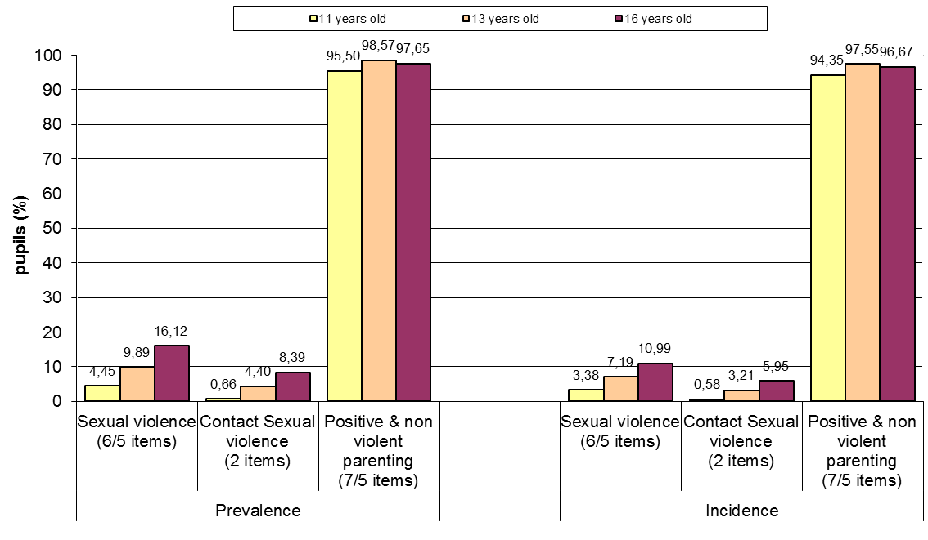

Figure D.3. Prevalence and incidence rates of pupils’ exposure to violent behaviors by grade group.
(Only the scales for which the analyses revealed a significant main effect of grade group and no significant interactions with grade group are presented here).
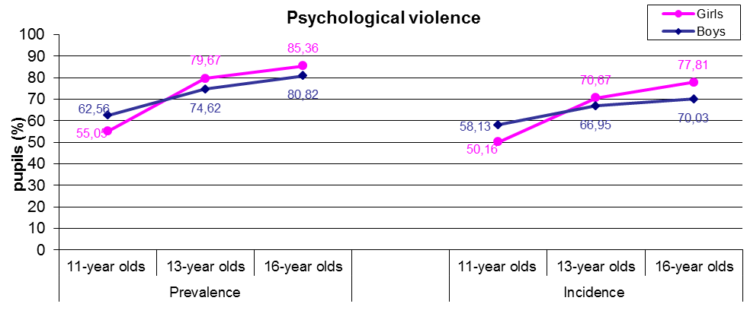

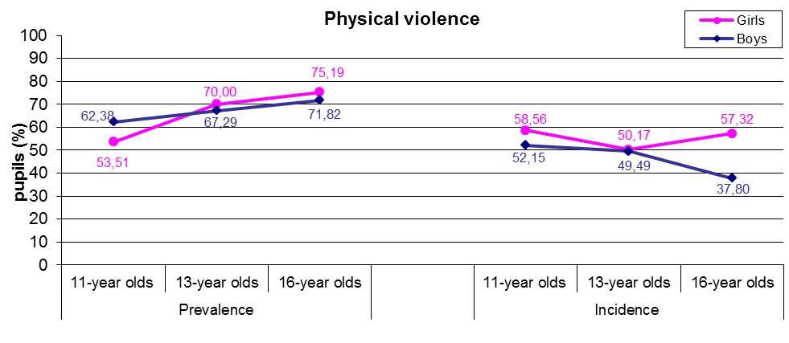

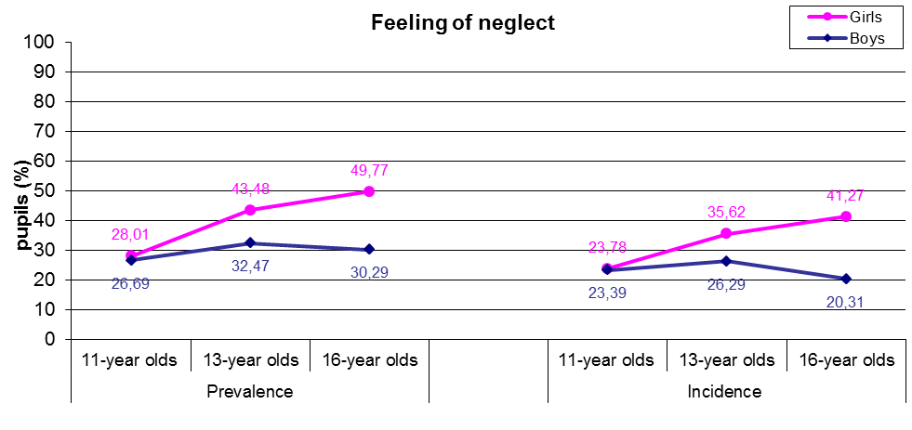

Figure D.4. Prevalence and incidence rates of pupils’ exposure to violent behaviors by child’s gender and grade group. (Only the scales for which the analyses revealed a significant interaction of gender x grade group are presented here).

Table D.3. Results of 12 Univariate GLM regression analyses conducted on the prevalence and the incidence of the 3 scales of violent behaviour, of the feeling of neglect scale and of the positive parenting scale; the results of the analyses on the subscale of contact sexual violence are also illustrated

 |  | Psychologi-cal violence | Physical violence | Sexual violence | Contact Sexual violence | Feeling of Neglect | Positive & non violent parenting
gender | PR. | 4.051* |  | 9.411*** | 4.341* | 82.254****
gender | IN. |  | 3.918* |  |  | 69.602****
grade group | PR. | 130.594**** | 52.736**** | 46.853**** | 43.678**** | 48.182**** | 465.272****
grade group | IN. | 66.829**** | 6.203*** | 27.463**** | 28.282**** | 25.827**** | 337.377****
gender x grade group | PR. | 11.161**** | 13.099**** | 3.986* |  | 19.002**** | 8.131****
gender x grade group | IN. | 12.207**** | 13.581**** |  |  | 20.719**** | 6.647****
* p<.05, **p<.01, ***p<.005, ****p<.001
PR: Prevalence, IN: Incidence
Note: In the cells of the table are depicted the F-values only for the main effects and the 2-way interactions that reached significance.

Figure D.5. Prevalence and incidence rates of pupils’ exposure to violent behaviors by number of different behaviors (items) they have been exposed to and by child’s gender.
(Only the scales for which the analyses revealed a significant main effect of gender and no significant interactions with gender are presented here).

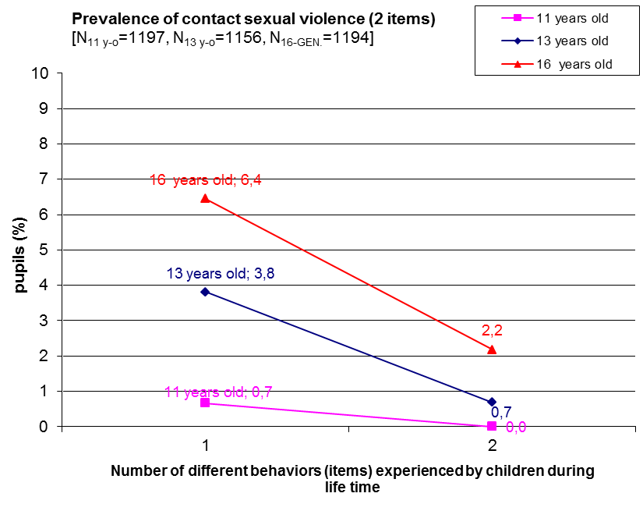
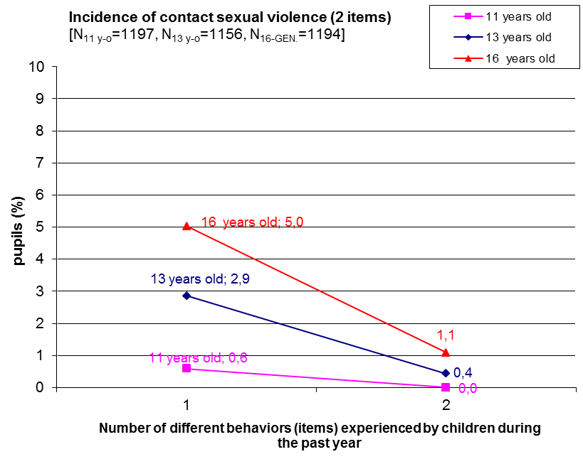
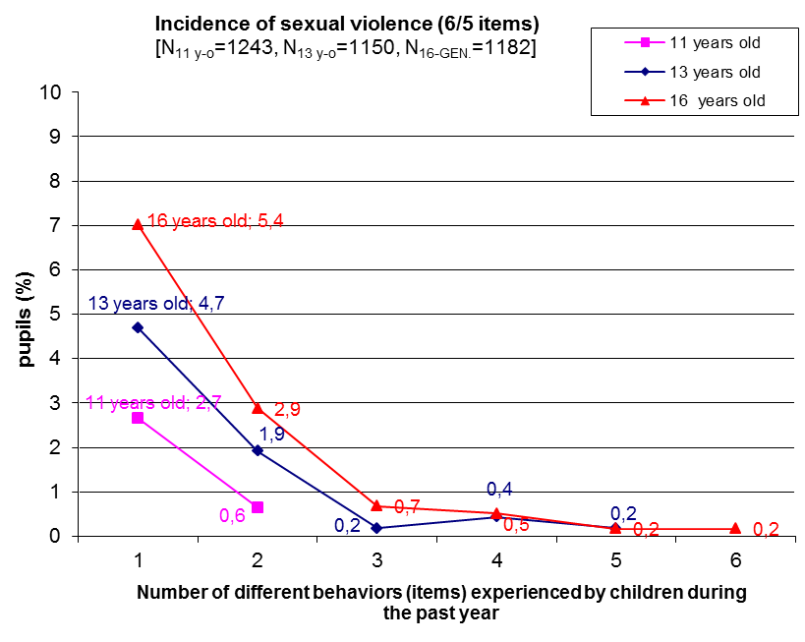
Figure D.6.Prevalence and incidence rates of pupils’ exposure to violent behaviors by number of different behaviors (items) they have been exposed to and by grade group.
(Only the scales for which the analyses revealed a significant main effect of grade group and no significant interactions with grade group are presented here).

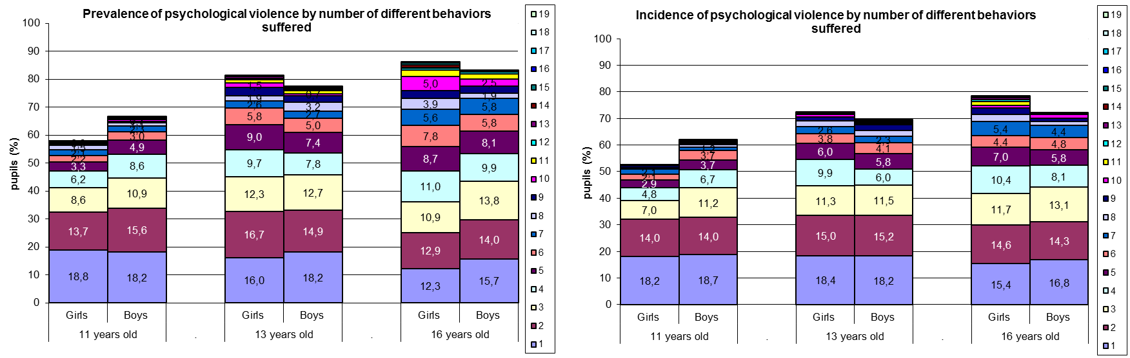

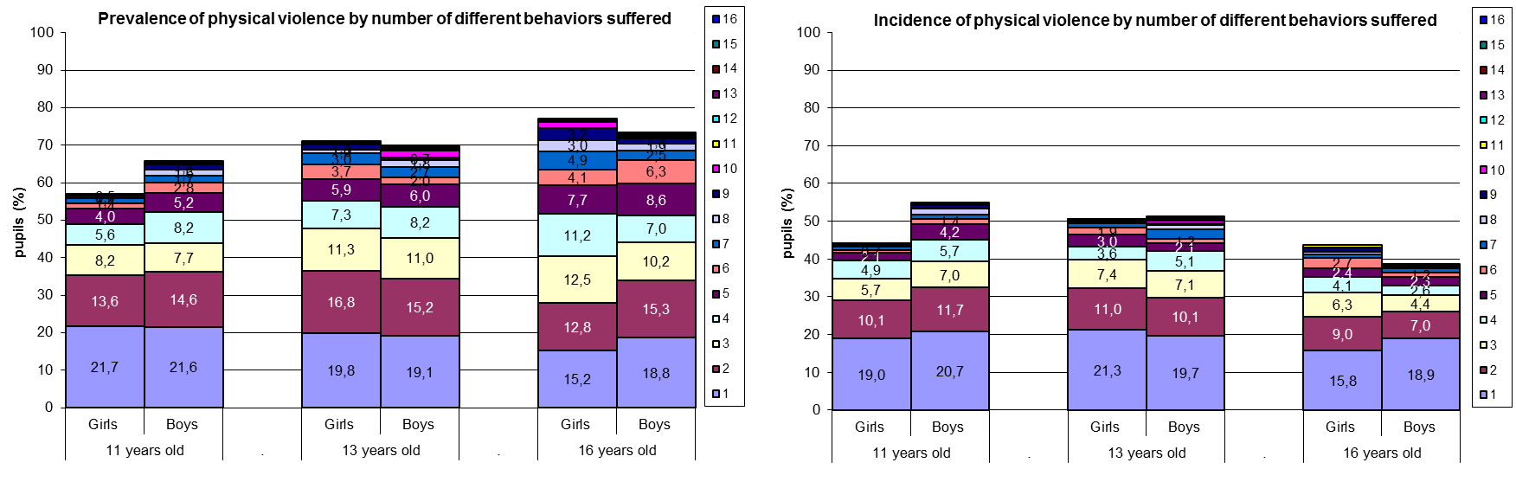

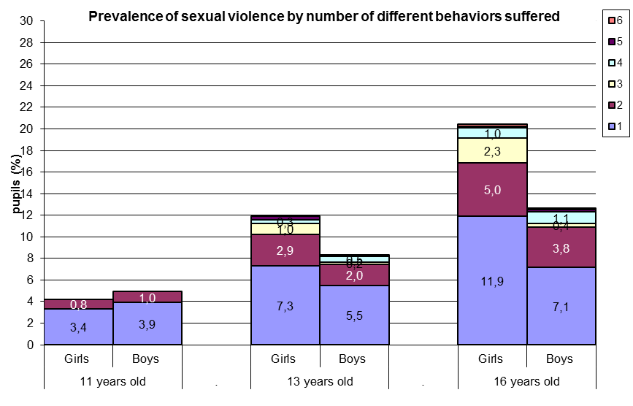

Figure D.7. Prevalence and incidence rates of pupils’ exposure to violent behaviors by number of different behaviors (items) they have been exposed to and by gender and grade group. (Only the scales for which the analyses revealed a significant interaction of gender x grade group are presented here).
(to be continued on the next page)

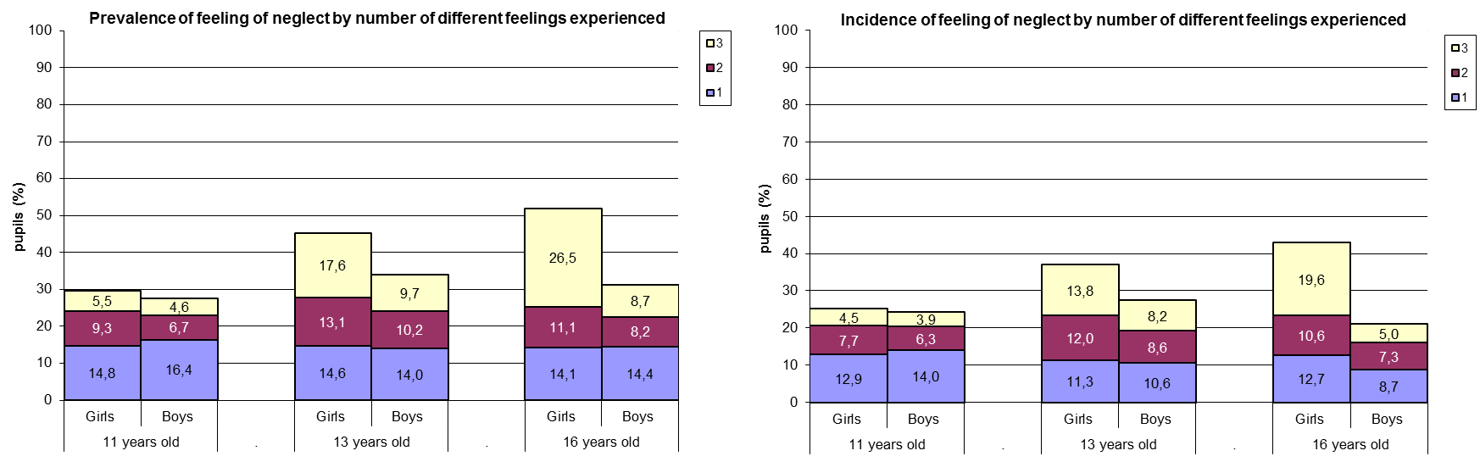

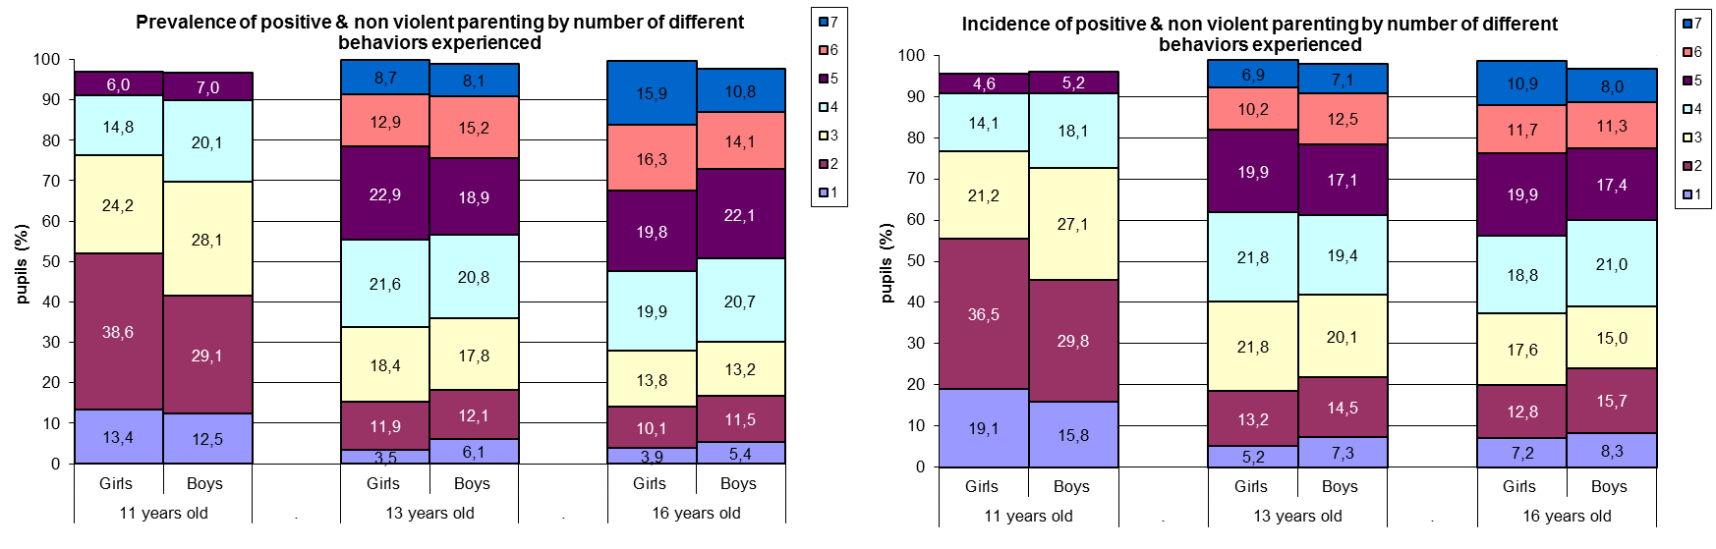

Figure D.8. Prevalence and incidence rates of pupils’ exposure to violent behaviors by number of different behaviors (items) they have been exposed to and by gender and grade group. (Only the scales for which the analyses revealed a significant interaction of gender x grade group are presented here).
(…continued from previous page)

Table D.4. Internal consistencies (Cronbach’s alpha) of 3 scales of maltreatment (psychologi-cal, physical and sexual violence), of the feeling of neglect and of the positive & non-violent parenting scales
 | Prevalence | Incidence
Psychological violence (19/17 items) | 0,805 | 0,895
Physical violence (16/15 items) | 0,781 | 0,920
Sexual violence (6/5 items) | 0,642 | 0,858
Contact sexual violence (2 items) | 0,502 | 0,764
Feeling of neglect (3 items) | 0,808 | 0,756
Positive & non-violent parenting (7/5 items) | 0,636 | 0,807

Table D.5. Distribution of children by the number of different types of violence they had experienced during their lifetime (prevalence) and during the past 12 months (incidence)
Different types  of violent experiences | Prevalence |  | Incidence
Different types  of violent experiences | N | % | N | %
0 | 529 | 14,72 | 825 | 22,96
1 | 627 | 17,45 | 901 | 25,08
2 | 1038 | 28,89 | 1014 | 28,22
3 | 1163 | 32,37 | 735 | 20,46
4 | 236 | 6,57 | 118 | 3,28
Multiple victimization  (2-4 types)¹ | 2437 | 67,83 | 1867 | 51,96
^{1.} Multiple victimization was operationally defined as a child’s exposure in more than one (up to 4) types of violent experiences, namely to psychological, physical and sexual violence as well as to domestic violence (items 11, 12, 13a and 14); the prevalence rate of the domestic violence scale is 46,14% (N=1681), while its incidence 35,60% (N=1297).

Figure D.9. Distribution of pupils’ exposure to 19/17* different experiences of psychological violence, by experience (item) and frequency they experienced it during the past year (incidence).

Items*
- Shouted, yelled, or screamed at you very loud and aggressively?
- Insulted you by calling you dumb, lazy or other names like that?
- Cursed you?
- Refused to speak to you (ignored you)?
- Blamed you for his/her bad mood?
- Read your diary, your SMS or e-mail messages without your permission?
- Went through your bag, drawers, pockets etc. without your permission?
- Compared you to other children in a way that you felt humiliated?
- Ashamed or embarrassed you intentionally in front of other people in a way that made you feel very bad or humiliated?
- Said that they wished you were dead or had never been born?
- Threatened to leave you or abandon you?
- Threatened to kick you out of house or send you away?
- Locked you out of the home?
- Threatened to invoke ghosts or evil spirits, or harmful people against you?
- Threatened to hurt or kill you?
- Did not get enough to eat (went hungry) and/or drink (were thirsty) even though there was enough for everyone, as a means of punishment?
- Have to wear clothes that were dirty, torn, or inappropriate for the season, as a means of punishment?
- Locked you up in a small place or in a dark room?
- Threatened you with a knife or a gun?

Scale
- 1-2 (once or twice a year)
- 3-5 (several times a year)
- 6-12 (monthly or bimonthly)
- 13-50 (several times a month)
- more than 50 (once a week or more often)

* Items in bold had been excluded from the short-version of the ICAST-CH completed by the 11 y-o grade’s pupils

Figure D.10. Distribution of pupils’ exposure to 16/15* different experiences of physical violence, by experience (item) and frequency they experienced it during the past year (incidence)

Items*
- Pushed or kicked you?
- Grabbed you by your clothes or some part of your body and shook you?
- Slapped you?
- Hit you on head with knuckle or back of the hand?
- Spanked you on the bottom with bare hand?
- Hit you on the buttocks with an object such as a stick, broom, cane, or belt?
- Hit you elsewhere (not buttocks) with an object such as a stick, broom, cane, or belt?
- Hit you over and over again with object or fist (“beat-up”)?
- Choked you or smothered you (prevent breathing by use of a hand or pillow) or squeezed your neck with hands (or something else)?
- Intentionally burned or scalded you?
- Put chilli pepper, hot pepper, or spicy food in your mouth (to cause pain)?
- Tied you up or tied you to something using a rope or a chain?
- Roughly twisted your ear?
- Pulled your hair?
- Pinched you roughly?
- Forced you to hold a position that caused pain or humiliated you as a means of punishment?

Scale
- 1-2 (once or twice a year)
- 3-5 (several times a year)
- 6-12 (monthly or bimonthly)
- 13-50 (several times a month)
- more than 50 (once a week or more often)

* The item in bold had been excluded from the short-version of the ICAST-CH completed by the 11 y-o grade’s pupils

Figure D.11. Distribution of pupils’ exposure to 6/5* different experiences of sexual violence, by experience (item) and frequency they experienced it during the past year (incidence)

Items*
- Made you upset by speaking to you in a sexual way or writing sexual things about you?
- Made you watch a sex video or look at sexual pictures in a magazine or computer when you did not want to?
- Made you look at their private parts or wanted to look at yours?
- Touched your private parts in a sexual way, or made you touch theirs?
- Made a sex video or took photographs of you alone, or with other people, doing sexual things?
- Tried to have sex with you when you did not want them to?

Scale
- 1-2 (once or twice a year)
- 3-5 (several times a year)
- 6-12 (monthly or bimonthly)
- 13-50 (several times a month)
- more than 50 (once a week or more often)

* The item in bold had been excluded from the short-version of the ICAST-CH completed by the 11 y-o grade’s pupils

Figure D.12. Distribution of pupils’ exposure to 3 different feelings of neglect, by feeling (item) and frequency they experienced it during the past year (incidence)

Items
- You did not feel cared for?
- Felt that you were not important?
- Felt that there was never anyone looking after you, supporting you, helping you when you most needed it?

Figure D.13. Distribution of pupils’ exposure to 7/5* different experiences of positive & non-violent parenting, by experience (item) and frequency they experienced it during the past year (incidence)

Items*
- Told you to start or stop doing something (e.g. start doing your homework or stop watching TV)?
- Explained you why something you did was wrong?
- Gave you an award for behaving well?
- Gave you something else to do in order to distract your attention (e.g. to tell you do something in order to stop you watching TV)?
- Took away your pocket money or other privileges?
- Forbade you something that you liked?
- Forbade you to go out?

Scale
- 1-2 (once or twice a year)
- 3-5 (several times a year)
- 6-12 (monthly or bimonthly)
- 13-50 (several times a month)
- more than 50 (once a week or more often)

* Items in bold had been excluded from the short-version of the ICAST-CH completed by the 11 y-o grade’s pupils

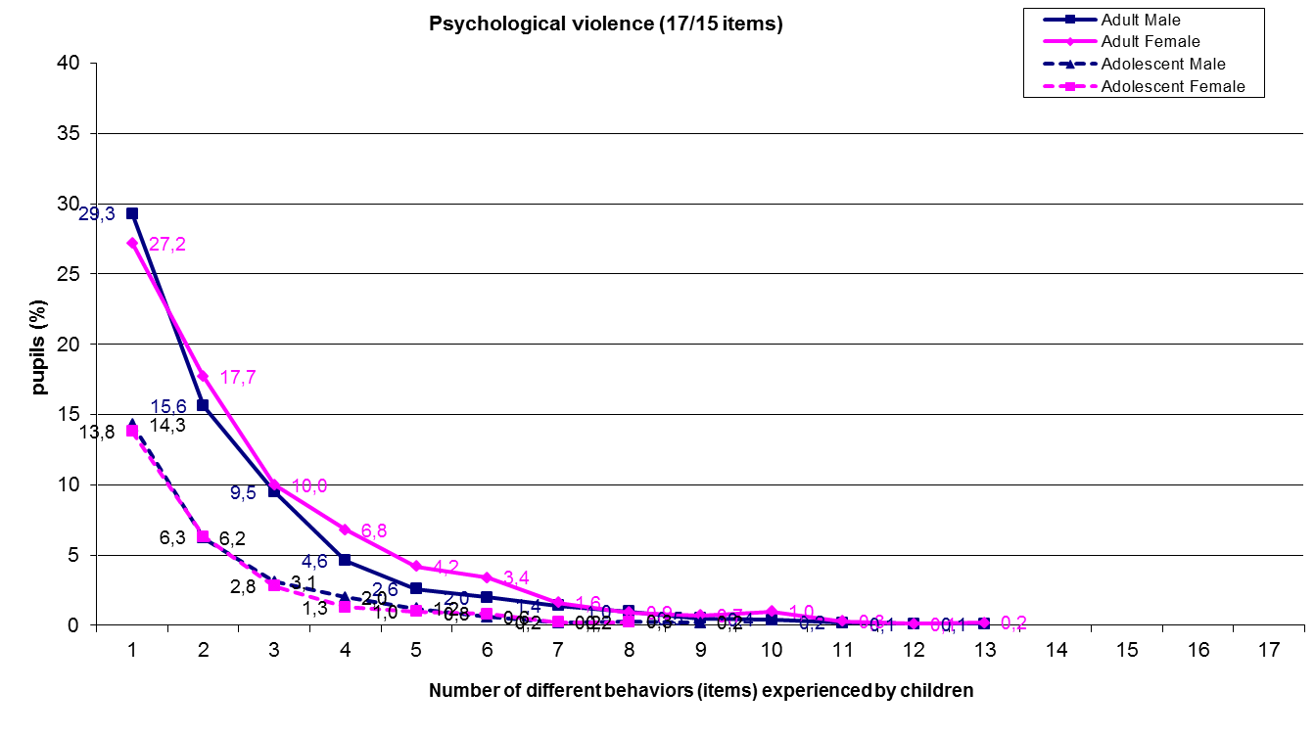

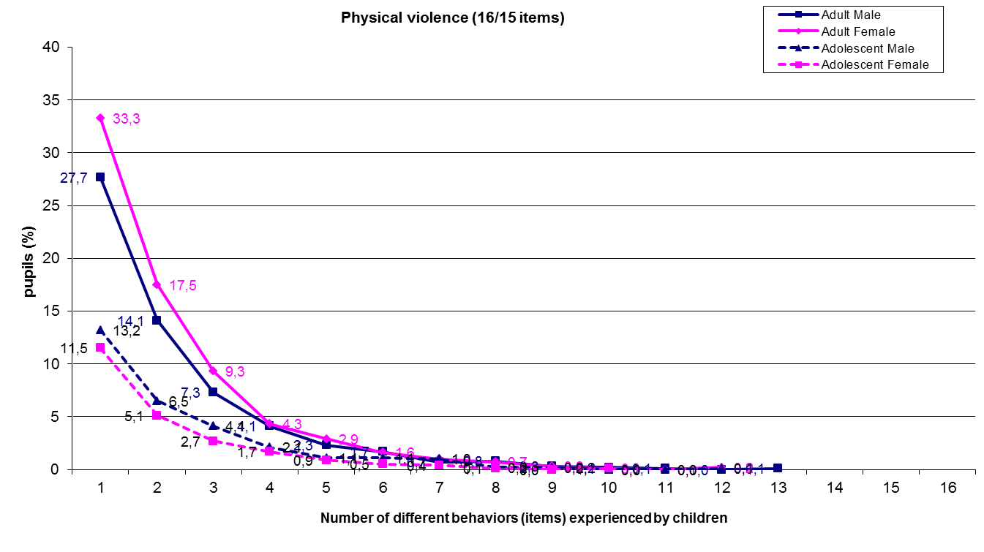

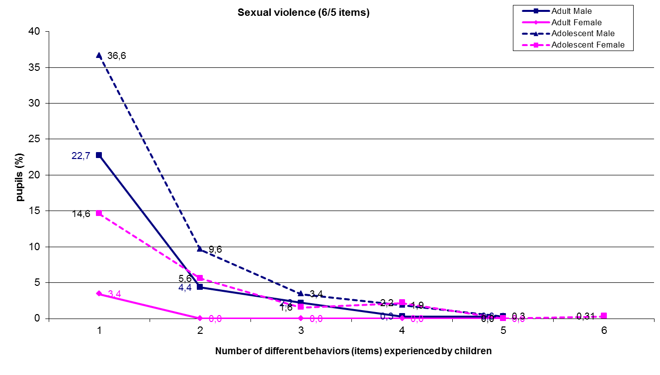

Figure D.14. Percentage of pupils who have experienced different violent behaviors by number of different behaviors (items) they have been exposed to and by type of perpetrator (adult male or female and adolescent male or female)
(to be continued on the next page)

Figure D.15. Percentage of pupils who have experienced different violent behaviors by number of different behaviors (items) they have been exposed to and by type of perpetrator (adult male or female and adolescent male or female)
(…continued from previous page)

Figure D.16. Percentage of pupils who have experienced 6 different behaviors of sexual violence by type of perpetrator (adult male or female and adolescent male or female).

Note
The percentages are calculated on the total number of children who had each experience; their sum exceeds 100%, in case some children have experienced the same behavior from different types of perpetrators.

Figure D.17. Distribution of perpetrators as reported by children who experienced each of 6 different behaviors of sexual violence, by type of perpetrator (adult male or female and adolescent male or female) and his/her relationship to the child (unknown person, familiar person, a relative).

Note
The percentages are calculated on the total number of perpetrators that had been reported by children who had each experience.

Paired analysis

Analysis of paired data for children and their parents was conducted on 2768 child-parent pairs. In calculating the results for children only the experiences with psychological and physical violence where the child labeled an adult male or female as a perpetrator were used.

Table D.6. Demographics for matched pairs of children and their parent/caregiver participated in the ICAST-CH and ICAST-P survey in Croatia, and information about their living conditions (Sample’s size = 2768 pairs of child – respondent parent/caregiver)
 | N | %
Child’s gender
Girls | 1479 | 53,43
Boys | 1289 | 46,57
Child’s age
Unspecified | 7 | 0,25
10 | 6 | 0,22
11 | 762 | 27,60
12 | 263 | 9,53
13 | 672 | 24,34
14 | 296 | 10,72
15 | 18 | 0,65
16 | 511 | 18,51
17 | 219 | 7,93
18 | 14 | 0,51
Grade group (typical age of attending pupils)
11 y-o | 1027 | 37,10
13 y-o | 986 | 35,62
16 y-o | 755 | 27,28
Child’s birth position in the family
Unspecified | 33 | 1,19
only child | 314 | 11,48
first child (oldest) | 903 | 33,02
middle child | 426 | 15,58
last child (youngest) | 1019 | 37,26
twins | 66 | 2,41
not biological child | 7 | 0,26
Persons cohabitating with the child
Unspecified | 4 | 0,14
Mother | 2286 | 82,71
father | 2391 | 86,51
stepmother (father’s spouse) | 11 | 0,40
stepfather (mother’s spouse) | 49 | 1,77
foster mother | 11 | 0,40
foster father | 9 | 0,33
mother’s partner | 23 | 0,83
father’s partner | 4 | 0,14
grandmother | 613 | 22,18
grandfather | 322 | 11,65
female siblings(s) | 1338 | 48,80
male siblings(s) | 1470 | 53,75
other relatives | 80 | 2,90
other non relatives | 24 | 0,87
Respondent’s relationship with the child
Unspecified | 19 | 0,69
mother | 2241 | 81,52
father | 471 | 17,13
foster mother | 8 | 0,29
foster father | 11 | 0,40
sister | 1 | 0,04
brother | 4 | 0,15
grandmother | 5 | 0,18
grandfather | 2 | 0,07
other relative | 2 | 0,07
other | 4 | 0,15
Respondent also replied for:
Unspecified | 683 | 24,67
none (for her/himself only) | 194 | 9,30
The other parent | 1699 | 81,49
her/his spouse/partner | 150 | 7,19
other person | 42 | 2,01

 | Mother |  | Father
 | N | % | N | %
Parents’ Nationality
Unspecified | 140 | 5,06 | 187 | 6,76
N/A (parent not alive) | 20 | 0,72 | 61 | 2,20
Croatian | 2441 | 93,60 | 2375 | 94,25
Serbian | 84 | 3,22 | 71 | 2,82
Bosnian | 26 | 1,00 | 18 | 0,71
Hungarian | 14 | 0,54 | 13 | 0,52
Albanian | 11 | 0,42 | 11 | 0,44
Other | 32 | 1,23 | 32 | 1,27
Parents’ marital situation
Unspecified | 91 | 3,22 | 162 | 5,85
N/A (parent not alive) | 20 | 0,72 | 61 | 2,20
married | 2294 | 86,34 | 2420 | 95,09
separated | 31 | 1,17 | 2 | 0,08
divorced | 115 | 4,33 | 33 | 1,30
remarried | 44 | 1,66 | 31 | 1,22
cohabitating | 63 | 2,37 | 32 | 1,26
single | 58 | 2,18 | 12 | 0,47
widow | 48 | 1,81 | 7 | 0,28
other | 4 | 0,15 | 8 | 0,31
Urbanicity of the place of residence
Unspecified | 152 | 5,49 | 232 | 8,38
N/A (parent not alive) | 20 | 0,72 | 61 | 2,20
Urban | 1704 | 65,64 | 873 | 35,27
Nonurban | 892 | 34,36 | 1602 | 64,73
Parents’ employment condition
Unspecified | 106 | 3,83 | 199 | 7,19
N/A (parent not alive) | 20 | 0,72 | 61 | 2,20
not working | 562 | 21,27 | 50 | 1,99
working | 1796 | 67,98 | 1945 | 77,55
unemployed | 241 | 9,12 | 188 | 7,50
retired | 43 | 1,63 | 325 | 12,96

 | Mother |  | Father
 | N | % | N | %
Parents’ educational level
Unspecified | 97 | 3,50 | 187 | 6,76
N/A (parent not alive) | 20 | 0,72 | 61 | 2,20
has not attended school | 2 | 0,08 | 1 | 0,04
Some grades of Elementary school | 18 | 0,68 | 22 | 0,87
Elementary school | 362 | 13,66 | 195 | 7,74
Secondary vocational school (1-3 years) | 501 | 18,90 | 663 | 26,31
Secondary vocational school (4 years) | 1023 | 38,59 | 1082 | 42,94
Gymnasium | 146 | 5,51 | 71 | 2,82
University | 558 | 21,05 | 441 | 17,50
Postgraduate studies (masters, doctorate) | 41 | 1,55 | 45 | 1,79

 | N | %
Respondent’s subjective
estimation of economic situation
Unspecified | 97 | 3,50
very bad | 245 | 9,17
bad | 396 | 14,83
moderate | 1597 | 59,79
good | 363 | 13,59
very good | 70 | 2,62

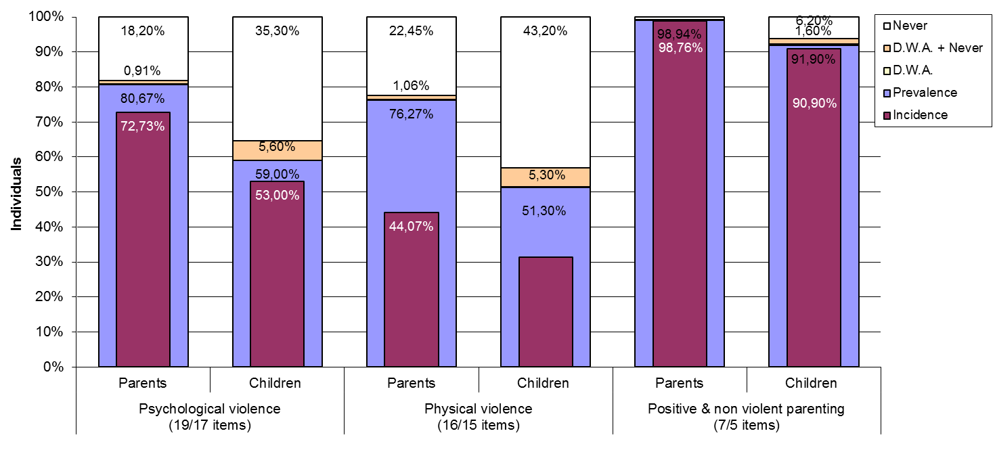
Figure D.18. Distribution of parents’ and pupils’ answers in regards to children’s exposure to psychological and physical violence and to positive parental behaviors during their life time (prevalence) and/or during past year (incidence), by scale.

Note
Incidence: percentage of parents/children reporting any frequency score under “During the past year (previous 12 months)” in at least 1 item of the scale
Prevalence: percentage of parents/children reporting doing/having experienced at least 1 behavior of the scale during their entire life time (either in the past year or before)
D.W.A.: percentage of parents/children answering “Don’t want to answer” in all items of the scale
D.W.A+Never: percentage of parents/children answering “Don’t want to answer” in 1 or more items of the scale and “Never” to all other items of this scale
Never: percentage of parents/children reporting that they have “Never” in their lives do/experience none of the scale’s behaviors.

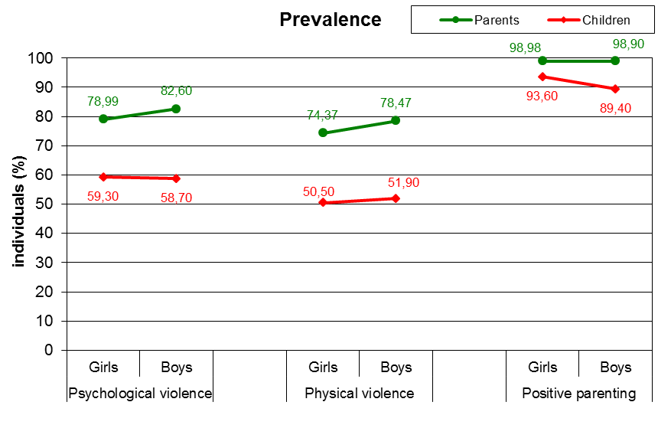
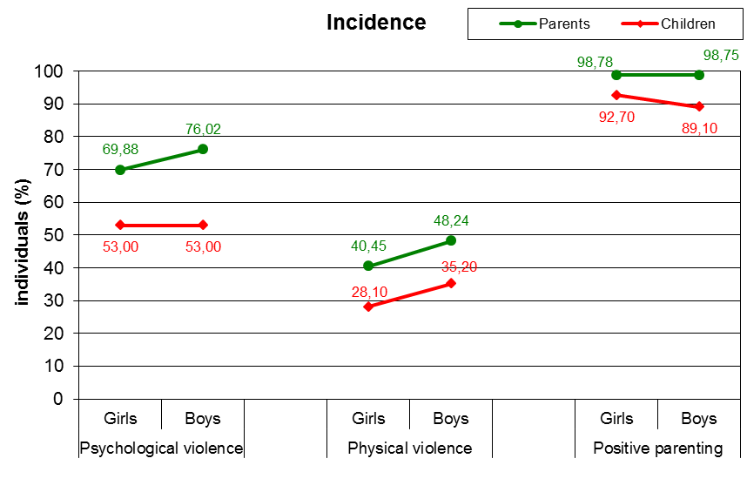
Figure D.19. Prevalence and incidence rates of parents’ use and children’s exposure to behaviors of psychological and physical violence and of positive parenting, by child’s gender.

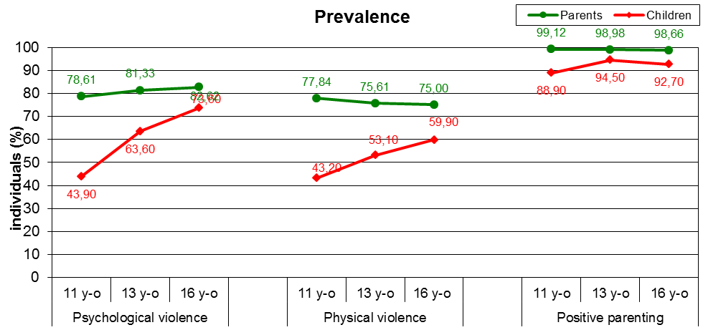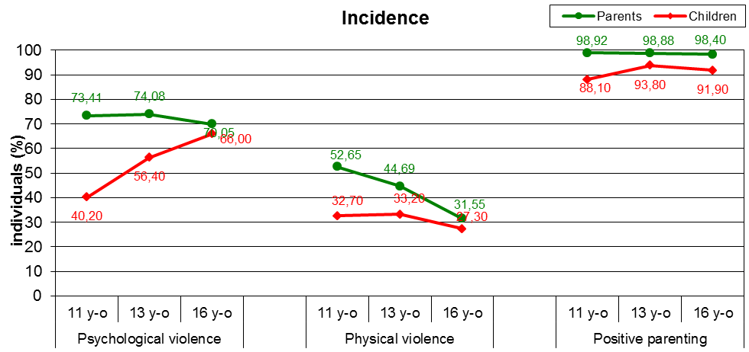

Figure D.20. Prevalence and incidence rates of parents’ use and children’s exposure to behaviors of psychological and physical violence and of positive parenting, by child’s grade group.

Figure D.21. Prevalence and incidence rates of children’s exposure to 6 different sexually violent behaviors and rates of parental awareness for their children’s exposure.

Figure D.22. Prevalence and incidence rates of children’s exposure to 6 different sexually violent behaviors and rates of parental awareness for their children’s exposure, by child’s gender.

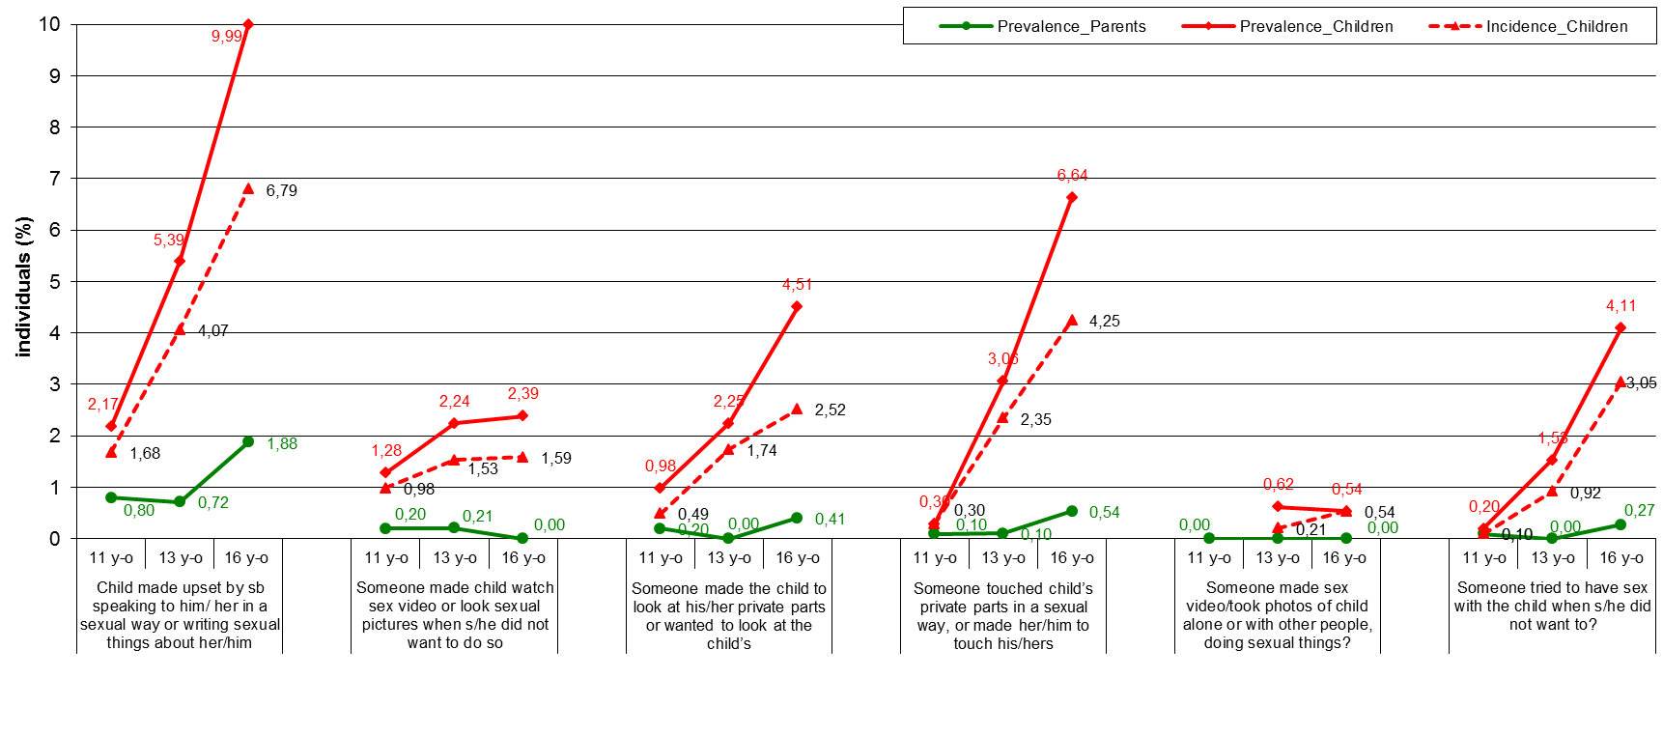

Figure D.23. Prevalence and incidence rates of children’s exposure to 6 different sexually violent behaviors and rates of parental awareness for their children’s exposure, by child’s grade group.
(The item “has anyone ever… made a sex video or took photographs of you alone, or with other people, doing sexual things?” was not included in the short ICAST-CH version, completed by the 11 y-o grade’s pupils, but it was included in the ICAST-P, their parents completed.)

Table D.7. Internal consistencies (Cronbach’s alpha) of 3 scales of maltreatment (psychologi-cal, physical and sexual violence) and of the positive & non violent parenting scales
 | Prevalence |  | Incidence
 | Children | Parents | Children | Parents
Psychological violence (19/17 items) | 0,861 | 0,910 | 0,861 | 0,910
Physical violence (16/15 items) | 0,909 | 0,920 | 0,909 | 0,919
Sexual violence (6/5 items) | 0,840 | N/A | 0,840 | N/A
Contact sexual violence (2 items) | 0,748 | N/A | 0,748 | N/A
Positive & non violent parenting (7/5 items) | 0,746 | 0,763 | 0,746 | 0,763

Table D.8. (In)consistency in children’s - parents’ reporting in regards to the parents’ use and children’s exposure to the different behaviors of the psychological and physical violence as well as of the positive parenting scales
Scale | Items¹ | N | Kappa coefficient²
Scale | Items¹ | N | PR | IN.
Psychological violence (19/17 items) | Shouted, yelled, or screamed at her/him very loud and aggressively? | 2616 | 0,187 | 0,166
Psychological violence (19/17 items) | Insulted him/her by calling him/her dumb, lazy or other names like that? | 2594 | 0,173 | 0,174
Psychological violence (19/17 items) | Cursed him/her? | 2656 | 0,073 | 0,074
Psychological violence (19/17 items) | Refused to speak to him/her (ignore him/her)? | 2617 | 0,106 | 0,109
Psychological violence (19/17 items) | Blamed him/her for your bad mood? | 1628 | 0,111 | 0,114
Psychological violence (19/17 items) | Read his/her diary or his/her SMS or e-mail messages without his/her permission? | 2651 | 0,185 | 0,167
Psychological violence (19/17 items) | Went through his/her bag, drawers, pockets etc. without his/her permission? | 2633 | 0,104 | 0,115
Psychological violence (19/17 items) | Compared him/her to other children in a way that s/he felt humiliated? | 2658 | 0,191 | 0,147
Psychological violence (19/17 items) | Ashamed or embarrassed her/him intentionally in front of other people in order to make him/her feel very bad or humiliated? | 2662 | 0,097 | 0,107
Psychological violence (19/17 items) | Told her/him that you wished s/he was dead or had never been born? | 2695 | 0,097 | 0,079
Psychological violence (19/17 items) | Threatened to leave or abandon him/her? | 2693 | 0,082 | 0,075
Psychological violence (19/17 items) | Threatened to kick out of house or send away? | 2676 | 0,142 | 0,130
Psychological violence (19/17 items) | Locked out of home? | 2695 | 0,075 | 0,075
Psychological violence (19/17 items) | Threatened to invoke ghosts or evil spirits or harmful people against him/her? | 1606 | 0,185 | 0,007
Psychological violence (19/17 items) | Threatened to hurt or kill her/him? | 2698 | 0,098 | 0,070
Psychological violence (19/17 items) | Locked her or him up in a small place or in a dark room? | 2705 | 0,075 | 0,065
Psychological violence (19/17 items) | Threatened him/her with a knife or gun? | 2712 | 0,092 | 0,036
Physical violence (16/15 items) | Pushed or kicked her/him? | 2615 | 0,109 | 0,101
Physical violence (16/15 items) | Grabbed him/her by clothes or some part of his/her body and shook him/her? | 2670 | 0,113 | 0,098
Physical violence (16/15 items) | Slapped him/her? | 2579 | 0,263 | 0,200
Physical violence (16/15 items) | Hit him/her on head with knuckle or back of the hand? | 2669 | 0,093 | 0,066
Physical violence (16/15 items) | Spanked her/him on the bottom with bare hand? | 2525 | 0,122 | 0,144
Physical violence (16/15 items) | Hit her or him on the buttocks with an object such as a stick, broom, cane, or belt? | 2626 | 0,151 | 0,136
Physical violence (16/15 items) | Hit elsewhere (not buttocks) with an object such as a stick, broom, cane, or belt? | 2640 | 0,119 | 0,085
Physical violence (16/15 items) | Hit her or him over and over again with object or fist (“beat-up”) | 2699 | 0,029 | 0,030
Physical violence (16/15 items) | Choked or smothered him/her (prevent breathing by use of a hand or pillow) or squeezed his/her neck with hands (or something else)? | 2686 | 0,048 | 0,057
Physical violence (16/15 items) | Intentionally burned or scalded him/her? | 2705 | 0,033 | 0,037
Physical violence (16/15 items) | Put chili pepper, hot pepper, or spicy food in his/her mouth (to cause pain)? | 1663 | 0,016 | 0,023
Physical violence (16/15 items) | Tied him/her up or tied him/her to something using a rope or a chain? | 2713 | 0,035 | 0,038
Physical violence (16/15 items) | Roughly twisted her/his ear? | 2652 | 0,151 | 0,146
Physical violence (16/15 items) | Pulled her/his hair? | 2614 | 0,219 | 0,171
Physical violence (16/15 items) | Pinched her/him roughly? | 2639 | 0,086 | 0,096
Physical violence (16/15 items) | Forced him or her to hold a position that caused pain or humiliated him/her as a means of punishment? | 2691 | 0,094 | 0,064
Positive and non-violent parenting (7/5 items) | Told her/him to start or stop doing something (e.g. start doing your homework or stop watching TV)? | 1588 | 0,117 | 0,120
Positive and non-violent parenting (7/5 items) | Explained him/her why something s/he did was wrong? | 2512 | 0,038 | 0,042
Positive and non-violent parenting (7/5 items) | Gave him/her an award for behaving well? | 2521 | 0,042 | 0,048
Positive and non-violent parenting (7/5 items) | Gave him/her something else to do in order to distract his/her attention (e.g. to tell him/her to do something else in order to stop watching TV)? | 1594 | 0,099 | 0,090
Positive and non-violent parenting (7/5 items) | Took away pocket money or other privileges? | 2649 | 0,152 | 0,149
Positive and non-violent parenting (7/5 items) | Forbade something that s/he liked? | 2621 | 0,185 | 0,187
Positive and non-violent parenting (7/5 items) | Forbade him or her from going out? | 2625 | 0,271 | 0,245
^{1.} Items in bold had been excluded from the short-version of the ICAST-CH completed by the 11 y-o grade’s pupils
^{2.} The lower the kappa coefficient, the higher the disagreement between children’s - parents’ reports; Kappas lower than ,40 considered to be poor, ,41-,75 fair to good and larger than ,75 excellent agreement

E. DISCUSSION (OF THE RESEARCH FINDINGS)
In this study, analyses of prevalence and incidence of psychological and physical violence, feeling of neglect, sexual violence and positive and non-violent parenting that children had experienced were performed. For each type of experiences analyses were performed to determine the existence of differences in relation to sex and grade.

Data on prevalence show that the largest number of children experienced some form of psychological violence (73.04%) during their lifetime, while physical violence was experienced by 66.73% of children. Feeling of neglect occurs in 35.30% of children. Sexual violence is specific in that the items related to this type of violence referred to the events both within and outside of the family, as opposed to other forms of violence that were related solely to the family. Prevalence of sexual violence is 10.18%, while contact sexual violence was experienced by 4.50% of children during their lifetime. Almost all of the children (97.23%) reported that they have experienced positive and non-violent parenting during lifetime.

Direction of the grade group differences is consistent, so that the largest numbers of those who have experienced all categories of violent behaviours and feeling of neglect are among the oldest participants, 16-year-olds. They are followed by 13-year-olds, and, as expected, the lowest prevalence of various forms of family violence, sexual violence and feeling of neglect during lifetime is in the youngest grade group. There is a curved trend for positive and non-violent parenting, with the highest prevalence among 13-year-old children (98.57%).

Gender differences were significant for the prevalence of sexual violence, feeling of neglect and positive and non-violent parenting. In all three types of experiences girls have a higher prevalence compared to boys.

In addition to gender and grade differences, interaction effects of gender and grade to the prevalence of all types of children's experiences were studied. The interaction effect of gender and grade proved to be significant for the prevalence of psychological and physical violence and feeling of neglect. For psychological and physical violence girls in the youngest grade group have a lower prevalence compared to boys, while girls in older grade groups showed a higher prevalence of experiencing both types of violence. Boys in different age groups show similar prevalence of feeling of neglect (26.69% - 32.47%), and the prevalence is only slightly higher for girls in the youngest group compared to the boys (28.01%), but this difference increases with age and in the oldest grade group of girls this prevalence amounts to 49.77%.

As stated earlier, besides prevalence, incidence of experiencing different types of violence, feeling of neglect and positive and non-violent parenting in the past year (in relation to the time of the survey) was also studied. Results show similar trends as the results of the prevalence analyses. Thus incidence was also the highest when it comes to psychological (65.69%) and physical violence (45.54%) that the children had experienced. Incidence of feeling of neglect is the next highest one, and it amounts to 28.63%. Sexual violence was experienced by 7.20% of children in the past year, whereby the incidence of contact sexual abuse is 3.26%. Positive and non-violent parenting was experienced by almost all children (96.18%) in the past year.

Age differences showed a higher incidence of all types of children's experiences in older groups, except for positive and non-violent parenting, where, as in the results regarding prevalence, a curved trend was found and 97.55% of the 13-year-old children experienced some of these behaviours in the past year. Gender differences exist only in the feeling of neglect, where girls show a higher incidence.

In addition to the main effects of gender and grade, significant interaction effects of gender and age to the incidence of psychological and physical violence and feeling of neglect have been identified. Thus incidence of psychological violence in the youngest grade group is higher for boys compared to girls, and this trend changes in the older grade groups, with the incidence being higher for girls than for boys in the oldest grade group. As for the physical violence, incidence is higher for girls than for boys in the youngest and the oldest grade group, while in the group of 13-year-old pupils incidence is equal for both genders. When it comes to the feeling of neglect, in the youngest grade group incidence is equal for girls and boys, while in the older grade groups the difference between them increases, being over 20% higher for girls than for boys in the oldest age group.

Along with prevalence and incidence, analyses based on the number of experienced behaviours for each type of children's experiences were performed for the whole life period and for the past year. It turned out that there is a significant effect of grade for the number of experienced behaviours within all forms of children's experiences during lifetime, the effect of sex did not prove to be significant for positive and non-violent parenting and physical violence, while the interaction effect of gender and grade was significant for all forms, except for contact sexual violence. A similar trend is also found for the events in the past year, with the differences being that in the past year the effect of gender was significant only for physical violence and feeling of neglect, and that the interaction effect of gender and grade was not significant for sexual violence in general. As the distributions of the number of experienced behaviours are similar to distributions of rare events, which means that most children have experienced one or two behaviours, we are talking about the steepness of the curves, that is, if we compare these data with data on prevalence and incidence, we can see that the resulting differences in prevalence and incidence are mostly manifested in children who had experienced one or two behaviours during lifetime, and during the past year, and to a lesser extent in children who had experienced multiple behaviours.
As a measure of reliability of the scales Cronbach's α coefficient was used. Reliability coefficients for incidence of different children's experiences were above .750, with the highest coefficient being the one for incidence of physical violence (.920). As for prevalence, slightly lower coefficients were found for positive and non-violent parenting (.636), sexual violence in general (.642) and contact sexual violence (.502).

If psychological, physical and sexual violence and domestic violence are put under the term of adverse children's experiences, we can see that 14.6% of children did not have any of these forms of adverse childhood experiences during their lifetime, and the percentage for the past year is 22.96%. One of the forms was experienced by 17.45% of children during their lifetime, and 25.08% in the past year. More than one of these types of adverse childhood experiences was experienced by 67.83% of children over lifetime, and 51.96% during the past year.

Psychological violence was experienced by 65.69% of children in the past year. Most of the children experienced being yelled at, insulted and compared with other children in a way that the child felt humiliated. Perpetrators of psychological violence are mostly mother and/or father, and to a lesser extent, other children in the family.

Physical violence was experienced by 45.54% of children in the past year, with children most often experiencing slaps, hair pulling, pushing and kicking, and spanking on the bottom with bare hand. Father and mother were also the most common perpetrators of physical violence, while the other children in the family were the perpetrators somewhat less often.

Sexual violence was experienced by 7.2% of children in the past year. Most children experienced being upset by someone speaking to them in a sexual way or writing sexual things about them, and someone touching their private parts in a sexual way or making the child touch theirs. It should be noted that the potential perpetrators of this type of violence were also the people who are not family members. The most common perpetrators of this type of violence are child/adolescent males, then adult males, and then child/adolescent females and the least common perpetrators are adult females. In most cases this was a familiar person, except for adult males who spoke to children in a sexual way or wrote sexual things about them, where most of the perpetrators were unknown.

Incidence of feeling of neglect is 28.63%. Most children said that they felt like they were not important, then that they did not feel cared for, and the least children reported that they felt that there was never anyone looking after them, supporting them and helping them when they most need it. In items that focused on the feeling of neglect children did not have to indicate the perpetrators.

Incidence for positive and non-violent parenting was 96.18%. Children mostly experienced getting a reward for behaving well and being explained to why something they did was wrong. Parents were the ones who did that most often, and so did the other children in the family but to a considerably lesser extent.

In addition to the analysis of children's responses, an analysis was performed for those children for whom parental questionnaires were collected. To be able to compare the responses to the ones given by parents, for children only the behaviours where the perpetrators were adult male or adult female have been taken into account. An exception is sexual violence where no such restrictions were performed (because both parents and children were asked about these events, regardless of the perpetrator being a family member or not), and the results for feeling of neglect are not shown because the parents did not respond to these questions.

The results show that children generally give lower estimates of experienced behaviours compared to parents. However, in case of sexual violence, parents usually do not know what happens to their children, so the prevalence of sexual violence that parents know about is almost non-existent.

In conclusion, we can say that prevalence and incidence of family violence experienced by children is high, and if we look at parental assessments, the results are even higher. This suggests that, despite them being forbidden by law, parents continue to practice behaviours that are harmful to children. It is important to note that in the oldest grade group, besides psychological violence, a great deal of physical violence is also still present. These data indicate the need to implement preventive programs for the prevention of family violence against children and the need to empower parents to use positive child rearing practices. Also, data on the discrepancy between parents and children regarding experienced sexual violence show that children do not confide in their parents about the violence that they have experienced.

The biggest limitation of the study is the fact that a number of children who wanted to participate in the study could not do so because they did not have the written parental consent. However, the response rate was very high, mainly because the parents were directly informed about the study at the parent-teacher meetings before giving their consent. This method has proven to be a good motivator, although it required additional time and effort of the researchers.

F. FACILITATORS AND BARRIERS
1. What factors (if any) can be considered as facilitators to the implementation of the research?

All authorities gave their permissions for the study very quickly and showed exceptional interest in the results. Significant facilitating factor in the implementation of the research was the excellent cooperation of schools in which the study was conducted. Also, schools have precise data about pupils, which facilitated the sampling procedure, the estimation of the realised sample size and the subsequent weighting procedure.

2. What were the main problems/difficulties (if any) encountered during the implementation of the research? How were these solved?

We did not face any specific problems during the implementation of the research.

G. CONCLUSIONS AND RECOMMENDATIONS
Although there has been a number of relevant research in Croatia regarding correlates and effects of violence against children in the family (Ajduković and Ogresta, 2010; Ajduković et al. 2010), the BECAN project enabled conducting the first real epidemiological study of incidence and prevalence of violence against children. In this perspective, valuable data were collected, which are the potential base-line for future research and monitoring trends.

As particularly valuable, we would like to point out the widening of the parents’ questionnaire with questions relating to exposure of the family to socio-economic stressors and other stressful life events. By doing so, a good and comprehensive understanding of the risk factors for family violence related to the social crisis was obtained for the first time. It allows for even more attention to be paid to social policy measures that should reduce the impact of the crisis on the lives of families with children and to the work of services for child protection in the early identification of risk circumstances for their exposure to violence.

Abundance of data collected as a part of the expanded epidemiological BECAN project in Croatia will, in the forthcoming period, result in a number of research papers and one doctoral dissertation, and as such contribute significantly to the scientific study of predictors and correlates of various types of violence against children in the family. For example, the theme of psychological violence has been neglected in previous studies, while this study makes it possible to investigate the specific set of predictors of physical and psychological violence. This is in itself a significant scientific contribution.

The fact that the research was conducted using identical methodology in 9 countries will allow us to better understand and interpret some of the information obtained in national surveys, which are not in line with previous studies, such as the high rate of incidence and prevalence of physical abuse of girls, high proportion of siblings as perpetrators of family violence and so on.

A high level of commitment to the ethical aspects in conducting epidemiological research in the BECAN project raised the level of thinking about the ethical principles of research with children in Croatia even higher, both in qualitative (Ajduković, Sušac and Rajter, 2011), as well as in quantitative research of violence (Rimac and Ogresta, 2012). Starting from the experiences of this project, organizing a national round table on the ethical aspects of research with children was included in the program of the Council for Children of the Republic of Croatia for 2013, the goal of which is also to encourage reviewing the existing Code of Ethics of Conducting Research with Children, which was adopted in 2003.

In general, participation in such a complex epidemiological study has further strengthened the research capacities of our institution. The National Conference where we presented the results of the project has become the standard of excellence for presenting similar projects and has made ​​an excellent effect in the media that has contributed to a better public awareness of violence against children and the importance of scientific research and knowledge as prerequisites of effective interventions in this field. Our research team has been recognized as a major partner and interlocutor with various government bodies, primarily with the Education and Teacher Training Agency, on whose initiative four regional assemblies were held where the results of the project were presented.

Studies such as the BECAN project should be conducted every five years in order to monitor trends and evaluate the effects of preventive measures. As can be seen from experiences in Croatia, in these periodic surveys it would be good to collect extensive data on socio-environmental and family stressors, so that the effect of preventive measures in the socio-economic context in which families with children live could be partially evaluated.
H. REFERENCES
Act on Amendments to the Act on Primary Education. Official Gazette, no. 59/2001.

Act on the Protection against Family Violence. Official Gazette, no. 137/2009.

Ajduković, M., Rajter, M., Ogresta, J. and Sušac, N. (2010). Report on the family abuse and neglect of children – Overview of the situation in Croatia. Retrieved from: http://www.becan.eu/sites/default/files/becan_images/Progress%20report%20CRO%20-%20attachments.zip (11th January 2013)

Ajduković, M. and Ogresta, J. (2010). What can we learn from the analysis of works and research on violence against children in the family published in Croatia from 1985 to 2009? (in Croatian). Dijete i društvo, 12 (1/2), 41 – 66.

Ajduković, M., Sušac N. and Rajter, M. (2011). Attitudes of experts towards some ethical issues in epidemiological studies of violence against children in the family (in Croatian). Dijete i društvo, 13 (1/2), 13-30.

Criminal Code. Official Gazette, no. 110/1997, 27/1998, 50/2000, 129/2000, 51/2001, 111/2003, 190/2003, 105/2004, 84/2005, 71/2006, 110/2007, 152/2008.

Family Act. Official Gazette, no. 116/2003.

Rimac, I. and Ogresta, J. (2012). Ethical standards of applying focus groups in the study of violence against children in the family (in Croatian). Ljetopis socijalnog rada, 19(3), (in print).

Grant Agreement No: HEALTH-F2-2009-223478.
This report shows the non-weighted data on prevalence and incidence. Information on the weighted parameters with more detailed categorization of psychological and physical violence can be found in Ajduković et al. (2012)

