

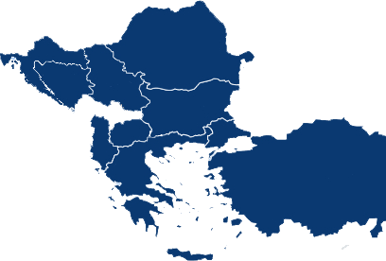
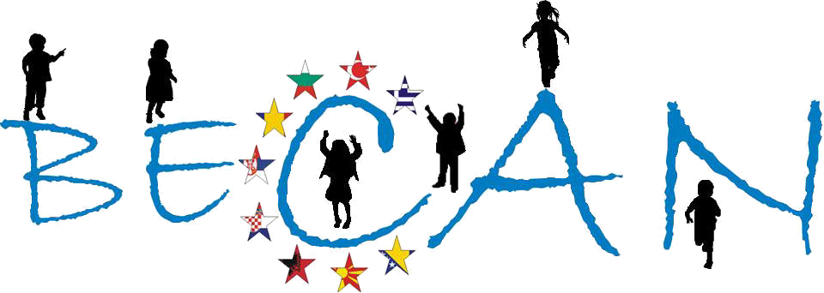
FP7 DG-RESEARCH [Contract No: HEALTH-F2-2009-223478]

The work leading to this document has received funding from the European Community’s 7th Framework Programme (FP7/2007-2013) under the Grant Agreement no HEALTH-F2-2009-223478
Athens, January 2012
Balkan Epidemiological Study on Child Abuse & Neglect (BECAN)
BECAN
Epidemiological Survey on Child Abuse and Neglect (CAN) in Serbia

INTRODUCTION
The Project “Balkan Epidemiological Study on Child Abuse and Neglect” (B.E.C.A.N.) run from September 2009 until January 2013 in 9 Balkan countries and was co-funded by the EU’s 7th Framework Programme for Research and Innovation (FP7/2007-2013) and the participating partner Organizations. The project’s coordinator was the Institute of Child Health, Department of Mental Health and Social Welfare, Centre for the Study and Prevention of Child Abuse and Neglect (ICH-MHSW), in Athens (Greece), while the national coordinators for each of the participating countries were the following Organizations:
- Children's Human Rights Centre of Albania (Albania)
- Department of Medical Social Sciences, South-West University "Neofit Rilski" (Bulgaria)
- Faculty of Political Sciences, University of Sarajevo (Bosnia & Herzegovina)
- Department of Social Work, Faculty of Law, University of Zagreb (Croatia)
- University Clinic of Psychiatry, University of Skopje (F.Y.R. of Macedonia)
- Social Work Department, Faculty of Sociology and Social Work, Babes-Bolyai University (Romania)
- Faculty for Special Education and Rehabilitation, University of Belgrade (Serbia)
- Association of Emergency Ambulance Physicians (Turkey)
The project’s evaluation was conducted by Istituto degli Innocenti (Italy) and the project’s external scientific supervision was undertaken by Prof. Kevin Browne, Head of the W.H.O. Collaborating Centre for Child Care and Protection (United Kingdom) and Chair of Forensic Psychology and Child Health, Institute of Work, Health & Organisations, University of Nottingham.
The BECAN project included the design and realization of an Epidemiological field survey and a Case-Based Surveillance study in 9 Balkan countries (Albania, Bosnia & Herzegovina, Bulgaria, Croatia, F.Y.R. of Macedonia, Greece, Romania, Serbia and Turkey).
The 9 Epidemiological Surveys that were conducted aimed at investigating the prevalence and incidence of child abuse and neglect (CAN) in representative randomized samples of the general population of pupils attending three grades (the grades attended mainly by children 11, 13 and 16 year-olds). In addition, supplementary surveys were conducted to convenience samples of children that have dropped-out of school in countries where the drop-out rates are high for producing estimates of respectful CAN indicators at national level. Data were collected by two sources, namely by matched pairs of children and their parents, by using two of the ICAST Questionnaires (the ICAST-CH and the ICAST-P) modified for the purposes of the BECAN project. (4,5)
The Case-Based Surveillance Study (CBSS) aimed at identifying CAN incidence rates based on already existing data extracted from the archives of agencies involved in the handling of CAN cases (such as child protection, health, judicial and police-services and NGOs) in the same geographical areas and for the same time period as the epidemiological field survey. The collected data were related to the characteristics of individual cases such as child, incident, perpetrator(s), caregiver(s), and information concerning the family. At the same time, the CBSS targeted to map the existing surveillance mechanisms, where available, and to outline the characteristics of the surveillance practices in each participating country. Moreover, comparison at national level between incidence of CAN as found in field survey in one hand and in case based surveillance study on the other would produce evidence based estimates of the instantiation of the “iceberg” phenomenon regarding CAN, viz. that actual rates of the phenomenon are substantially higher than the number of cases actually known or provided for by services in the participant countries.
In addition, in the context of the BECAN Project were built National Networks of agencies (governmental and non-governmental) working in the fields of child protection from the areas of welfare, health, justice, education and public order. In total, 9 National Networks were developed in the participating countries, having more than 430 agencies-members. Last but not least, a wide range of dissemination activities were conducted which included the organization of National Conferences and one International Conference, scientific papers, announcements to scientific conferences and meetings, publications in press/media, publication of Reports, etc (more information about the project’s activities can be found at the project’s website: www.becan.eu).
Finally, BECAN aimed to include all aforementioned outcomes in terms of evidence produced, experience gained and networking of resources into comprehensive consolidated reports at national and Balkan level that could facilitate evidence based social policy design and implementation for improving child protection services and overall provisos.
The current Report describes in detail the methodology and the main results of the epidemiological survey conducted in the Republic of Serbia to the samples of pupils attending the 5th (age: 11) and 7th (age: 13) grade of elementary schools and 2nd (age: 16) grade of secondary schools and their parents.

A. GENERAL INFORMATION
The national survey started in February 2011. and ended in June 2011. It was done simultaneously in all four geographic regions.
During this interval the research team and field researchers faced with some difficulties. The major difficulty in the implementation of the field study were strikes in the majority of the primary and secondary schools in Serbia. The strike has started on 28. January 2011, affecting about 1400 out of 1578 schools in Serbia. On January 31st 478 schools did not work, and about 900 schools cut the duration of the lessons from 45 to 30 minutes. At the end of March many schools still did not normalize teaching process, with 1/3 or schools having shorter lessons (30 minutes). The strike affected our field study twofold:
a) It is difficult to organize research in the schools participating in the strike because we need to take 2 school hours instead of only one, and teachers already lag behind the schedule. Also, school directors and teachers are frequently too preoccupied with their own issues (balancing between requests and threats from the Ministry, requests from the trade unions, dissatisfaction of the parents...) and not willing to make special arrangements (parental meetings) or motivate students/parents for participation in the study.
b) There is significant number of parents not supporting requests from the teachers’ trade unions. They are very angry because their children work less and will need to make up for the missed lessons. In the very complex socio-economical and political situation, marked by dissatisfaction, poverty and feelings of being manipulated, parents are very suspicious and distrusting to our researchers no matter with whom they identify BECAN study – the school, the Ministry, University, nongovernmental organizations… Their suspiciousness is additionally augmented by the information letter and consent form.
There is one reason why the very topic (no matter how hidden behind the neutral formulation of the research topic) of the research makes parents upset: The case of the Serbian family Nastić, living in the USA. Under suspicion for being sexually abused, their two children were taken away from parental home, only to be revealed (after many months) that the suspicion was not justified. Parents in Serbia are well informed about the case and felt resentment about it. Many parents refused to give their consent for the participation of the child with the argument that the state didn't help them to raise the child and it has no right to interfere into what is being done in their family, especially nowadays when it is so easy to take a child away from its parents.
To conclude, we worried that low percentage of consent given to the children and low participation of the parents themselves may compromise the planned sample. Also, the planned schedule for realization of the main study was compromised and it was prolonged to June, 2011.
The national partner in BECAN is Faculty for Special Education and Rehabilitation, Belgrade University. The National Scientific Coordinator is professor Veronika Ispanovic – Radojkovic, PhD (Faculty for Special Education and Rehabilitation, Belgrade University). The researchers are professor Lazar Tenjovic, PhD in methodology and statistics (Faculty of Philosophy, Belgrade University), associate professor Natasa Hanak, PhD in clinical psychology (Faculty for Special Education and Rehabilitation, Belgrade University), and assistant professor Ana Vlajkovic, MSc in social psychology (Faculty of Media and Communications, Department of Psychology, Singidunum University).
National BECAN team engaged 33 field researchers for WP3 survey. All were psychologists and pedagogues, mainly employed in schools (minority in the Ministry of Education) and have specialization in school psychology/pedagogy.

B. ORGANIZATION OF THE STUDY
1. Permission(s) to access schools
The first step in conducting the study was to obtain permission from the Ministry of Education. The negotiation with the Ministry of Education (State Secretary, Ms. Tinde Kovac-Cerovic) started in January 2010, and the research team obtained a verbal agreement and support.
Next step was to provide full written information to the Ministry of Education on the project including objectives, design and instruments of the study (translations of ICAST Questionnaire for children and for parents, Information letters and consent forms for parents and children), sampling (list of schools in which the study will be carried out), qualification of the researchers, compliance with ethical standards (how the data privacy and data security will be provided; how the support to children will be provided in case of need). The full written information was provided to the Ministry in February 2010 when the instruments were finalized and the sampling plan was done.
It was followed by a meeting of the research team with the State Secretary in March 2010 when the details of the project were discussed, especially the ethical issues. The Ministry agreed to be a partner in the research and promised to give a general written permission for implementing the research in schools and also to give permissions to access to sampled schools for specific activities (i.e. focus groups, pilot study etc). This permission was obtained on April 12th, 2010, and was meant only for purposes of conducting focus groups and a pilot study.
After completing focus groups (May 2010) the Ministry of Education was informed about the progress of the study, and the final Permission for the main study was obtained on August 28th, 2010, for all sampled schools.

2. Field Researchers’ Training
The Field Researchers’ Training lasted 3 days (Friday, September 3rd to Sunday, September 5th, 2010), total of 21 hours. The trainers were Veronika Ispanovic Radojkovic, Lazar Tenjovic, Natasa Hanak, and Ana Vlajkovic. National BECAN team decided to engage (during the Researchers’ Training) one person as organizational assistant. It was not realistic to expect from trainers to implement the training according to the high EU standards and at the same time to tackle issues regarding breaks, additional materials needed, and other technical issues). Organizational Assistant was a postgraduate student, Sonja Milojevic.
Initially 52 candidates applied for the training, and 36 were selected, based on their education, specialties, additional trainings, etc (see Table B.2.1.). Actual number of trainees trained was 33, due to the fact that one female participant was unable to attend the training due to personal reasons; the other due to the last-minute job-related obligations, and one male participant failed to meet the basic criteria for training completion (attending the training in its full duration).

Table B.2.1.: The credentials and specialties of trainees
A/A | Sex (M=male, F=female) | Researcher’s Specialty/Education Credentials
 | F | School psychologist/Psychology, Novi Sad University/ additional credentials: School without Violence UNICEF programme, Family Violence – prevention, detection, reaction
 | M | School psychologist and Teacher/Psychology, Belgrade University/ additional credentials: REBT therapist, additional trainings in human (children) rights, non-violent conflict resolution; active researcher
 | F | Psychologist – therapist for children and adolescents/Psychology, Belgrade University/ additional credentials: Gestalt therapy training, additional trainings in prevention of CAN; active researcher
 | F | School Psychologist/Psychology, Belgrade University/additional trainings in prevention and detection of sexual violence, gender equality, family violence, School without violence UNICEF programme
 | F | Psychologist/Psychology, Belgrade University/additional credentials: member of experts’ teams: “School without violence” – UNICEF; member of experts’ groups for NPA for children, General Protocol on Protection of Children from Abuse and Neglect, Special Protocol on Protection of Children from Violence, Abuse and Neglect in Educational Institutions; Regulations on Implementation of Special Protocol – Manual
 | F | Psychologist/Psychology, Belgrade University/Specialisation in school psychology/ additional credentials: Co-author and trainer: “Children - Violence Prevention” (for adults), trainer in project Children Rights, trainer in non-violent communication and conflict resolution, co-author, coordinator and trainer: “Policeman – Protector of children”; member of experts’ team, co-author “School without violence” – UNICEF; member of experts’ groups for NPA for children, General Protocol on Protection of Children from Abuse and Neglect, Special Protocol on Protection of Children from Violence, Abuse and Neglect in Educational Institutions; Regulations on Implementation of Special Protocol – Manual/ active researcher
 | F | Psychologist/Psychology, Belgrade University/ additional credentials: Gestalt therapist – specialisation for children and adolescents, trainings in non-violent communication and conflict resolution in school context
 | F | Psychologist/Psychology, Belgrade University/ Specialisation in school psychology/additional credentials: trainer: “Children - Violence Prevention” (for adults), trainer in project Children Rights, trainer in non-violent communication and conflict resolution, member of experts’ team “School without violence” – UNICEF; member of experts’ groups for NPA for children, General Protocol on Protection of Children from Abuse and Neglect, Special Protocol on Protection of Children from Violence, Abuse and Neglect in Educational Institutions
 | F | School Psychologist/Psychology, Belgrade University/ Specialisation in school psychology/ additional credentials: certified REBT and Gestalt therapist, trainings in: prevention and detection of sexual abuse, PSY KRIN – Psychological Interventions in crisis situation in school context (Belgrade University in cooperation with Society for Psychological Support, Croatia)/ active researcher
 | F | School Pedagogue/Pedagogy, Belgrade University/ additional credentials: “School without Violence - UNICEF” – mentor for 4 schools, LPA – UNICEF, education in peer mediation, trauma healing and conflict resolution/ active researcher
 | F | Psychologist/Psychology, Belgrade University/ additional credentials: mediation in conflict resolution in school context, individual therapeutic work with children and adolescents, training in Gestalt therapy (ongoing)/ active researcher
 | F | School Pedagogue/Pedagogy, Torun University, Poland/ additional credentials: certified Systemic Family therapist, education in: protection of victims of family violence, School without violence – UNICEF, prevention of delinquent behaviour/ researches with children and adults as subjects (local and national)
 | F | School Psychologist/Psychology, Belgrade University/ additional credentials: trainings in non-violent communication, peer mediation, School without Violence – UNICEF (mentor in 5 schools”/ research experience with children and adolescents as subjects
 | F | School Psychologist/Psychology, Belgrade University/ additional credentials: trainings in School without Violence – UNICEF, crisis intervention in school context, inclusive education/ active researcher (programmes: TIMSS, MasMi)
 | F | School Psychologist/Psychology, Belgrade University/ additional credentials: certified REBT therapist, trainings in: inclusive education, prevention of delinquent behaviour, crisis intervention in school context, implementation of UN Convention on Children Rights /additional experience: monitoring and evaluation of Social Innovation Fund programmes, member of local team for prevention of CAN, co-author of following programmes: “Child Trafficking Prevention” , “Children without Borders – ethnic prejudices prevention” (Save the Children), “Prevention of ab/use of psychoactive substances among children and youth” (Red Cross, Germany). Research experience in CAN detection (children and adults).
 | F | School Psychologist/Psychology, Belgrade University/ additional credentials: crisis intervention in school context, “Prevention of ab/use of psychoactive substances among children and youth” (Red Cross, Germany)/research experience in school context
 | M | School Pedagogue/Pedagogy, Belgrade University/ additional credentials: trainings in implementation of UN Convention on Children Rights, non-violent conflict resolution, School without Violence - UNICEF/ additional experience: School District Coordinator for the implementation of the Special Protocol on Protection of children from violence, abuse and neglect in educational institutions/ active researcher
 | F | Psychologist/Psychology, Nis University/ additional credentials: certified family therapist, certified therapist in Client centred therapy; trainings in psychosocial counselling, PSY KRIN – Psychological Interventions in crisis situation in school context (Belgrade University in cooperation with Society for Psychological Support, Croatia), focused interventions on “breaking” the violence cycle in families, recovering from trauma training/ additional experience: author and co-author/coordinator of 6 certified programmes supporting foster care in Serbia, as well as peer mediation (Social Innovation Fund, Open Society Institute, UNICEF), experience in CAN prevention, detection, reaction and therapy, experience in team coordination
 | F | Psychologist/Psychology, Nis University/ additional credentials: trainings in psychosocial counselling, PSY KRIN – Psychological Interventions in crisis situation in school context (Belgrade University in cooperation with Society for Psychological Support, Croatia), recovering from trauma training, School without Violence - UNICEF/ additional experience: School District Coordinator for the implementation of the Special Protocol on Protection of children from violence, abuse and neglect in educational institutions/ active researcher
 | F | School Psychologist/Psychology, Nis University/ additional credentials: trainings in psychosocial support and counselling, PSY KRIN – Psychological Interventions in crisis situation in school context (Belgrade University in cooperation with Society for Psychological Support, Croatia)/ active researcher
 | F | School Pedagogue/Pedagogy, Pristina University/ additional credentials: trainings in School without Violence – UNICEF, prevention of delinquent behaviour, peer education (in school context) for prevention of CAN, crisis interventions in school context
 | F | Psychologist/Psychology, Nis University/ additional credentials: trainings in CAN prevention (International centre for assault prevention), non-violent conflict resolution, mediation/ additional experience: LPA for Roma children and adolescents, School District assistant coordinator for the implementation of the Special Protocol on Protection of children from violence, abuse and neglect in educational institutions/ active researcher
 | F | Psychologist/Psychology, Novi Sad University/ MSc in Management in Education/ additional credentials: training in REBT and Gestalt therapy, trainings in conflict resolution, mediation, peer counselling, author and coordinator of more than 10 programmes for prevention and improvement of mental health of children and adolescents, coordinator of national teams (in national and EU funded projects)/active researcher
 | F | Psychologist/Psychology, Novi Sad University/ MSc and PhD in Developmental Psychology/ additional credentials: trainings in Post trauma stress, disorder and psychological debriefing, member of the national team for rapid assessment and response, author and coordinator of more than 10 programmes for promotion and improvement of mental health of children and adolescents (including 2 SOS telephone lines for children and adolescents victims of abuse and neglect)/active researcher (proficiency in SPSS)
 | F | Psychologist/Psychology, Novi Sad University/ additional credentials: trainings in PSY KRIN – Psychological Interventions in crisis situation in school context (Belgrade University in cooperation with Society for Psychological Support, Croatia), School without Violence – UNICEF/research experience in school context
 | M | School Psychologist/Psychology, Novi Sad University/additional trainings: LPA – UNICEF, Work with challenged children and youth
 | F | School Psychologist/Psychology, Belgrade University/additional trainings: CAN prevention and detection, non-violent conflict resolution, inclusive education, decentralisation in education
 | F | School Pedagogue/Pedagogy, Novi Sad University/additional credentials: PSY KRIN – Psychological Interventions in crisis situation in school context (Belgrade University in cooperation with Society for Psychological Support, Croatia), School without Violence – UNICEF, psychosocial support for children and youth, implementation of draft NPA for CAN prevention/additional experience: School District Coordinator for inclusion
 | F | School Pedagogue/Pedagogy, Novi Sad University/ additional credentials: trainings in School without Violence – UNICEF, psychosocial support for children and youth/research experience in school context (children and adults)
 | F | School Psychologist/Psychology, Belgrade University/ additional credentials: trainings in constructive, non-violent communication, inclusion processes in school context, School without Violence – UNICEF/active researcher in CAN
 | M | Psychologist/Psychology, Belgrade University/ additional credentials: certified family therapist, trainings in CAN prevention in the local community/active researcher
 | F | School Psychologist/Psychology, Belgrade University/ additional credentials: trainings in counselling – individual in school context, CAN prevention and reaction, gender equality, prevention of sex trafficking
 | F | Psychologist/Psychology, Belgrade University/ additional credentials: trainings in gender equality, CAN prevention, children rights/active researcher

The training was interactive, in form of workshops, with theoretical input. Topics covered were: BECAN epidemiological study – international context, BECAN epidemiological study – characteristics in Serbia, ICAST questionnaires – introduction, ICAST – CH, ICAST – P, Role play: Mock interview - ICAST-CH, Role play: Mock interview – ICAST-P, Technical realization: Field research, Child Abuse and Neglect: Prevention and Protection in Local Community, Ethical and security issues (handling information, supervision, reaction in revealed CAN cases), Meetings with regional teams – division of sampled schools, trainees reporting concerning teams (2+1 field researcher), Technical issues: standardized answers for ICAST-CH and ICAST-P; standardized answers on questions raised during the training; detailed plan for the pilot study; time-frame and steps for epidemiological study, and Training evaluation.
During The Field Researchers’ Training Local Field Researchers Coordinators (LC) were selected, for all four geographic regions. Previously planned number of LCs was four (one LC per geographic region) had to be carefully examined, and adapted, based on the field researchers’ experience, and full geographic coverage. It was not feasible to plan efficient, cost-effective, and executable time-table of regular meetings, supervision, delivery of materials, and team members’ communication with only four LCs. Thus, the decision was made (by the Serbian BECAN team) to engage one more LC for each of the four geographic regions. These eight LCs divided four regions adequately, being focal points for nearest School Districts, and sampled schools. In addition, LCs will act also as field researchers.
Post-training obligations included administering self-completed questionnaires (to at least 2 children and 2 parents) and conducting structured interviews (with at least 2 children and 2 parents). All trainees met the required obligations.
For evaluation of the training national BECAN team used two instruments: Pre-training questionnaire (Training Needs Assessment - TNA) and Final training evaluation questionnaire.
TNA was a questionnaire with 9 questions. Total of 29 participants sent back their TNAs (see Table B.2.2.).

Table B.2.2. Results of the Training Needs Assessment
On the scale from 1 (insufficient) to 5 (excellent) please estimate how proficient you are in the following topics: |  |  |  |  |  |  | MID RANK
 | CAN types and prevalence | 1 | 2 | 3 | 4 | 5 | 3,71
 | Conditions enhancing CAN occurrence and consequences on child development | 1 | 2 | 3 | 4 | 5 | 3,57
 | Legal procedure in CAN suspected case/revealed CAN case | 1 | 2 | 3 | 4 | 5 | 3,28
 | General methodological standards for research implementation | 1 | 2 | 3 | 4 | 5 | 3,83
 | Specifics in administering interview and questionnaire | 1 | 2 | 3 | 4 | 5 | 3,71
On the scale from 1 (almost none) to 5 (immense) estimate your personal experience in: |  |  |  |  |  |  | MID RANK
 | Administering questionnaire | 1 | 2 | 3 | 4 | 5 | 4,31
 | Administering research interview | 1 | 2 | 3 | 4 | 5 | 3,52
 | Data collection, as a part of a research team | 1 | 2 | 3 | 4 | 5 | 3,52
 | Field research organization and management | 1 | 2 | 3 | 4 | 5 | 3,21
Mid ranks showed that participants’ estimations are realistic (based on their professional curriculum vitae). TNA helped the training team to prepare adequate training program, to meet the needs of all trainees.
At the end of the training all (33) participants filled out the Evaluation questionnaire. The results are as presented in the Table B.2.3.

Table B.2.3. Results of the final training evaluation
On the scale from 1 (I strongly disagree) to 5 (I strongly agree) rank following statements: |  |  |  |  |  |  | MID RANK
 | I got sufficient information about the BECAN study. | 1 | 2 | 3 | 4 | 5 | 4.79
 | I got sufficient information regarding tools for questioning children and parents. | 1 | 2 | 3 | 4 | 5 | 4.88
 | It is clear for me how the field research will be organised. | 1 | 2 | 3 | 4 | 5 | 4.33
 | My role in the research is clear to me. | 1 | 2 | 3 | 4 | 5 | 4.76
 | I will be well prepared for the field research after completing my post-training obligations. | 1 | 2 | 3 | 4 | 5 | 4.76
On the scale from 1 (not satisfactory at all) to 5 (excellent) rank following aspects of this training: |  |  |  |  |  |  | MID RANK
 | Training venue | 1 | 2 | 3 | 4 | 5 | 4.21
 | Training materials received | 1 | 2 | 3 | 4 | 5 | 4.91
 | Accommodation, food and refreshments during breaks | 1 | 2 | 3 | 4 | 5 | 4.70
 | Trainers preparedness for the training | 1 | 2 | 3 | 4 | 5 | 4.94
 | Quality of the training delivered | 1 | 2 | 3 | 4 | 5 | 4.79

C. METHODOLOGY

1. Sampling Method – Sample
Target population for the survey were pupils attending 5. and 7. grade of elementary schools and pupils attending 2. grade of secondary schools on the territory of the Republic of Serbia (without Kosovo and Metohija) in 2010/2011 schoolyear, as well as their parents (one parent per each student or, if the child has no biological parent, person who is in the role of parent).
Assessment of the population size was based on data in following publications: Statistical bulletin – Regular secondary education – beginning of 2008/2009 schoolyear, Belgrade: Statistical Office of the Republic of Serbia, 2009; Elementary schools’ pupils in the Republic of Serbia, by municipalities – beginning of 2008/2009.schoolyear.,RELEASE no. 37 – year LIX, 18. 02. 2009, Belgrade: Statistical Office of the Republic of Serbia, School Offices – Elementary schools, Belgrade: Ministry of Education of the Republic of Serbia 2008/2009 schoolyear; School Offices – Secondary schools, Belgrade: Ministry of Education of the Republic of Serbia 2008/2009 schoolyear). Based on available data assesed population size is 235.154 pupils (5. grade of elementary school: 80.638 pupils; 7. grade of elementary school: 79.318 pupils and 2. grade of secondary school: 75.198 pupils).
To estimate needed sample size we include in calculations following elements:
- Estimate of prevalence of the least represented form of violence (sexual abuse): 2%.
- Tollerable margin of error for 95% confidence interval for prevalence of the least represented form of violence in targeted population: ± 0.5%.
- Necessary size of the sample for a given target population for a simple random sample: 2.974
- Design effect = 1.9 (rough estimate) based on homogenity cluster indicator equal to 0.01 and mean cluster size equal to 88
- Expected non-response rate: 30%
Based on these elements it was estimated that sample should comprise 8.072 pupils (and the same number of their parents).
Sampling frame comprised all elementary and secondary schools quoted in the Registry of the Ministry of Education of the Republic of Serbia for the schoolyear 2008/2009 (1.100 elementary schools and 478 secondary schools).
All schools in the sampling frame were stratified within each of the three gradegroups (5th grade of elementary school or grade group of 11 years old; 7th grade of elementary school or grade group of 13 years old; 2nd grade of secondary school or grade group of 16 years old).
Elementary schools (5th and 7th grade) were stratifies according to following features:
- regional location of the school – region, with four strata (and two substrata): Belgrade, Vojvodina (substratum within this stratum were municipalities with majority of Hungarian population), Western and Southwestern Serbia (substratum within this stratum were municipalities with majority of Bosniak population) and Eastern-Southeastern Serbia;
- urbanicity, with strata: urban and non-urban
Secondary schools were stratified according to following features:
- regional location of the school – region, with four strata (and two substrata): Belgrade, Vojvodina (substratum within this stratum were municipalities with majority of Hungarian population), Western and Southwestern Serbia (substratum within this stratum were municipalities with majority of Bosniak population) and Eastern-Southeastern Serbia;
- urbanicity, with two strata: place defined as a city and place defined as a town;
- type of school, with two strata: general schools and vocational schools.

Sampling is made by stratified cluster sampling with schools as uneven cluster sizes. Additionally, two-stage stratified cluster sampling is used for large secondary schools and elementary schools with majority of ethnic minorities, since in those cases there were much bigger number of classes compared to assessment of the sample. Number of schools (and approximate number of classes) from each stratum which should comprise the sample was assessed in advance, based on average size of the school in the stratum (i.e. on average number of pupils per school in a given stratum). Selection of schools for the sample from the list of all elementary schools was made independently for 5th and 7th grade. Within each stratum, during the selection of clusters (i.e. schools) for the sample we have followed the procedure which encompasses probability proportional to cluster size - PPS method. As a measure of cluster size number of pupils who attend the school is used. In most cases, all classes within the chosen school and all children from those classes were included in the sample. Anyhow, in three minority schools in the region Western-Southwestern Serbia and in a significant number of secondary schools (19 in total) second stage of cluster sampling is used, where classes represented clusters: in these schools, in the next stage of sampling, just a certain number of classes is sampled, in accordance to the number of pupils planed to enter the sample from a given stratum. Adjustment was done because inclusion of all the classes in these schools would make that certain population strata would be overrepresented in the sample, while others underrepresented. Sampling of clusters, i.e. classes from the list of all classes in each of these schools was made by simple random sampling, with classes as sampling units. Accordingly, all registered pupils from chosen classes were included in the sample.

Sample obtained by described sampling procedure (sample for the survey) included 7.565 pupils (and same number of parents/caregivers) representing 3.2% of targeted population of children (see Table C.1.1.). Since the sample is obtained by cluster sampling, the size of obtained sample deviate (but not significantly) from the size of the sample assessed as necessary based on statistical criteria, described above (8.072 pupils). Sample for the survey included 2.131 students of 5th grade from 35 schools, 2.623 students of 7th grade from 38 schools, and 2.811 students of 2nd grade of secondary school from 27 schools (719 students from 12 general schools and 2.092 students pupils from 15 vocational schools).

Table C.1.1. Number of schools, classrooms and pupils in the sample, by grade group and geographical region. (Total sample: 7.565 pupils, attending 322 classes in 100 schools)

Geographical Region |  | Grade group
Geographical Region |  | 11-year olds |  |  |  | 13-year olds |  |  |  | 16-year olds General school |  |  |  | 16-year olds Vocational school
Geographical Region |  | Schools | Class-rooms | Pupils |  | Schools | Class-rooms | Pupils |  | Schools | Class-rooms | Pupils |  | Schools | Class-rooms | Pupils
Belgrade |  | 6 | 17 | 428 |  | 7 | 23 | 542 |  | 2 | 6 | 171 |  | 3 | 15 | 419
Vojvodina |  | 12 | 28 | 552 |  | 11 | 32 | 697 |  | 4 | 7 | 192 |  | 5 | 24 | 572
W & SW Serbia |  | 9 | 24 | 528 |  | 9 | 26 | 574 |  | 4 | 8 | 208 |  | 4 | 21 | 557
E & SE Serbia |  | 8 | 27 | 623 |  | 11 | 39 | 810 |  | 2 | 6 | 148 |  | 3 | 19 | 544
TOTAL |  | 35 | 96 | 2.131 |  | 38 | 120 | 2.623 |  | 12 | 27 | 719 |  | 15 | 79 | 2.092

Regarding the size of sample of the parents, ICAST-P questionnaires were sent to all parents whose children completed ICAST-CH, as well as to the parents who did not gave their consent for the participation to children who attended school on the day od collecting the data.

2. Response rates and description of the realized sample
After receiving permission from the Ministry of Education, we have not encountered any major problems in participation of the selected schools in the research. Out of 100 schools there were four where collaboration with the school staff was described by our field coordinators as "poor" because of some of the following problems: a) the school director was absent when the initial meeting took place; b) he/she did not inform all relevant stake-holders who should have participated in the meeting, c) they were unwilling to motivate teachers to offer their lessons and thereby enable data collection. In some cases headmasters even openly discouraged students/parents from participation. Still, the permission of the Ministry of Education meant, as the matter of fact, obligation for the schools to participate in the BECAN study and therefore school directors did not refuse to participate even in cases when they did not support the study.

The realized sample consists of 4027 pupils, 1959 girls (48,65%) and 2068 boys (51,35%). The complete description of the realized sample according to the all relevant socio-demographic data is presented in the Table C.2.1.

Sample is balanced regarding sex, and 1.959 girls (48,7%) and 2.068 boys (51,3%) was examined. Sample comprised of 908 children (22,55%) from 5th grade of elementary school. 1.400 (34,77%) from 7th grade of elementary school, 509 (12,64%) pupils of 2nd grade from general schools and 1.210 (30,05%) pupils of the 2nd grade of vocational schools. Regarding the nationality, representative structure of the sample is obtained: 85,3% of children are of Serbian nationality, 4,35% are Hungarian and 4,7% Bosniak. Majority of the children attend schools in places classified as urban settlements (63,95%).

Table C.2.1. Demographics for children participated in the ICAST-CH survey in Serbia, and information about their living conditions and their parents (Sample’s size = 4027)
N%Urbanicity of the place of residence Unspecified370,92Urban 254963,88Nonurban144136,12NationalityUnspecified60,15 Serbian343185,33 Bosniak1894,70 Hungarian1754,35Mixed (official and other)621,54Romany471,17 Montenegrian451,12Croatian320,80Macedonian70,17Slovenian40,10Albanian40,10Don’t want to answer471,17Don’t know40,10ReligionUnspecified290,72Orthodox304576,16Catholic2195,48Muslim2085,20Other340,85None2546,35Don’t want to answer681,70Don’t know1704,25Parents’ marital situationUnspecified70,17married328781,77divorced/separated4019,98never married1453,61one parent is not living anymore1483,68both parents are not living anymore30,07Don’t want to answer 210,52Don't know 150,37
N%GenderGirls195948,65Boys206851,35Grade group (typical age of attending pupils)11 y-o90822,5513 y-o140034,7716 y-o, General school50912,6416 y-o, Vocational school121030,05Age (completed years)10 40,101156213,96123438,521382220,411457114,181590,221696423,941769917,3618531,32Flunked years in schoolUnspecified180,45No388997,01Yes*1202,99Persons cohabitating with the childUnspecified130,32father349987,17mother382195,19stepfather (mother's spouse)791,97stepmother (father's spouse)210,52foster father150,37foster mother130,32mother's partner100,25father's partner40,10grandfather86121,45grandmother123730,82male sibling(s)192647,98female sibling(s)175043,60other relatives1603,99other non relatives190,47
*104 pupils had flunked one and 16, two years
Parental Educational levelMotherFather N % N %Unspecified400,991243,08Hasn’t gone to school110,2850,13Some grades of primary school471,18300,77Primary school (8 years)48412,1439710,17Vocationall school (3 years)88022,07103526,52Vocational school (4 years) / Gymnasium143435,97125332,10High School (2 or 3 years)3047,623097,92University58014,5553013,58Postgraduate studies (master, doctorate)631,58842,15Don't know 1844,612606,66

Majority of pupils (63,88%) attend the schools in urban settlements, while the rest (36,12%) attend the schools in nonurban settlements.
The great majority of pupils live in the complete families with married parents (81,77%), only 9,98% pupils have divorced/separated parents. In small number of cases (3,61%) the parents have never married and 3.68% pupils have one parent that has died.
Most of the pupils declare themselves as orthodox (76,16%), 5,48% as catholic, 5,20% as muslim and 6,35% stated that they do not belong to any religious group.

The response rates, both in children and parents, are well below the expected response rates that were projected at about 70%. Response rates for the children were calculated on the basis of the number of pupils who were present in the classroom the day ICAST-CH was distributed. We have collected questionnaires from 57% of the children that were present at the school on the day of data collection. The total number of valid questionnaires was 53.23%. The lowest response rate was in the 5th grade (44,44%). For the 7th grade the response rate is 54,63%, for the pupils from the vocational schools the response rate is 60,17%, while the highest response rate was obtained for the pupils from the general schools (70,62%) (see Tables C.2.2. and C.2.3.)
The response rate of parents is even lower, with only 41.95% of valid parent questionnaires (see Table C.2.4.).
The number of completed pairs children and parent questionnaires is in the youngest group (5th grade) 720. There is 1091 pair for the seventh grade, 274 pairs for the general school and 616 for the vocational school (see Table C.2.5) .

Table C.2.2. Pupils’ and parents’ samples, participation/response rates and reasons for samples’ losses
 | Grade group
 | 11-year olds |  | 13-year olds |  | 16-General |  | 16-Vocational |  | TOTAL
Pupils | N | % | N | % | N | % | N | % | N | %
Sample size (registered pupils) | 2131 | 100,00 | 2623 | 100,00 | 719 | 100,00 | 2092 | 100,00 | 7565 | 100,00
Unreturned parental consent &/or child's absenteism | 501 | 23,51 | 290 | 11,06 | 16 | 2,23 | 320 | 15,30 | 1127 | 14,90
Negative parental consent form | 676 | 31,72 | 844 | 32,18 | 108 | 15,02 | 424 | 20,27 | 2052 | 27,12
Child's refusal | 15 | 0,70 | 61 | 2,33 | 83 | 11,54 | 109 | 5,21 | 268 | 3,54
Completed ICAST-CH (valid & invalid) | 939 |  | 1428 |  | 512 |  | 1239 |  | 4118
Excluded ICAST-CH | 31 | 1,45 | 28 | 1,07 | 3 | 0,42 | 29 | 1,39 | 91 | 1,20
Not valid, due to respondent's age (18+) |  | 0,00 |  | 0,00 |  | 0,00 |  | 0,00 | 0 | 0,00
Not valid, due to respondent’s unknown age | 30 | 1,41 | 11 | 0,42 | 1 | 0,14 | 8 | 0,38 | 50 | 0,66
Not valid, due to invalid completion | 1 | 0,05 | 17 | 0,65 | 2 | 0,28 | 21 | 1,00 | 41 | 0,54
Participation rate (valid ICAST-CH) | 908 | 42,61 | 1400 | 53,37 | 509 | 70,79 | 1210 | 57,84 | 4027 | 53,23
Parents | N | % | N | % | N | % | N | % | N | %
Sample size | 2113 |  | 2614 |  | 725 |  | 2059 |  | 7511
Completed ICAST-P (valid & invalid) | 923 | 43,68 | 1332 | 50,96 | 288 | 39,72 | 686 | 33,32 | 3229 | 42,99
Excluded ICAST-P | 31 | 1,47 | 28 | 2,10 | 5 | 1,74 | 14 | 2,04 | 78 | 2,42
due to invalid completion | 12 | 0,57 | 11 | 0,83 | 1 | 0,35 | 5 | 0,73 | 29 | 0,90
due to another reason | 19 | 0,90 | 17 | 1,28 | 4 | 1,39 | 9 | 1,31 | 49 | 1,52
Response rate (valid ICAST-P) | 892 | 42,21 | 1304 | 49,89 | 283 | 39,03 | 672 | 32,64 | 3151 | 41,95

Table C.2.3. Description of pupils’ sample, collected, excluded and valid ICAST-CH questionnaires, participation and response rates, by grade group and geographical region
Grade  group | Geographical  Region | Pupils’ Sample |  | Completed  ICAST-CH  (valid & invalid) | ICAST-CH that excluded due to |  | valid ICAST-CH questionnaires
Grade  group | Geographical  Region | N_{reg.}¹ | N_{pres.}² | Completed  ICAST-CH  (valid & invalid) | invalid  completion | another  reason³ | Ν | P.R.⁴  (%) | R.R.⁵  (%)
11-year olds | Belgrade | 428 | 431 | 165 |  | 2 | 163 | 38,08 | 37,82
11-year olds | Vojvodina | 552 | 552 | 273 |  | 10 | 263 | 47,64 | 47,64
11-year olds | W & SW Serbia | 528 | 517 | 239 | 1 | 6 | 232 | 43,94 | 44,87
11-year olds | E & SE Serbia | 623 | 613 | 262 |  | 12 | 250 | 40,13 | 40,78
TOTAL 11-year olds |  | 2131 | 2113 | 939 | 1 | 30 | 908 | 42,61 | 42,97
13-year olds | Belgrade | 542 | 539 | 229 | 3 | 2 | 224 | 41,33 | 41,56
13-year olds | Vojvodina | 697 | 698 | 433 | 5 | 5 | 423 | 60,69 | 60,60
13-year olds | W & SW Serbia | 574 | 560 | 319 | 3 | 2 | 314 | 54,70 | 56,07
13-year olds | E & SE Serbia | 810 | 817 | 447 | 6 | 2 | 439 | 54,20 | 53,73
TOTAL 13-year olds |  | 2623 | 2614 | 1428 | 17 | 11 | 1400 | 53,37 | 53,56
16-General school | Belgrade | 171 | 172 | 97 |  |  | 97 | 56,73 | 56,40
16-General school | Vojvodina | 192 | 192 | 130 |  |  | 130 | 67,71 | 67,71
16-General school | W & SW Serbia | 208 | 213 | 176 | 2 | 1 | 173 | 83,17 | 81,22
16-General school | E & SE Serbia | 148 | 148 | 109 |  |  | 109 | 73,65 | 73,65
TOTAL 16-GENERAL |  | 719 | 725 | 512 | 2 | 1 | 509 | 70,79 | 70,21
16-Vocational school | Belgrade | 419 | 409 | 155 | 2 |  | 153 | 36,52 | 37,41
16-Vocational school | Vojvodina | 572 | 564 | 346 | 7 | 4 | 335 | 58,57 | 59,40
16-Vocational school | W & SW Serbia | 557 | 544 | 443 | 8 | 3 | 432 | 77,56 | 79,41
16-Vocational school | E & SE Serbia | 544 | 542 | 295 | 4 | 1 | 290 | 53,31 | 53,51
TOTAL 16-  VOCATIONAL |  | 2092 | 2059 | 1239 | 21 | 8 | 1210 | 57,84 | 58,77
 | TOTAL | 7565 | 7511 | 4118 | 41 | 50 | 4027 | 53,23 | 53,61
^{1.}
N_{registered:} Number of pupils registered to school
^{2.} N_{present}: Number of pupils who were present in the classroom the day the ICAST-CH was administered
^{3.} Child’s gender and/or age was missing from both ICAST-CH and –P; there was a discrepancy between ICAST-CH and –P in regards to the child’s gender and/or age (by 2 or more years); the main questions (q_18_A to q_46) answered exclusively by use of the options "Never in my life" or "Don't want to answer".
^{4.} P.R.: Participation Rate; it is calculated as a percentage of N_{registered}, indicating thus the percentage of the pupils’ total sample that the survey managed to reach
^{5.} R.R.: Response Rate; it is calculated as a percentage of N_{present} in the classroom.

Table C.2.4. Description of parents’ sample, collected, excluded and valid ICAST-P questionnaires and response rates, by children’s grade group and geographical region
Grade  group | Geographical  Region | Parents’ Sample | Completed  ICAST-P  (valid & invalid) | ICAST-P that excluded  due to |  | valid ICAST-P questionnaires
 |  |  |  | invalid  completion | another  reason³ | Ν | R.R.⁴  (%)
 | Belgrade | 431 | 161 | 2 | 3 | 156 | 36,19
11-year olds | Vojvodina | 552 | 273 | 6 | 6 | 261 | 47,28
11-year olds | W & SW Serbia | 517 | 206 | 3 | 2 | 201 | 38,88
11-year olds | E & SE Serbia | 613 | 283 | 1 | 8 | 274 | 44,70
TOTAL 11-year olds |  | 2113 | 923 | 12 | 19 | 892 | 42,21
13-year olds | Belgrade | 539 | 179 | 2 | 2 | 175 | 32,47
13-year olds | Vojvodina | 698 | 380 | 2 | 3 | 375 | 53,72
13-year olds | W & SW Serbia | 560 | 308 | 2 | 3 | 303 | 54,11
13-year olds | E & SE Serbia | 817 | 465 | 5 | 9 | 451 | 55,20
TOTAL 13-year olds |  | 2614 | 1332 | 11 | 17 | 1304 | 49,89
16- General school | Belgrade | 172 | 49 |  | 1 | 48 | 27,91
16- General school | Vojvodina | 192 | 103 |  | 2 | 101 | 52,60
16- General school | W & SW Serbia | 213 | 84 | 1 | 1 | 82 | 38,50
16- General school | E & SE Serbia | 148 | 52 |  |  | 52 | 35,14
TOTAL 16-GENERAL |  | 725 | 288 | 1 | 4 | 283 | 39,03
16- Vocational  school | Belgrade | 409 | 77 |  |  | 77 | 18,83
16- Vocational  school | Vojvodina | 564 | 221 | 2 | 4 | 215 | 38,12
16- Vocational  school | W & SW Serbia | 544 | 186 | 1 | 4 | 181 | 33,27
16- Vocational  school | E & SE Serbia | 542 | 202 | 2 | 1 | 199 | 36,72
TOTAL 16-VOCATIONAL |  | 2059 | 686 | 5 | 9 | 672 | 32,64
 | TOTAL | 7511 | 3229 | 29 | 49 | 3151 | 41,95

Table C.2.5. Children and parents paired samples, by children’s grade group and geographical region
Grade  group | Geographical  Region | Valid questionnaires |  | Valid ICAST CH-P pairs
Grade  group | Geographical  Region | ICAST-CH | ICAST-P | Valid ICAST CH-P pairs
11-year olds | Belgrade | 163 | 156 | 107
11-year olds | Vojvodina | 263 | 261 | 220
11-year olds | W & SW Serbia | 232 | 201 | 183
11-year olds | E & SE Serbia | 250 | 274 | 210
TOTAL 11-year olds |  | 908 | 892 | 720
13-year olds | Belgrade | 224 | 175 | 150
13-year olds | Vojvodina | 423 | 375 | 346
13-year olds | W & SW Serbia | 314 | 303 | 237
13-year olds | E & SE Serbia | 439 | 451 | 358
TOTAL 13-year olds |  | 1400 | 1304 | 1091
16- General school | Belgrade | 97 | 48 | 40
16- General school | Vojvodina | 130 | 101 | 101
16- General school | W & SW Serbia | 173 | 82 | 81
16- General school | E & SE Serbia | 109 | 52 | 52
TOTAL 16-GENERAL |  | 509 | 283 | 274
16-Vocational school | Belgrade | 153 | 77 | 76
16-Vocational school | Vojvodina | 335 | 215 | 192
16-Vocational school | W & SW Serbia | 432 | 181 | 179
16-Vocational school | E & SE Serbia | 290 | 199 | 169
TOTAL 16-VOCATIONAL |  | 1210 | 672 | 616
 | TOTAL | 4027 | 3151 | 2701

There were several reasons for low response rate in general. From January 28th till April 1st 2011 there was the school strike affecting about 1.400 out of 1.804 schools in Serbia. It means that in some schools which continued to work but with shorter duration of the lessons (30 minutes instead of 45) the research was organized in very unfavorable conditions. We had to take two school hours instead of only one, and teachers already lag behind the schedule. Also, school directors and teachers were frequently too preoccupied with their own issues (balancing between requests and threats from the Ministry, requests from the trade unions, dissatisfaction of the parents...) and not willing to make special arrangements or motivate students/parents for participation in the study. Unfortunately, the majority of the sample was assessed in the last two months of the school year, the time we wanted to avoid because of heavy workload of both students and teachers. It has certainly affected the cooperation with the teachers and it has proved to be of greatest importance for the response rate, especially in small schools, how the headmasters reacted to the study and if they encouraged their students to participate.
From the telephone calls made from parents to local coordinators we have become aware of another path by which school strike may have affected response rate, in particular parents consent for children's participation. Namely, a significant number of parents did not support requests from the teachers’ trade unions. They were very angry because their children worked less and would need to make up for the missed lessons. In the very complex socio-economical and political situation, marked by dissatisfaction, poverty and feelings of being manipulated, parents were very suspicious and distrusting to our researchers no matter whom they identified BECAN study with – the school, the Ministry, University, nongovernmental organizations or EU… Their suspiciousness was additionally augmented by the information letter and consent form, which were, for our culture, very strange and disconcerting.
There is one more reason why the very topic (no matter how hidden behind the neutral formulation of the research topic) of the research made parents upset: The case of the Serbian family Nastic, living in the USA, was widely covered at that time by written and electronic media. Under suspicion for being sexually abused, their two children were taken away from parental home, only to be revealed (after many months) that the suspicion was not justified. Parents in Serbia were well informed about the case and felt resentment about it. Some parents refused to give their consent for the participaton of the child with the argument that the state didn't help them to raise the child and it had no right to interfere into what was being done in their family, especially nowadays when it was so easy to take a child away from it's parents.

We have analysed the available data about the children's and parent's response rates in relation to the school grade, type of the school, region and urbanicity.
The lowest response rate was in Belgrade, it was considerably higher in the region of Vojvodina as well as in the other two regions. Since we have a significant rate of Hungarian ethnic minority living in Vojvodina and Bosniak ethnic minority living in W-SW Serbia, we have compared the response rate in schools where ethnic minorities comprised majority of students with response rates in the other schools. In the schools with majority of ethnical minority students the response rate was almost 20% higher than in the other schools. The response rate for parents' participation was also higher, but only slightly.
In urban schools there was 12% higher response rate for children and 13% higher response rate for parents than in non-urban schools.
As expected, the percentage of the children who have returned their completed questionnaires was higher in secondary schools than in the primary schools, because they could have participated even if their parents did not give consent. There were 70,21% children from the general schools and 58,77% children from the vocationals schools with valid questionnaires, compared with 53.56% of children from VII and only 42.97% of children from V grade of the primary school.

3. Research Tools
The ICAST Questionnaires (the ICAST-CH and the ICAST-P) developed by the International Society for Prevention of Child Abuse and Neglect (ISPCAN) and modified for the purposes of the BECAN project were used for the epidemiological survey.

The ICAST-CH consists out of 51 items that belong to five subscales. The scale of self reported experiences of psychological violence consists of 19 items; Physical violence subscale has 16 items; Sexual violence subscale has 6 items, two of which are related to contact sexual violence; three items belong to Feeling of neglect subscale, and finally there are seven items that measure positive and non-violent parenting.

In order to establish the reliability of subscales, or their inner consistency the Cronbach's alpha was calculated. The most reliable was subscale Physical violence (for asessment of the prevalence) with 0.890. Very reliable were also subscales Psychological violence (alpha = 0.840) and Sexual violence (alpha for all six items is 0.850). Subscale Positive and non-violent parenting consists of more heterogenous items which reflects in lower reliability (alpha = 0.737), although the subscale is still eligible due to the number of its items. Same is applicable to the subscale Feeling of neglect with three items only. Its reliability of 0.653 is low but eligible.
When applied to assesment of the incidence, reliability of subscales is in whole somewhere lower then in the assessment of prevalence. Maximum decline of reliability was suffered the subscale Sexual violence, where alpha declined to 0.752. Exception is scale Feeling of neglect with significantly higher reliability in the assessment of events during the last year: alpha is 0.748, which makes a very good result for a scale with three items only.

ICAST-CH consists of several other questions besides those divided in described subscales. There are four items assessing exposure of the child to violence in the family, witnessing to violent scenes in the family, such as witnessing quarrels of adult family members who shout and yell to each other, who hurt each other physically or act, due to alcohol or drug abuse, in a way which scares the child.

Cultural validation of ICAST-CH and ICAST-P questionnaires in Serbia had two phases. In the first phase focus groups were organized and in the second phase pilot study took place.
Focus groups were organized for all age groups, and with parents. Their structure can be seen in the Table C.3.1

Table C.3.1. The structure of the focus groups

 | Children |  |  |  | Parents
 | 11 years-old |  | 13 years-old | 16 years-old
Focus groups conducted | 2 |  | 1 | 1 | 1
School | Elementary School “Nikola Tesla”, N.Banovci, Vojvodina | Elementary School “Despot Stefan Lazarevic”, Belgrade | Elementary School “Nikola Tesla”, N.Banovci, Vojvodina | Boarding Technical School, Belgrade | Elementary School “Nikola Tesla”, N.Banovci, Vojvodina
Urbanicity | Rural | Urban | Rural | Urban | Rural
Number of participants | 11 | 10 | 14 | 13 | 5
Gender | Boys: 5  Girls: 6 | Boys: 6  Girls: 4 | Boys: 5  Girls: 9 | Boys: 6  Girls: 7 | Male:1  Female: 5

For all focus groups the common invitation procedure was followed, and for each group 20 potential participants were invited, by school psychologists who were well informed about the BECAN study and the purpose of focus groups, as well as the school principals and Parents’ Board. Low response rate was due to the suspiciousness of the parents, who were reluctant firstly to give consent for child participation, and secondly due to the fact that parents were not interested to participate in the focus group.
The main finding was that for the children who are 11 years old the questionnaire is too long, and that after 30 minutes their attention deteriorate, and for the main study shorter version of the ICAST-CH for this age group was developed in cooperation with all BECAN partners, and under direct supervision of the Coordinator.
Pilot study took place in the period between September 27th, 2010 and November 10th, 2010. Schools were selected randomly, but not from the final sample, but from the preliminary sample.
The procedure for contacting schools, initial meetings, distribution of materials, and other field work issues will be discussed in the next section of this report, and it was standard both for the pilot study and the main study.
In the Table C.3.2. figures show the number of schools, pupils and other relevant data about the pilot study.

Table C.3.2. Description of the sample for the pilot study
 |  | 11 years old |  | 13 years old |  | 16 years old
Total Number of schools where the pilot study was conducted |  | 3 |  | - |  | 1
What type of schools (private/ public schools, General/Vocational) |  | Public |  | - |  | Public/General
N of classrooms  (per school) | 1st school | 1 |  | - |  | 1
N of classrooms  (per school) | 2nd school | 2 |  | -
N of classrooms  (per school) | 3rd school | 2 |  | -
How many researchers present per classroom? | 1st school | 2 |  | - |  | 3
How many researchers present per classroom? | 2nd school | 2 |  | -
How many researchers present per classroom? | 3rd school | 2 |  | -
In what area were the schools located? |  | Rural | Urban | Rural | Urban | Rural | Urban
N of schools |  | 1 | 2 | - | - | - | 1
N of students present in all classrooms |  | 15 | 39 |  |  |  | 31
N of questionnaires collected by students |  | 15 | 38 |  |  |  | 31
N of questionnaires collected by parents |  | 13 | 36 |  |  |  | 17

The type of consent was passive for both age groups. For the children who are 11 years old, this decision was made by Ministry of Education’s authoritative body that gave consent for the BECAN study. According to our legislation and the opinion of our National Ethical Board, 16 years old children can participate in the study even if they are not given the consent. Nevertheless, some children did not want to complete the questionnaire because they were not allowed to do it by their parents.
Also, during the pilot study field researchers reported that the ICAST-CH for 11 years old children should be shorter, since that it was difficult to keep pupils’ attention after 30 minutes, which was reported to the Coordinator and later accepted by all partners, for the main study.

4. Data Collection & Fieldwork process
Before data collection the first step was to contact Heads of Administrative School Districts, to inform them about the study. The letter of information was sent via regular mail with all materials needed for the purpose of obtaining full cooperation of Administrative School Districts (Letter of Information about the BECAN study, Permission of the Ministry of Education, List of schools for each respective district). Researchers (Natasa Hanak and Ana Vlajkovic) personally made telephone contact with all Heads of Administrative School Districts, and agreement was made that the Administrative School Districts would be the first instance to contact principals in sampled schools, and to announce that the Local Coordinator will contact the school in order to organize initial meeting in the school.
The second step was the responsibility of Local Coordinators - establishing contact with school principals. It was a telephone conversation, during which the date and the time, as well as participants of the first appointment were decided. The parties that were to be present at the first appointment were: school principal, school psychologist/pedagogue, representative of the Parents’ Board, representative of the Students’ Parliament. To a number of schools Local Coordinators had to send all materials about the study, since the time line between the information delivered from the Administrative School Districts and organization of the first meeting was interrupted due to the strike (as mentioned in the Section A. of this report).
During the initial meetings Local Coordinators achieved to have full cooperation with school psychologists/pedagogues, and their involvement was very appreciated during the fieldwork process. In direct contact Local Coordinators checked – out all needed data (e.g. number of students per classroom), and the decision was made if the parental meetings were needed in all classrooms in the sample. In a small number of schools principals insisted on parental meeting, while in a majority of schools this step was not necessary. In addition the exact date of the data collection was decided.
Information letters and Consent forms for parents for child participation in the survey were distributed to students by Local Coordinator, on the same day when the initial meeting took place, in two separated envelopes. Parents were informed to give a sealed envelope with the Consent form for child participation to their child, and the school psychologist/pedagogue collected Consent forms for child participation, and made a list of students for whom parents declined participation. This procedure enabled school psychologist/pedagogue to organize another activity for those students.
The data collection was done according to the Guidelines and Manual for field researchers: in the classroom, without the presence of the teacher. In each classroom two field researchers were present, and the full procedure (Consent for own participation, familiarization with the answering scale, guided answers) was followed.
At the same time when the ICAST-CH was distributed to the students one big sealed envelope (with the same ID number) was given to them. The field researchers instructed students to give that envelope to one of the parents/caregivers. The envelope contained: Consent form for own participation for parents, ICAST-P questionnaire, one big envelope and one small envelope. Parents were informed about the deadline, and the procedure about the delivery of ICAST-P questionnaires – they were to be delivered by their child to the school and to be collected by the field researcher. The students had to bring one big envelope (sealed) with two sealed envelopes inside: the big envelope (with ICAST-P questionnaire), and a sealed small envelope (with parents consent form for own participation).
On the chosen date the field researcher would come to school to collect the ICAST-P questionnaires. The procedure was done in the classroom, following the Guidelines and the Manual: envelopes were collected by the field researcher, visibly separating big and small sealed envelopes (due to the anonymity). In average three visits to the school were necessary to collect all the materials.
Following data collection (both ICAST-CH and ICAST-P) Local Coordinators were responsible to deliver all the materials, including field researchers’ reporting forms.
Concerning supervision, it was done on a daily basis, on the local level. Local Coordinators were in the constant touch with the field researchers, and held weekly meetings with field researchers. On the regional level, supervision meetings with Local Coordinators took place once a month with the BECAN researchers (Natasa Hanak, Ana Vlajkovic), except when the consultations were needed, and in those cases telephone contacts were helpful to resolve any misunderstandings or field research problems.

5. Ethical considerations related to the fieldwork process
The information letter for parents and introduction to assent form for children provided participants with basic information about their rights to decline participation and to withdraw from the study, as well as about the anonymity and confidentiality of the data. If needed, additional clarification of the meaning of anonymity and confidentiality was given to the children in the classroom, before they started with completing the questionnaires, or by telephone to their parents. Information letter for parents included the telephone number of the field coordinator who was available for their questions before or after the research.
The setting during the data collection in the classrooms was carefully prepared so that children had required privacy and were not disturbed by other classmates. There were always two field researchers in the classroom, and they could quickly and in a discrete manner give assistance to the children who asked for help during questionnaire completion. Nobody else was allowed to be present the classroom. Completed questionnaires were handed over to the field researchers and then brought to a safe place where nobody else except the field researchers had the access to the questionnaires. Parental questionnaires were given to children, in the sealed envelope. The envelope included questionnaire, accompanying material (information letter, consent form, thankful note) and another empty envelope for returning the completed questionnaire. Parental questionnaires were returned by children to the school on the predefined day and collected by the researchers. They examined the questionnaires, coupled the pairs of child-parent questionnaire, completed the reporting form and together with questionnaires from the other schools in their region transported the research material back to Belgrade where it was stored on the Faculty of Special Education and Rehabilitation, in the room serving as an archive for BECAN project. Access to the archive was allowed only to BECAN staff working on data entry.
Both children and parents received thankful note for their participation in the research. This paper also served another function – it contained contact information of the local Center for social work and thus it encouraged participants to report experiences of abuse or to ask for support. Children were also encouraged to contact the school psychologist or school pedagogist, who are members of the team for prevention of abuse, operating in almost all schools, if they felt the need to talk about their experiences related to the content of the questionnaire.

In Serbia, passive consent procedure was used. It means that parents give their consent or non-consent for their child's participation and send it back to the school. But, if they fail to provide the school with their decision, it is considered that they are not against the child's participation. This procedure is in detail described in the information letter sent to the parents together with the consent form.
According to our legislative, children who are 16 years old may participate in the research regardless of their parents' (non)consent. Still, the parents were informed and asked for consent regardless of the child's age.
In few schools directors were very cautious and they didn't agree with the passive consent procedure. They were concerned that some children might forget or intentionally wouldn't hand out the envelope with the information letter and consent form, and that parents may react negatively if their child nevertheless participated in the research. In those schools field researchers followed the active consent procedure.
Parents received consent form for their own participation in the research together with the questionnaire in the sealed envelope. They were kindly asked to return the questionnaire and the consent form even if they decide not to participate.

There were no cases of direct disclosure of abuse from a child to field researchers. Nevertheless they were well prepared how to react in case of disclosure and the procedure was described in detail in the Guidelines for researchers and discussed in the course of the training, as well as afterwards, on the meetings of the field researchers with local coordinators and the research coordinators.
Researchers have inspected the returned questionnaires and they noted the cases under suspicion of abuse. Those cases were discussed with the local coordinator. School psychologists were informed if a case of severe abuse was discovered among the questionnaires from their school. The school team for prevention of abuse would then bring decision about the further steps.
Whenever researchers or local coordinators had dilemma about the ethical issues, research coordinators were consulted and they discussed the issues with the National Advisory Board, a body constituted out of three independent experts who provided their recommendations.

D. RESULTS
1. Data analysis and Presentation of results

Descriptive measures and results of statistical tests will be presented for both life-long prevalence and for incidence (experiences within one year before the data collection took place).

Almost 70% of tested children experienced at least one case of psychological or physical violence during their life (see Graph D.1.1.). More than 25% of tested children felt neglected at leat once in their lifetime. More than 8% of children (340 of 4.027 tested) experienced at least one case of sexual violence during their lifetime, of which more than 3.7% of children experienced contact sexual violence in the last year before testing. Comparing values of total prevalence and prevalence in the last year before testing for each examined category, the total prevalence is significantly higher only in the category of physical violence: 22.7% of children did not ecperience physical violence in the previous year, although experienced some sort of physical violence earlier in life.
Exposure to family violence is also highly represented problem in children: 37.95% of children witnessed at least one violent scene between adults in the family (shouting, injuries), of which 26.20% in the previous year.

Figure D.1.1: Distribution of pupils’ answers in regards to their exposure to different maltreatment forms and to positive parental behaviors during their life time (prevalence) and/or during past year (incidence) by scale
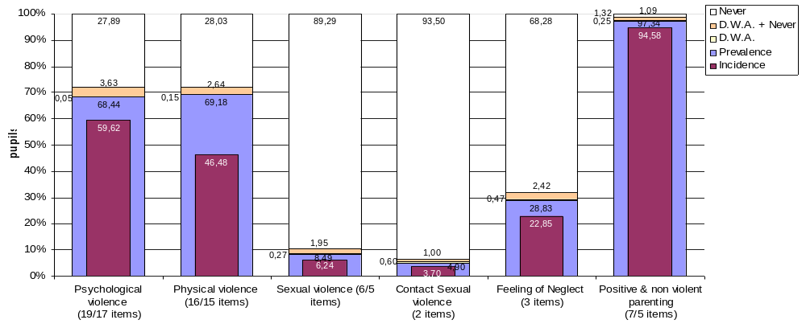

Note
Incidence: percentage of children reporting any frequency score under “During the past year (previous 12 months)” in at least 1 item of the scale
Prevalence: percentage of children reporting having experienced at least 1 behavior of the scale during their entire life time (either in the past year or before)
D.W.A.: percentage of children answering “Don’t want to answer” in all items of the scale
D.W.A+Never: percentage of children answering “Don’t want to answer” in 1 or more items of the scale and “Never” to all other items of this scale
Never: percentage of children reporting that they have “Never” in their lives experience none of the scale’s behaviors.

According to data on the prevalence of each examined experience of violence/neglect (see Table 1 in Appendix) we can conclude that the most frequent forms of violence against the children comprise those acts which are categorized as a lesser violence (psychological aggression vs. psychological abuse, or physical punishment vs. physical abuse. Calling names, or calling dumb, lazy etc. is the most frequent form of psychological violence for the majority of children. In previous year, 10.21% of children experienced such a form of violence, several times in month, or more frequently. More than one third of the examined children (36.26%) was offended in such a manner during the previous year.
The most frequent forms of physical violence, categorized as "physical punishment", experienced by the children in Serbia are slapping (23.36% of the children was slapped at least once in the previous yera), spanking the bootom with bare hand (22.44%) and pulling a hair (13.6%). Frequent experience is mostly significant for spanking: 5.33% of the children is punished during the previous year in that way several times in month or more frequently.
Experience with behaviour of the parents characterized as a non-violent or positive parenting reported almost every child; nevertheless, 1% of examined children answered that thay never experienced for example, appreciation from their parent, or explain them why something they have done is not good.

From the Figures 1.4-1.7. in Appendix 1, we see that the violent behaviors with the highest overall incidence have also been experienced by higher percentage of children with high frequency. For example out of all children who have experienced in the past 12 months to be insulted by calling dumb, lazy or other names like that, there are 8,7% of children who were exposed to this behavior once a week or more frequently and 8.3% of children who have experienced this behavior several times a month.

We were interested in the level of multiple victimization of the children, or, what percentage of the children experienced more than one type of a violent act (for example, experience of physical and psychological violence, or experience of familial violence, physical violence and sexual violence). In total, 18.15% of the children did not experienced any form of violent behavious during their life (28.76% in the previous year). Approximately same number of children (18.65%) experienced only one type of violent behaviour (25.70% in the previous year). Percentage of the children who experienced two (28.27%) or three types of violence (28.27%) is higher (see Figure D.1.2.). The percentage of children who experienced all types of violence (physical, psychological, sexual and familial violence) is 5.37%, or 2.91% in the previous year. There is total of 63,20% children with multiple victimisation (2-4 types of violent experiences) in a lifetime and 45,54% of children with multiple victimmisation during the past 12 months. Average number of violent experiences reported by the children is 1.84, or 1.38 in the previous year.
Figure D.1.2. Percentage of children with multiple victimisation, that means behaviors from different categories of violence (psychological, physical, sexual and domestic violence). The maximal number of different types of behaviors is, therefore, four.
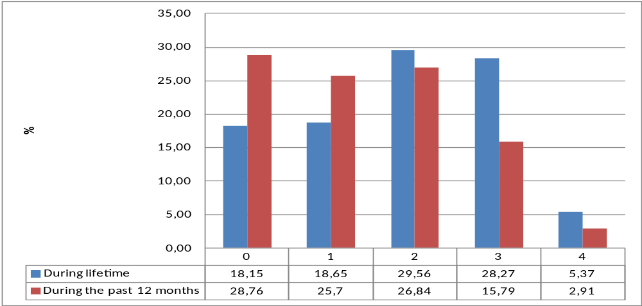

Who are the perpetrators of violence against the children in family? Adult female person is most frequently mentioned as a perpetrator of psychological violence – total of 68.13% of the children reported at least once that they experienced some sort of psychological violence by an adult female person (see Figure D.1.3.). Keeping in mind who are members of the household of the child, we can conclude that in most cases perpetrators are mothers, and in lesser extent other family members (grandmother, aunt, etc.). Perpetrators of psychological violence are adult male persons in 55.90% cases. Boys and adolescents are quoted as perpetrators in 37.68, while girls and adolescents are quoted in 32.72% cases.
Likewise, physical violence against the children is comitted more frequently by adult female persons (62.51%) than adult male pesons (56.44%). Children and young boys (brothers mostly) are more often perpetrators of physical violence against the children in family (38.21%) than girls and young women (27.39%).

Figure D.1.3. Percentage of children who indicated at least one perpetrator in the specified gender/age category
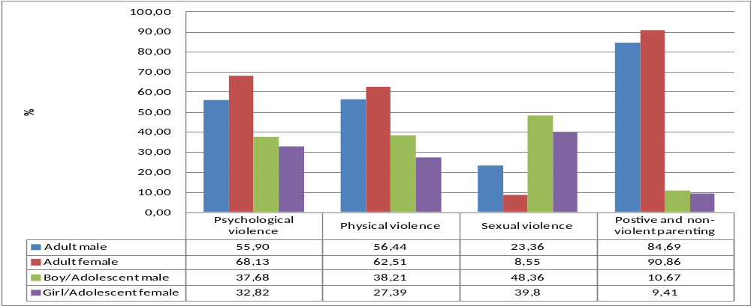
In cases of sexual violence, age and sex structure of perpetrators is rather different. Most frequently, perpetrators of of sexual violence are male peers (48.36%), then female peers (39.80%), adult male persons (23.36%), while adult female peson is quoted as a perpetrators in 8.55% cases only. Distribution of the perpetrators for each item of the sexual violence scale, for the children who have experienced the different behaviors, is presented on the Figure D.1.4.. Besides sex and age, children were allowed, answering the question about sexual violence, to mark the perpetrator as a person known to the child, a relative, or an unknown person. When peers are marked as perpetrators of sexual violence they are in majority of cases known persons (70% cases at least), rarely as unknown person, and in only a few cases the perpetrator was a relative (see Figure D.1.5.). Adult male persons, as perpetrators of sexual violence, in many cases are unknown to the child (more than 50% adult males who upset the children speaking to them in a sexual way or writing sexual thing about them, whomade children watch a sex video or look at sexual pictures, children have marked as persons unknown to them). Adult persons who tried to have sex with children when children did not want to, in 13 cases are men and in 7 cases women, of whom three men and two women are marked as relatives.

Figure D.1.4. Perpetrators, by age and gender, on the sexual violence items
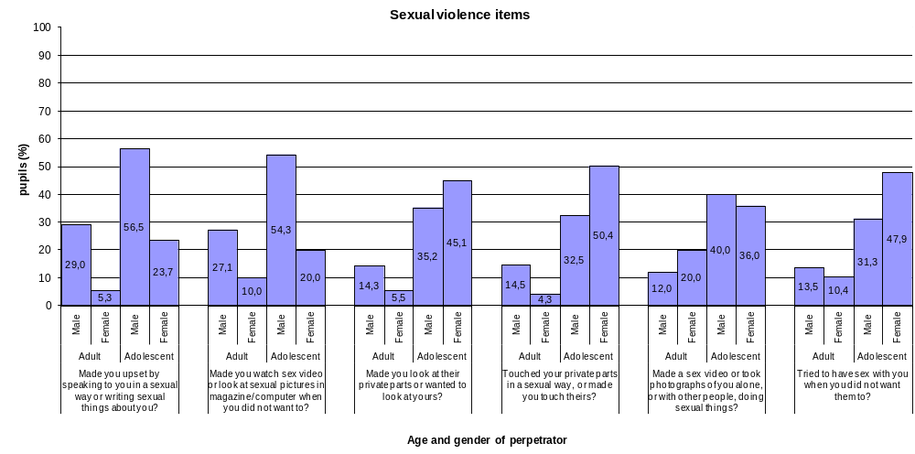

Figure D.1.5. Relation of the child to the perpetrator, by age and gender, on the sexual violence items
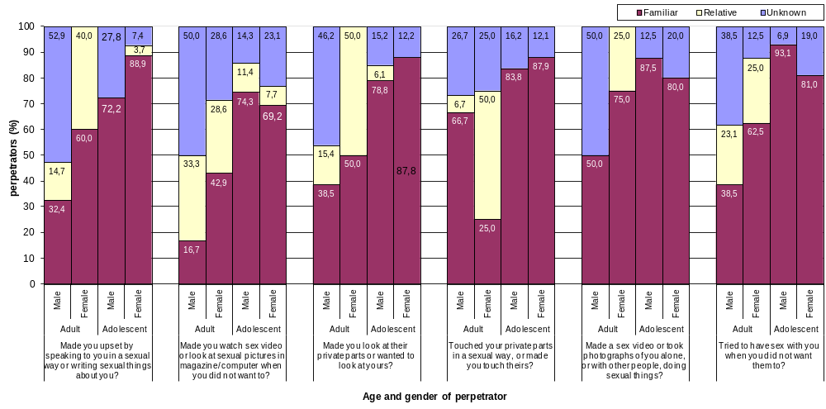

Adult female persons (mothers) more frequently apply positive and non-violent educational methods (90.86%) comparing to adult male persons (fathers) (84.69%) (see Figure D.1.3). As persons who apply those methods, peers are rarely marked. Boys/young men are marked by 10.67% of the children, and girls/young women by 9.41% of the children.

We also explored if there are differences in prevalence and incidence of examined forms of violence and feelings of neglect, in regard to the sex and age of the children, to the region and urbanicity of the place where school from the sample is situated, and interactions of these variables were examined.

There are significant sex and age differences in regard to the prevalence and incidence of various forms of violence and feelings of neglect. Besides, these variables were in interaction, so we shall show in detail the results which take in consideration sex and age crossing.

Experience of psychological violence is reported more frequently in girls than in boys (see Figure D.1.6.). When results are expounded by age, however, we can see difference in 16-years old adolescents only, who are attending vocational schools (Pearson Chi square = 26.100, p = 0.000), where 81.21% of girls reported at least one experience of the psychological violence during their life (72.44% in previous year), and 68.67% of boys (58.00% in previous year). In other age groups, as well as in children attending secondary school (gymnasium) differences in regard to the sex are not significant (see Figure D.1.7.). There is a same trend in children of both sexes – with age, prevalence and incidence of experienced psychological violence increase. Only in boys attending vocational schools the prevalence and incidence are at the same level as in thirteen years old boys. In other words, general difference in regard to the sex existed in exposure to the psychological violence due to the fact that adolescent boys attending vocational schools experience less exposure to psychological violence than adolescent girls, as well as less than their male peers attending gymnasium.

Figure D.1.6. Prevalence and incidence rates of pupils’ exposure to violent behaviors by child’s gender. (Only the scales for which the analyses revealed a significant main effect of gender are presented here).

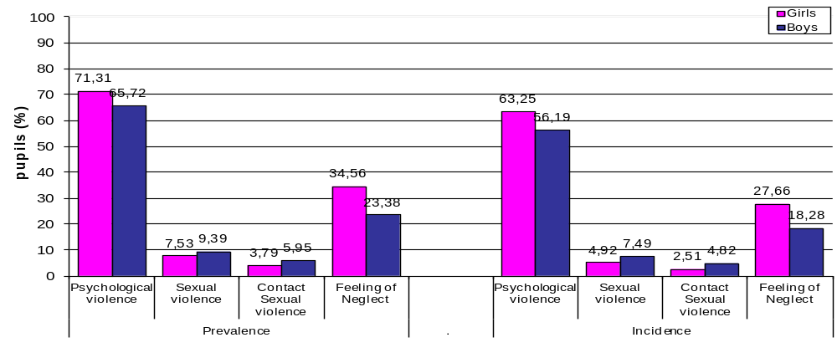

Figure D.1.7. Prevalence and incidence rates of pupils’ exposure to psychological violence by child’s gender and grade group

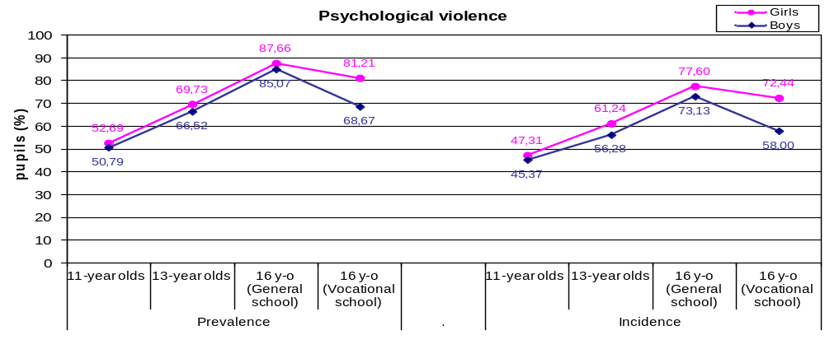
Although in total sample the difference between girls and boys regarding exposure to physical violence is not found, the difference exists in two age groups: in eleven years old group (Pearson Chi Square = 5.691, p = 0.017) and in sixteen years group, but only in those attending technical schools (Pearson Chi Square = 5.402, p = 0.017). In the group of youngest children, boys are reporting more physical violence during their lifetime than girls, while in pupils attending technical scools the result is vice cersa: prevalence in girsl is 77.20%, and in boys 71.29% (see Figure D.1.8.). Regarding experiences from the previous year only, sex differences in group of the youngest children are even more significant: 43.01% of girls experienced physical violence in the previous year, while 53.86% of boys reported such an experience (Pearson Chi Square = 10.664, p = 0.001). Monitoring age groups only, we notice that the incidence of physical violence in girls is generally constant, or slightly increased – in girls attending technical schools; in boys, the incidence slightly decreases with age. In other words, girls attending technical schools are exposed to physical violence more than their male peers attending same type of school or their female peers attending secondary schools.

Figure D.1.8. Prevalence and incidence rates of pupils’ exposure to physical violence by child’s gender and grade group.

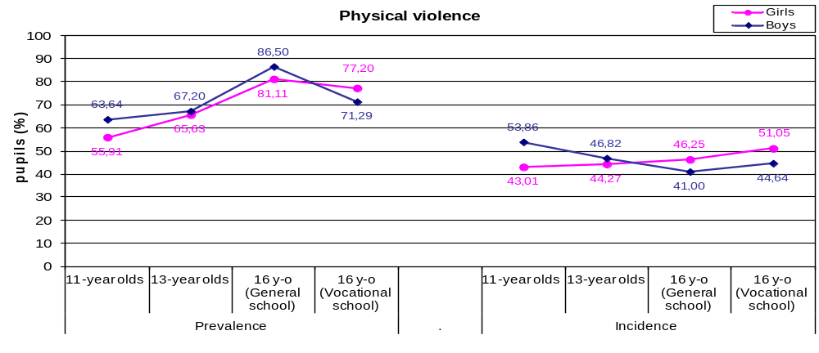

Prevalence, and especially incidence of the sexual violence are higher in boys than in girls (see Figure D.1.6.). It is also clearly visible from comparison of number of different violent sexual behaviors experienced by children during the life time (prevalence) or in the past 12 months (incidence) (see Figures D.1.9. i D.1.10.).

Figure D.1.9. Differences between girls and boys in the number of experienced violent sexual behaviors (prevalence)

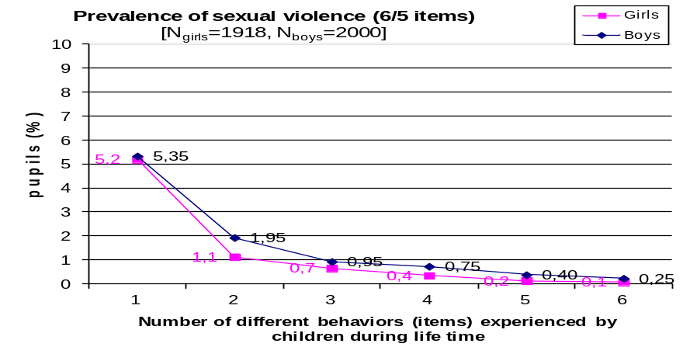
Figure D.1.10. Differences between girls and boys in the number of experienced violent sexual behaviors (incidence)

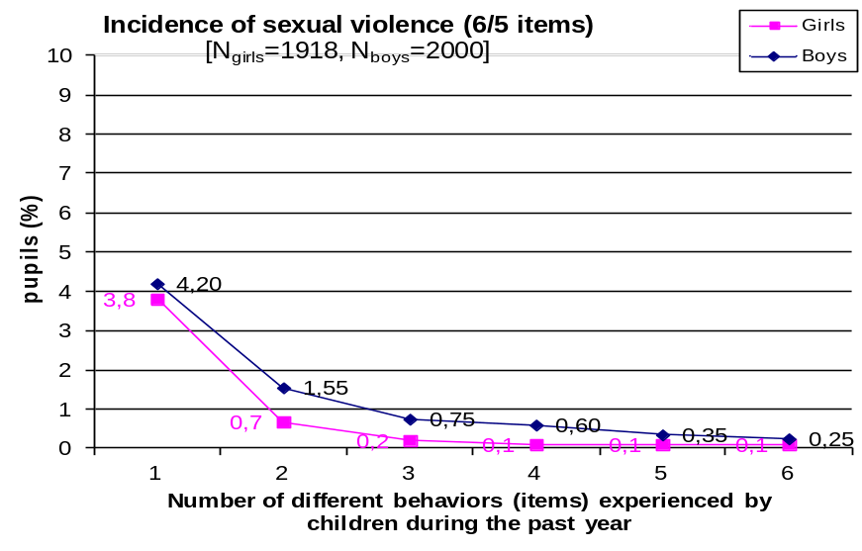

However, when sex differences are examined as a function of age, we discover that they are significant in eleven years old only (see Figure D.1.11.). (prevalence: Pearson Chi Square = 14,715, p = 0,000; incidence: Pearson Chi Square = 10.067, p = 0.002): 7.55% of boys reported at least one experience of sexual violence during the life (5.72% in previous year) compared to 2.17% of girls (1.74% in previous year). Difference according to sex in that age group exists even when only two items which examine experience of contact sexual violence are extracted (Pearson Chi Square = 4.574, p = 0.032)

Figure D.1.11. Prevalence of sexual violence by gender and age
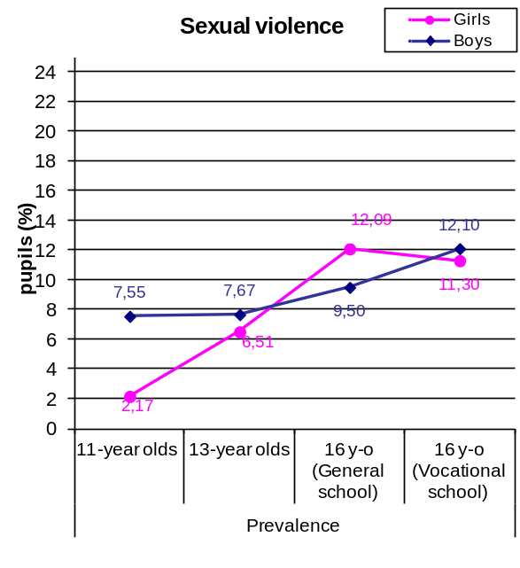
Monitoring the prevalence/incidence in relation to age in boys and girls we have observed that there is more pronounced increase in prevalence and incidence between examined ages in girls, while there is slight increase of both indicators of the rate of sexual violence in boys with age, with an exception of adolesents attending technical schools, who have higher prevalence and incidence than their peers attending secondary school. Given that peers are the most common perpetrators of sexual violence, it seems that peer pressure for participation in sexual matters and activities begin in boys earlier than in girls.
It is interesting that we observed significant sex difference in adolescents attending technical schools, but only in the incidence of contact sexual violence (7.44% boys compared to 4.39% girls, Pearson Chi Square = 4.574, p = 0.032).
Older children more frequently reported experiences of sexual violence, mainly by peers. Age differences, however, are significant mostly in children who have an experience with one type of sexually violent behaviour. There is, of course, smaller number of children who reported experience with several types of sexually violent behaviour (e.g. three or four different behaviour), but in that group of children age differences are not significant any more (see Figures D.1.9. and D.1.10.).

Figure D.1.12. Prevalence and incidence rates of pupils’ exposure to sexual violent behaviors by number of different behaviors (items) they have been exposed to and by grade group.

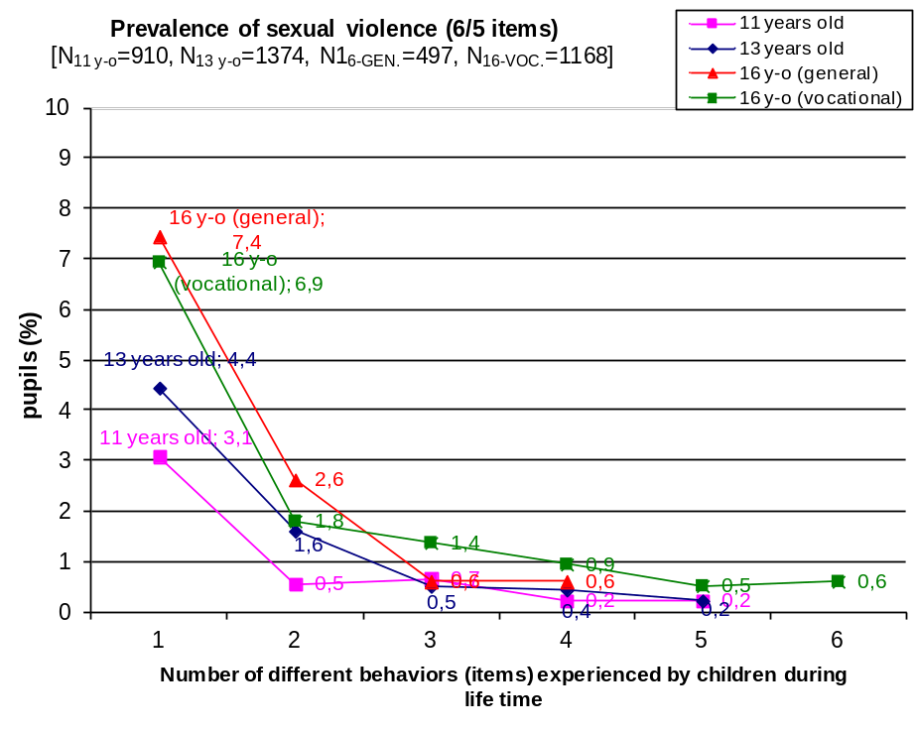

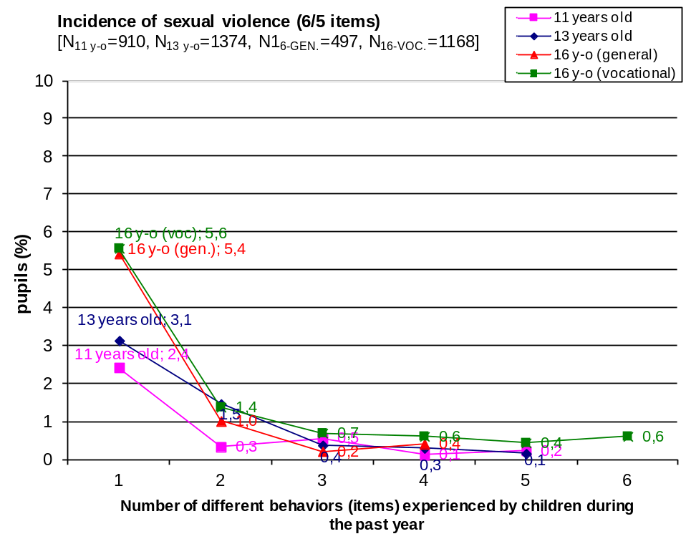

There are larger number of children with both experiences of contact sexual violence in vocational schools, in comparison to general schools (see Figure D.1.13.).

Figure D.1.13: Prevalence and incidence rates of pupils’ exposure to contact sexual violence by number of different behaviors (items) they have been exposed to and by grade group.

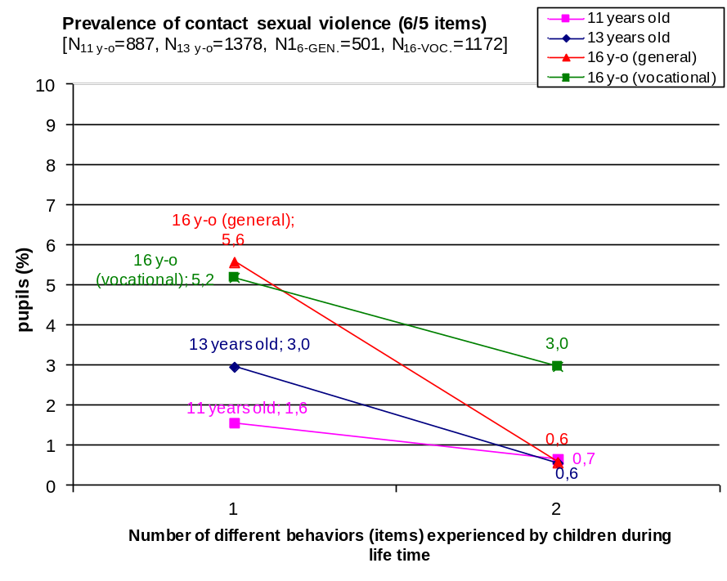
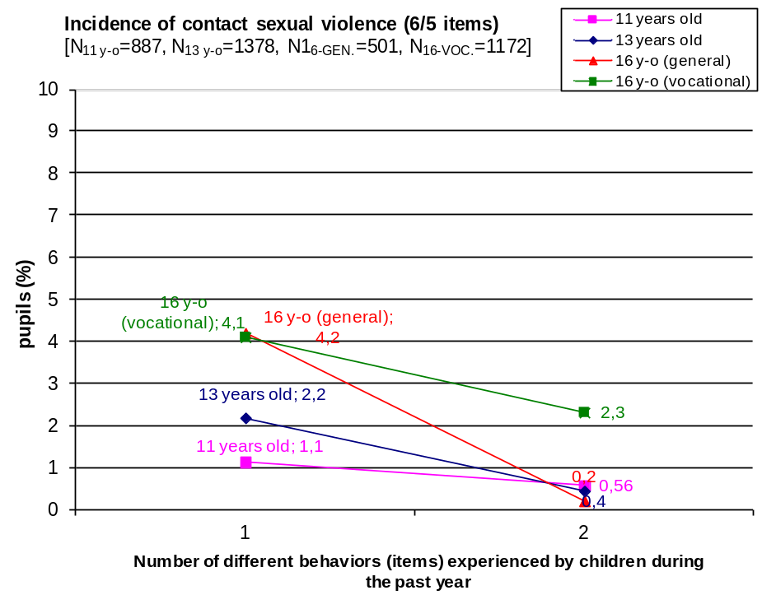
The most prominent general sex difference is shown in the category of experience of feelings of neglect. This conspicuous difference in total sample is the result of consistent sex differences in the prevalence and incidence manifested in every age, except for the prevalence in adolescents in secondary school and for the incidence in eleven years old boys and girls (see Figure D.1.14.).

Figure D.1.14. Prevalence and incidence rates of pupils’ exposure to feeling of neglect by child’s gender and grade group.

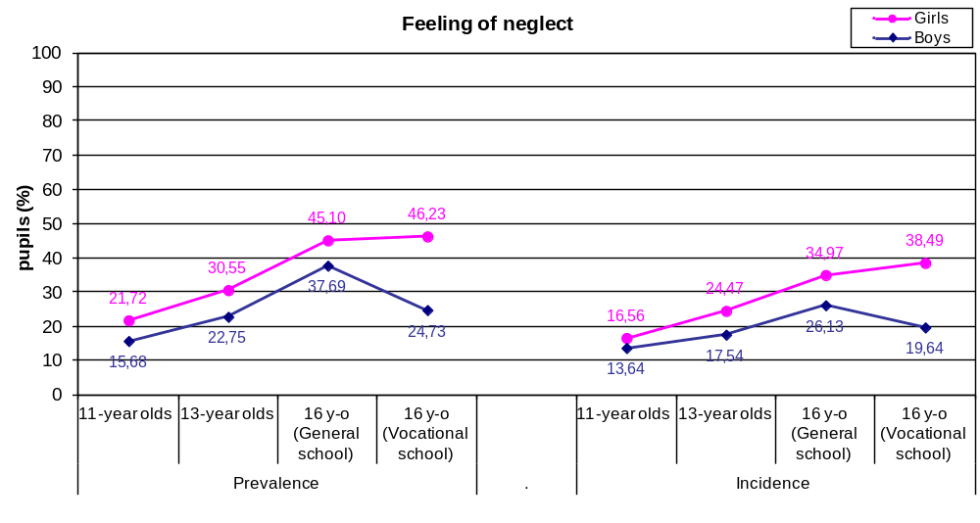

Namely, in each group girls more frequently reported experience of feelings of neglect than boys. The difference is especially dramatic in pupils attending technical schools: 46.23% of adolescent girls reported on feelings of neglect once during the life at least (38.49% in previous year), comparing to 24.73% adolescent boys only (19.64% in previous year), Pearson Chi square = 60.317, p = 0.000, for the incidence Pearson Chi square = 51.317, p = 0.000, respectivelly. There is significant increase in the prevalnce and incidence of the feelings of neglect, in regard to the age. Exception is made for adolescents attending technical schools in whom during the previous year, and in general, feelings of neglect is not reported more frequently than in thirteen year olds. These findings are telling us about very important developmental aspects of exposure to the violence and feelings of neglect, as well as about interaction of developmental processes with socio-economic and cultural factors which we will understand better comparing socio-demographic profile od the adolecents attending secondary schools and technical schools.
Complex interactions of the sex, age and type of experienced violent behaviour are shown well in graphs D.1.15., D.1.16., D.1.17. i D.1.18. Example of the incidence of psychological and physical violence and positive and non-violent parenting we can see that a number of children with different experiences within one category is larger in case of non-violent parenting than in cases of violent experiences. Approximately 8% eleven years olds experienced three different experiences of psychological violence in the previous year, while more than 18% of them experienced three different behaviours of non-violent parentng in previous 12 months. Age differences and sex differences are significant also in a variety of behaviours to which children are exposed, or reported of. In average, older chldren report more diverse behaviours, which is especially conspicuous in the category of positive and non-violent parenting, and girls report larger number of behaviours, comparing to the boys, especially in the category of psychological violence.

Figure D.1.15. Incidence of psychological violence, in regard to the number of experienced violent behaviours by sex and grade group
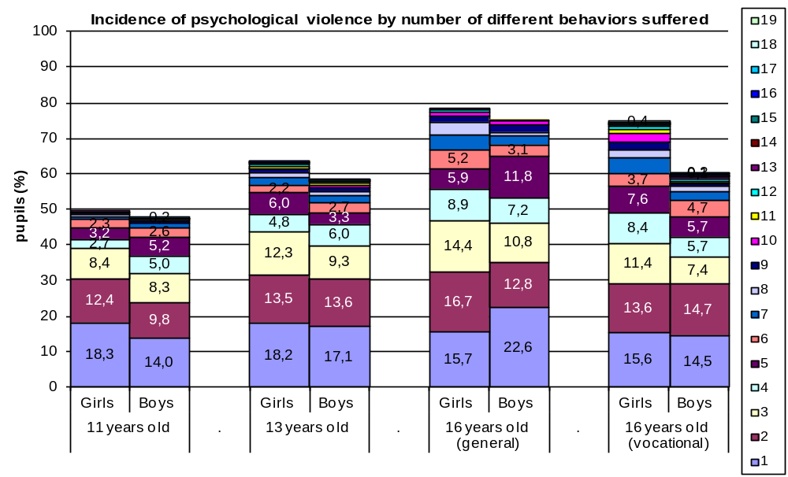
Graph D.1.16. Incidence of physical violence, in regard to the number of experienced violent behaviours by sex and grade group

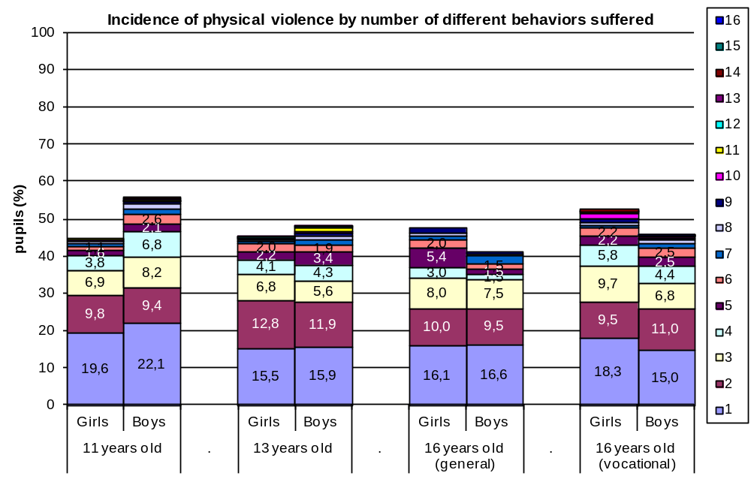
Graph D.1.17. Incidence of positive and non-violent parenting, in regard to the number of experienced behaviours by sex and grade group

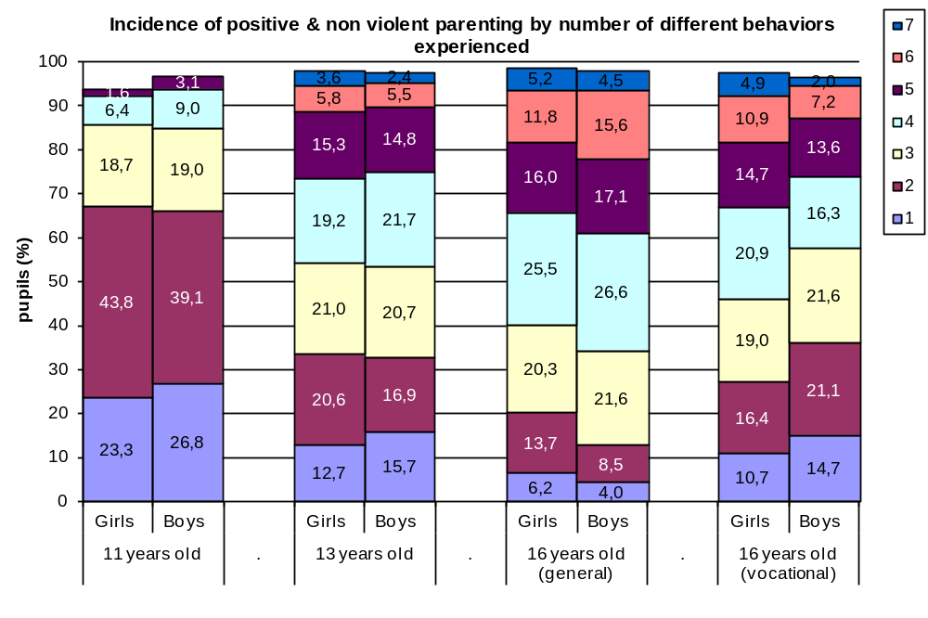
Urbanicity was noted as an important factor of variation in the prevalence and incidence of violence against the children in family (see Figure D.1.18.), although in unexpected manner – children in urban environment have reported on more psychological violence (71.48% in urban environment, comparing to 63.08% non-urban envirnoment; 62.57% comparing to 54.44% in previous year, respectively), physical violence (72.42% in urban environment, comparing to 63.77% in non-urban envirnoment; 48.54% compared to 43.05% in previous year, respectivelly), more feelings of neglect (30.54% in urban environment, comparing to 25.94% in non-urban environment; 24.07% compared to 20.72% in previous year, respectivelly; but they have reported on more positive and non-violent parental behaviour too (Pearson Chi square is significant in all cases, both for the prevalence and for the incidence). It seems that children in urban environment are, in general, exposed more to disciplining by their parents, no mattter is that positive disciplinin or negative, or violent one.

Figure D.1.18. Differences in the prevalence and incidence of psychological and physical violence and positive and non-violent parentin, in regard to the urbanicity

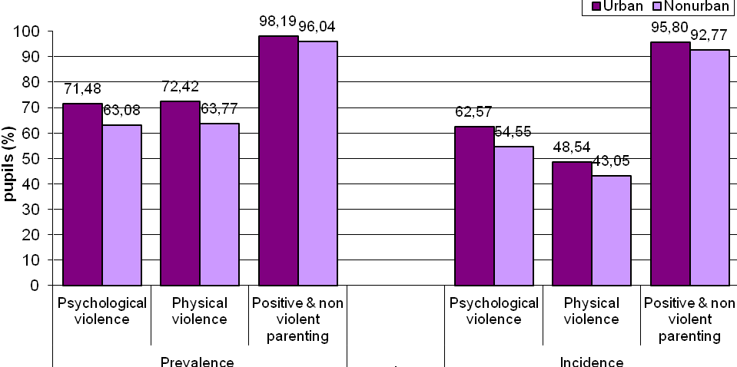

The effect of urbanicity is to be considered, however, in regard to the sex and age of the children, since these variables are in interaction in some types of violence. Although the described connection between urbanicity and prevalence/incidence is noted in both girls and boys, it is statistically significant in both sex groups only in case of psychological violence (see Figure D.1.19.).

Graph D.1.19. Prevalence of psychological violence by gender and urbanicity

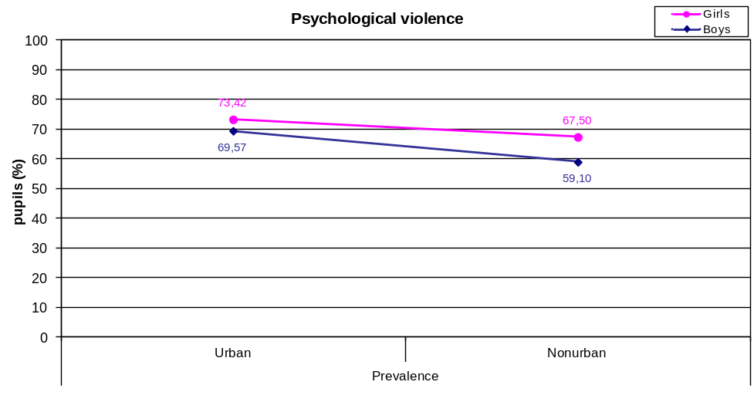

Thus in boys was not established significant difference in the incidence of physical violence in regard to the urbanicity of the environment. Similarly, differences between children from urban and non-urban environment in regard to the prevalence of feelings of neglect wew significant in girls only. Girls from urban and non-urban environments did not show, on the other hand, difference in regard to prevalence of positive and non-violent parental behaviour. Differences between the children from urban and non-urban environment fade with older age. There is no significant difference in adolescents attending both types of secondary school in regard to the prevalence/incidence of psychological and physical violenceand feelings of neglect.

Prevalence and incidence of examined types of violence and feelings of neglect do not differ in regard to geographical region, when total sample is considered. However, isex-geographical region nteraction was established. Namely, prevalence and incidence of the psychological violence are higher in Belgrade and Vojvodina comparing to two other regions (see Figure D.1.20.) (Pearson Chi square = 14,653, p = 0,002 for prevalence, 13,793, p = 0,003 for incidence, respectivelly). Similar trend is noted, although not so conspicuous, in the prevalence of physical violence too: boys from Belgrade reported more physical violence comparing to boys from other regions, especially from Western and Southwestern Serbia (Pearson Chi square = 8,026, p = 0,045) (see Figure D.1.21.).

Figure D.1.20. Prevalence and incidence of psychological violence by gender and geographical region

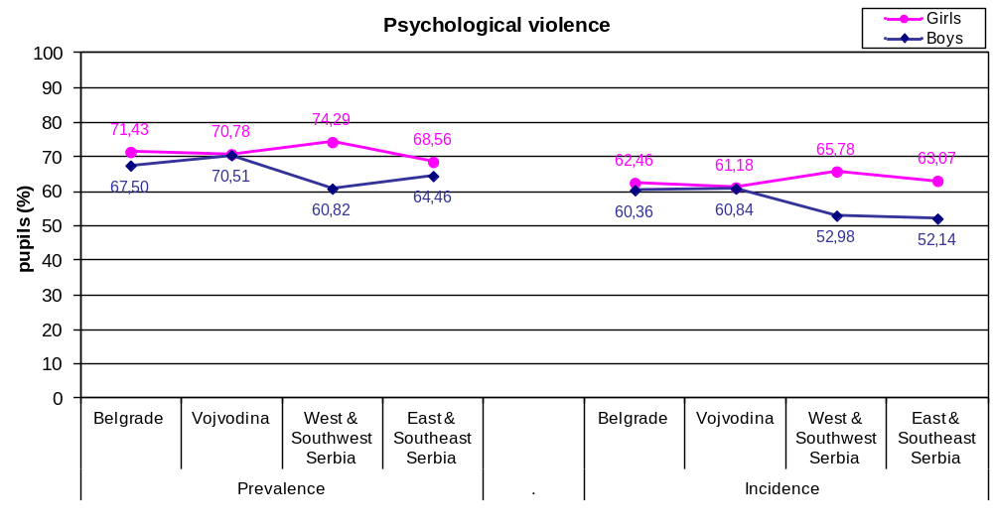
Figure D.1.21. Prevalence of physical violence by gender and geographical region

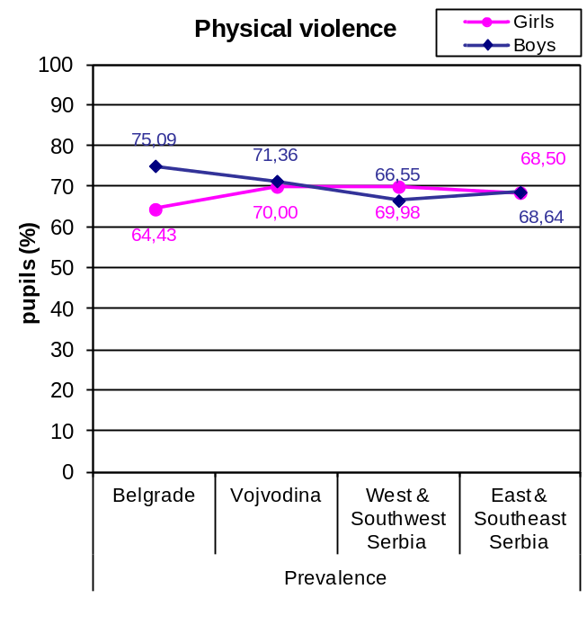
Finaly, all statistically significant major effect and double interactions are shown in the Tables 1.2 and 1.3 in the Appendix 1.

2. Paired analysis section

From planned sample of 7.565 children and their parents, i.e. realized sample of 4.027 examined pairs, data for 2.701 child-parent pair were obtained. Table D.2.1. represents their socio-demographic characteristics.
In this section we shall present the most important results, indicating the differences in reporting of children and their parents on psychological and physical violence, sexual violence and positive and non-violent parenting.

Table D.2.1.Demographics for matched pairs of children and their parent/caregiver participated in the ICAST-CH and ICAST-P survey in Serbia, and information about their living conditions (Sample’s size = 2701 pairs of child – respondent parent/caregiver)
N%Child’s genderGirls140251,91Boys129948,09Child’s age1030,111143316,031228210,441361722,841447017,401560,221644816,591742015,5518220,81Grade group (typical age of attending pupils)11 y-o72026,6613 y-o 109140,3916 y-o, General school27410,1416 y-o, Vocational school61622,81Child’s birth position in the familyonly child32712,11first child (oldest)98936,62middle child 27710,26last child (youngest)104038,50twins542,00not biological child140,52Persons cohabitating with the childmother261396,74father235287,08stepmother (father’s spouse)130,48stepfather (mother’s spouse)542,00foster mother 70,26foster father80,30mother’s partner60,22father’s partner30,11grandmother80029,62grandfather54720,25female siblings(s)119344,17male siblings(s)131948,83other relatives1033,81other non relatives120,44Respondent’s relationship with the childUnspecified60,22mother187369,50father64323,86both parents1485,49stepmother20,07stepfather10,04foster mother 70,26foster father10,04sister10,04brother10,04grandmother90,33grandfather60,22other relative30,11Respondent also replied for:Unspecified25513,04none (for her/himself only)32118,87the other parent 126074,07her/his spouse/partner 653,82other person, who looks after the child 422,47other person130,76
MotherFather N % N %Parents’ NationalityUnspecified1555,742459,07N/A (parent not alive)150,56672,48Serbian208782,46200483,88Hungarian1726,801405,86Bosnian1154,541034,31Mixed/Other682,69572,39Croatian361,42301,26Romany361,42291,21Montenegrian100,40190,80Other70,2870,29Parents’ marital situationUnspecified471,74933,44N/A (parent not alive)150,56672,48married214681,32215084,61separated250,95250,98divorced1575,951425,59remarried411,55481,89cohabitating 1515,721495,86single501,8970,28widow672,54150,59other20,0850,20Urbanicity of the place of residenceUnspecified2168,0030711,37N/A (parent not alive)150,56672,48Urban91537,0488237,90Nonurban155562,96144562,10Parents’ employment conditionUnspecified742,741836,78N/A (parent not alive)150,56672,48not working80930,9730112,28working151558,00183874,99unemployed2519,612399,75retired371,42732,98
MotherFather N % N %Parents’ educational levelUnspecified772,851806,66N/A (parent not alive)150,56672,48nas not attended school50,1900,00Some grades of Primary school291,11180,73Primary school35013,4227211,08 Vocational school (3 years)62223,8471329,05Vocational school (4 years)/Gymnasium104640,0995038,71 High School (2 or 3 years)1897,241998,11University33512,8426710,88 Postgraduate studies (masters, doctorate)331,26351,43
N %Respondent’s subjective
estimation of economic situationUnspecified582,15very bad1244,69bad29511,16moderate148656,22good61823,38very good1204,54

Considering the prevalence and incidence of psychological and physical violence and positive parenting, the percentage of parents who are reporting on implementation of violent or non-violent acts toward the examined child significantly is higher then percentage obtained on the children (see Figures D.2.2. and D.2.3.). Differences are especially prominent between eleven years olds and their parents. For example: while 29.58% of 11 years old children reports on experience of psychological violence in previous year, 59,94% of their parents report on at least one act of psychological violence in the same period.

Figure D.2.2. Prevalence of psychological and physical violence and positive parenting, comparison of parents and children
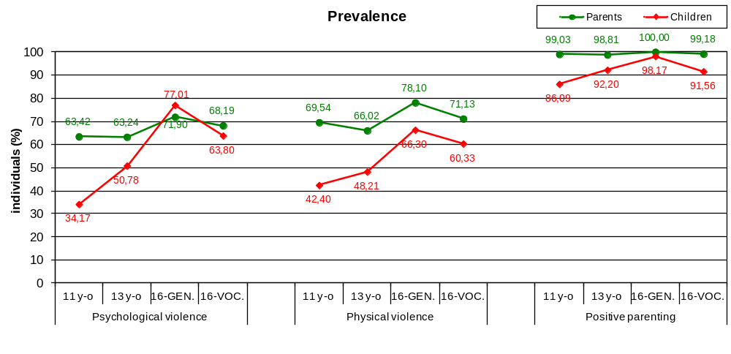

Figure D.2.3. Incidence of psychological and physical violence and positive parenting, comparison of parents and children
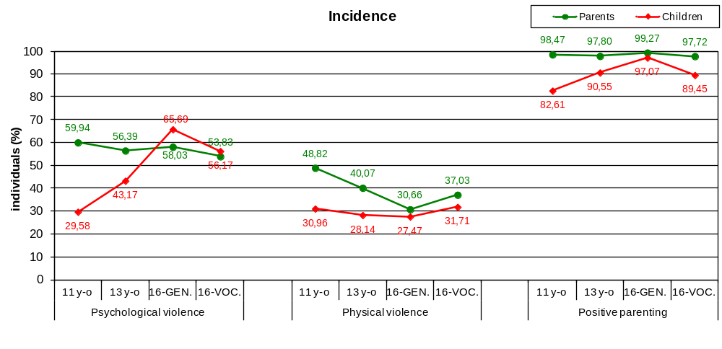
Analysis of accordance of responses of parents and children at the item level of the ICAST questionnaire reveals that accordance is higher in moderate forms of violence, and lowest in most severe forms of violence, e.g. at items "Choked or smothered him/her (prevent breathing by use of a hand or pillow) or squeezed his/her neck with hands (or something else)?" (kappa coefficient for prevalence = 0,049, for incidence = 0,008); "Intentionally burned or scalded him/her?" (kappa for prevalence = 0,052, for incidence = 0,061) (see Table D.2.4.).

Table D.2.4. (In)consistency in children’s - parents’ reporting in regards to the parents’ use and children’s exposure to the different behaviors of the psychological and physical violence as well as of the positive parenting scales
Scale | Items¹ | N | Kappa coefficient²
Scale | Items¹ | N | PR | IN.
Psychological violence (19/17 items) | Shouted, yelled, or screamed at her/him very loud and aggressively? | 2599 | 0,255 | 0,197
Psychological violence (19/17 items) | Insulted him/her by calling him/her dumb, lazy or other names like that? | 2573 | 0,255 | 0,238
Psychological violence (19/17 items) | Cursed him/her? | 2624 | 0,185 | 0,201
Psychological violence (19/17 items) | Refused to speak to him/her (ignore him/her)? | 2608 | 0,188 | 0,149
Psychological violence (19/17 items) | Blamed him/her for your bad mood? | 1892 | 0,154 | 0,151
Psychological violence (19/17 items) | Read his/her diary or his/her SMS or e-mail messages without his/her permission? | 2622 | 0,189 | 0,154
Psychological violence (19/17 items) | Went through his/her bag, drawers, pockets etc. without his/her permission? | 2605 | 0,133 | 0,104
Psychological violence (19/17 items) | Compared him/her to other children in a way that s/he felt humiliated? | 2573 | 0,264 | 0,230
Psychological violence (19/17 items) | Ashamed or embarrassed her/him intentionally in front of other people in order to make him/her feel very bad or humiliated? | 2614 | 0,163 | 0,136
Psychological violence (19/17 items) | Told her/him that you wished s/he was dead or had never been born? | 2635 | 0,148 | 0,137
Psychological violence (19/17 items) | Threatened to leave or abandon him/her? | 2636 | 0,207 | 0,211
Psychological violence (19/17 items) | Threatened to kick out of house or send away? | 2635 | 0,144 | 0,218
Psychological violence (19/17 items) | Locked out of home? | 2634 | 0,134 | 0,101
Psychological violence (19/17 items) | Threatened to invoke ghosts or evil spirits or harmful people against him/her? | 1885 | 0,231 | 0,060
Psychological violence (19/17 items) | Threatened to hurt or kill her/him? | 2638 | 0,122 | 0,121
Psychological violence (19/17 items) | Locked her or him up in a small place or in a dark room? | 2637 | 0,126 | 0,139
Psychological violence (19/17 items) | Threatened him/her with a knife or gun? | 2635 | 0,054 | -0,003
Physical violence (16/15 items) | Pushed or kicked her/him? | 2605 | 0,180 | 0,162
Physical violence (16/15 items) | Grabbed him/her by clothes or some part of his/her body and shook him/her? | 2591 | 0,180 | 0,181
Physical violence (16/15 items) | Slapped him/her? | 2514 | 0,296 | 0,208
Physical violence (16/15 items) | Hit him/her on head with knuckle or back of the hand? | 2627 | 0,087 | 0,070
Physical violence (16/15 items) | Spanked her/him on the bottom with bare hand? | 2463 | 0,202 | 0,152
Physical violence (16/15 items) | Hit her or him on the buttocks with an object such as a stick, broom, cane, or belt? | 2596 | 0,243 | 0,223
Physical violence (16/15 items) | Hit elsewhere (not buttocks) with an object such as a stick, broom, cane, or belt? | 2623 | 0,175 | 0,174
Physical violence (16/15 items) | Hit her or him over and over again with object or fist (“beat-up”) | 2634 | 0,139 | 0,129
Physical violence (16/15 items) | Choked or smothered him/her (prevent breathing by use of a hand or pillow) or squeezed his/her neck with hands (or something else)? | 2646 | 0,049 | -0,008
Physical violence (16/15 items) | Intentionally burned or scalded him/her? | 2644 | 0,052 | 0,061
Physical violence (16/15 items) | Put chili pepper, hot pepper, or spicy food in his/her mouth (to cause pain)? | 1937 | 0,221 | 0,116
Physical violence (16/15 items) | Tied him/her up or tied him/her to something using a rope or a chain? | 2633 | 0,068 | 0,084
Physical violence (16/15 items) | Roughly twisted her/his ear? | 2566 | 0,223 | 0,198
Physical violence (16/15 items) | Pulled her/his hair? | 2572 | 0,222 | 0,193
Physical violence (16/15 items) | Pinched her/him roughly? | 2595 | 0,164 | 0,149
Physical violence (16/15 items) | Forced him or her to hold a position that caused pain or humiliated him/her as a means of punishment? | 2636 | 0,106 | 0,052
Positive and non-violent parenting (7/5 items) | Told her/him to start or stop doing something (e.g. start doing your homework or stop watching TV)? | 1852 | 0,157 | 0,199
Positive and non-violent parenting (7/5 items) | Explained him/her why something s/he did was wrong? | 2464 | 0,063 | 0,091
Positive and non-violent parenting (7/5 items) | Gave him/her an award for behaving well? | 2439 | 0,083 | 0,107
Positive and non-violent parenting (7/5 items) | Gave him/her something else to do in order to distract his/her attention (e.g. to tell him/her to do something else in order to stop watching TV)? | 1855 | 0,189 | 0,191
Positive and non-violent parenting (7/5 items) | Took away pocket money or other privileges? | 2613 | 0,219 | 0,166
Positive and non-violent parenting (7/5 items) | Forbade something that s/he liked? | 2588 | 0,261 | 0,253
Positive and non-violent parenting (7/5 items) | Forbade him or her from going out? | 2533 | 0,348 | 0,304
^{1.} Items in bold had been excluded from the short-version of the ICAST-CH completed by the 11 y-o grade’s pupils
^{2.} The lower the kappa coefficient, the higher the disagreement between children’s - parents’ reports; Kappas lower than ,40 considered to be poor, ,41-,75 fair to good and larger than ,75 excellent agreement

Quite a different picture is obtained by analysis of parent-child pairs in regard to sexual violence. It was mentioned already that most frequently the perpetrators of sexual violence are peers, and in lesser extent adults. Adult perpetrators of sexual violence usually are males, unknown to the child in half of cases, rarely relatives. Thus, the analysis is giving an answer to our question if parents are informed on the victimization of their child by his/her peers or adult persons. Previous analyses were indicating inaccordance in reporting, i.e. admitting violence by possible perpetrator (parent) and victim (it should be considered that perpetrators of physical and psychological violence could be other household members too).
As we can see in Graph D.2.5. prevalence and incidence of all types of sexual violence are higher in reports of the children, comparing to reports of the parents. Especially large are differences in sixteen years olds, and particularly for contact sexual violence (see Figure D.2.6). Only 0,65% of parents of adolescents attending vocational schools is informed (and reporting) that their child was a victim of an attempt to have sex with a child against his/her will, while 4,72% of their children reports on such a behaviour.

Figure D.2.5. Prevalence and incidence of sexual violence, comparison of parents and children
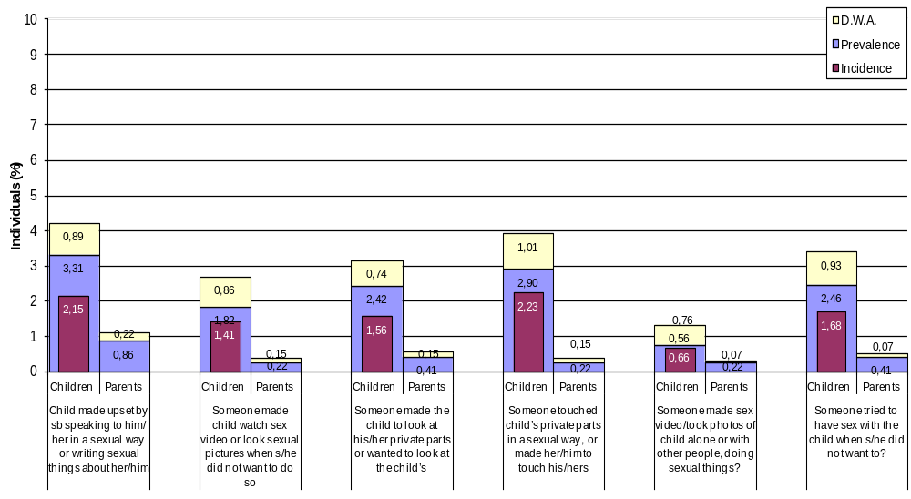

Graph D.2.6. Prevalence and incidence of four items of sexual violence, comparison of parents and children, according to the age
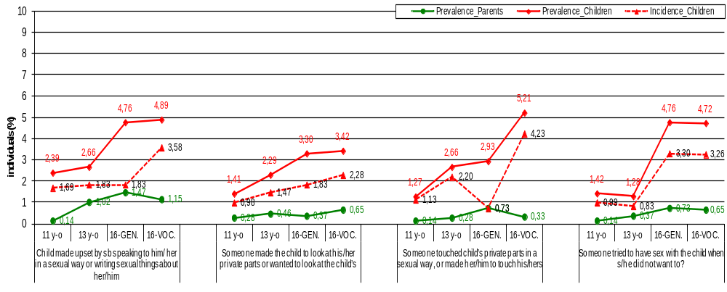

It should be emphasized that inconsistency amogn parents-children's replies is much larger than the one indicated if one simply substract the children's prevalence rate from the parents' (see Table D.2.7.).

Table D.2.7. (In)consistency in children’s - parents’ reports in regards to the parents’ use and children’s exposure to 4 specific behaviors (items asked)

 |  | Individual answers (Yes) |  | Paired answers (Yes)
 |  | Parent | Child | Both | Only the  parent | Only the child
Went through his/her bag, drawers, pockets etc. without his/her permission? | N | 904 | 248 | 146 | 739 | 96
 | % | 34,81 | 9,32 | 5,60 | 28,37 | 3,69
Grabbed him/her by clothes or some part of his/her body and shook him/her? | N | 782 | 260 | 154 | 601 | 103
 | % | 29,53 | 9,84 | 5,94 | 23,20 | 3,98
Slapped him/her? | N | 866 | 830 | 427 | 374 | 390
Slapped him/her? | % | 32,61 | 32,45 | 16,98 | 14,88 | 15,51
Spanked her/him on the bottom with bare hand? | N | 1584 | 772 | 586 | 878 | 173
Spanked her/him on the bottom with bare hand? | % | 59,93 | 30,66 | 23,79 | 35,65 | 7,02

E. DISCUSSION (OF THE RESEARCH FINDINGS)
As each finding of the epidemiological study has been already discussed in the previous chapter, we shall discuss here only our results in relation to some other research findings in Serbia and point to some limitations of our study.
Our study revealed that nearly 70% of children in Serbia, aged 11, 13 and 16 years, experienced psychological or physical violence at least once during the life. More than a quarter of children at least once in their lives felt neglected. Over 8% of the children had suffered sexual violence, out of which more than 2% of the children had experienced contact sexual abuse in the past year. Girls are more exposed to psychological violence and report more feeling of neglect. Boys are more vulnerable to sexual violence. The rate of severe forms of physical, psychological and sexual violence is about 0.5 to 1%, and these are the children that social welfare system should recognize and intervene.
Analyses of child-parent pairs has revealed that parents report more psychological and physical violence and more positive parenting, on the level of overall prevalence and incidence, than their children. On the other side, prevalence and incidence of all types of sexual violence are higher in the reports of the children, comparing to reports of the parents. Analysis of accordance of responses of parents and children at the item level of the ICAST questionnaire reveals that accordance is higher in moderate forms of violence, and lowest in most severe forms of violence.
The Multiple Indicators Cluster Survey (MICS3,2005) is practically the only other epidemiological study on CAN in family which was done in Serbia (2). It found that in 72,8% of children aged 2 to 14 years the parents applied corporal punishment and psychological maltreatment as a measure of discipline. The results of the MICS study done in 28 developing and transitional countries are similar (1).
In our sample out of it 51% children experienced mild while 7% of children experienced severe corporal punishment, The severe corporal punishment was twice higher (14%) in children from very poor families (under the poverty line) and three times higher (21%) in Roma children from Roma settlements. These findings are somewhat higher then in our BECAN study. The explanation of these differences could be done in terms of differences in the sample and the research method. The MICS study was related to younger children in the family (2-14 years) while the BECAN study targeted school children aged 11, 13 and 16. Beside that, the MICS study included children from very deprived social groups (very poor children, Roma children from Roma settlements) while the BECAN study comprised school children who attended the school regularly.
The limitation of the BECAN study is that it did not include children who remain completely out of the school system. It is true that the BECAN previewed a study of drop out children also but the definition of drop out children (children who attended the school in the previous but not in the actual school year) was not appropriate for our culture where the drop out of children from very deprived social groups happens much earlier, mostly in first years of schooling. Reaching those children for a survey would require a completely different strategy then the one used in the BECAN study.

The main limitation of the study was the rather low response rate of children and particularly of parents. The response rates, both in children and parents were projected at about 70%. The response rate of children was only 53,2% while in parents it was even lower, with only 41.95% of valid parent questionnaires.
The reasons for this low response rate were twofold. First factor was the negative impact of the strike of teachers on the cooperation between the teachers and the parents- It has been explained in details in the section Methodology, (C2. Response rate). The dissatisfaction of parents provoked a hostile attitude towards the school and towards everything what was coming from the school, thus to the BECAN research also. The mistrust of parents was additionally augmented by the information letter and consent form which were sent to them, and which were not appropriate to our culture. Our parents are not used to give such written consent and it provoked their suspiciousness. We believe that the response rate would be higher if the parents were informed about the research and their consent asked at the parental meeting organized jointly by teachers and the researchers. However, in the situation of the strike, there was no chance to organize such meetings.
In favour of our opinion that the general socio-economic situation and particularly the strike were one of the main reasons of low response rate, speaks also the fact that the lowest response rate was in Belgrade (45,86% of collected questionnaires) where the effects of the overall situation and of the strike were most prominent., The response rate was considerably higher in the region of East and Southeastern Serbia (56.34%) and Vojvodina (60.73%), and the highest rate was in West and Southwest Serbia (65.7%). It is interesting that in the schools with majority of ethnical minority students (Hungarian, Bosniak) the response rate was almost 20% higher than in the other schools. In those regions the response rate for parents' participation was also higher, but only slightly. The reason for this finding remain unclear.
The response rate was higher in secondary schools that is in 16 years old students (61.2%) compared with 53.4% in 13 years (VII grade) and 42.6% in 11 years old students (V grade) of the primary school. Namely, according to the Family Law of Serbia the 16 years students did not need the consent of their parents and they could have participated even if their parents did not give consent. This raises the question of the rights of the child to express his/her opinion. One can assume that among the younger children who did not get the consent of their parents to participate in the research, there was a considerable proportion of those who were exposed to adverse experiences in the family and the parents were afraid that it will be revealed through the research and they will be prosecuted. Therefore, it might be that the real prevalence of CAN would be higher if those children would participate also. Their right to express freely their opinion and feelings was limited by the right of the parent not to consent with the research. This raises an important ethical issue which should be resolved in near future in order to make the research compliant with the ethical standards of the Convention of the Child Rights.

F. FACILITATORS AND BARRIERS
The implementation of the epidemiological study was greatly facilitated by the cooperative attitude of the Ministry of Education which gave promptly its consent for the research in the schools and supported it in other ways also i.e. informing the school directors about the study and asking them to support its implementation.
The high level of commitment and expertise of the whole research team and particularly of the field researchers and coordinators were a great asset to the study also.
The main problem was that the study was done in very complex socio-economic and political situation marked by poverty, dissatisfaction and particularly by the strike of teachers who were angry and preoccupied with their problems and thus not motivated to support the participation of students and the parents in the study. The majority of primary and secondary schools did not work at all or the lessons were shortened (30 min instead of 45 min). For more details regarding the impact of the strike on the implementation of the research, please see the chapter General introduction.
Due to the strike, our field researchers had to go more times to the schools and spend more time then planned trying to motivate the teachers, and to schedule and conduct the research. These problems were overcome thanks to great commitment and efforts of the field researchers and coordinators.
This overall situation augmented the costs of the WP3 field study which were already higher then planned due to raised prices of transportation in 2011.
The higher then planned costs of the epidemiological research resulted in shortage of funds for WP4 activities and therefore the sample for the CBSS study (WP4) had to be reduced from 72 to 14 Centers for Social Work.

G. CONCLUSIONS AND RECOMMENDATIONS
The BECAN epidemiological survey provided a much better insight in the phenomenon of CAN in the population of children 11-16 years old in Serbia and enable a comparison of CAN magnitude and characteristics in Serbia with other European countries,
The data on the prevalence and incidence as well as its interaction with gender, urban/rural setting and regional distribution offers a better starting point for planning and implementation of CAN preventive measures as well as for the monitoring and evaluation of their effectiveness and efficacy.
Although the instruments used in the study (ICAST-CH and ICAST-P) proved to be applicable and useful in general, the research revealed the need for some further modification of the instrument.
The valuable lesson learnt concerning the organization of the study .is that the procedure for obtaining the consent of parents for their child participation in the research has to be simplified and made less threatening to the parents.
The recommendations based on the lessons learnt are the following:
It is recommended to make periodic research on the prevalence and incidence of CAN using the same method and instruments in order to measure the trends of CAN (increase or decrease) in general population.
The findings of the epidemiological study should be regularly compared with the findings of surveillance studies in order to inform the functioning of the child protection system. An establishment of a central data base on CAN children would make this effort much easier and more fruitful.
The future CAN research should target specifically highly vulnerable and deprived groups of children (Roma, children from very poor families,, drop out children, disabled children etc) but specific methods has to be developed in order to reach those children also.
The ethical issue regarding the right of the child to consent/participate in this kind of surveys even if the parents are not giving their consent, should get more attention. A special Code of Ethics in psychosocial research with children should be developed or alternatively, articles concerning that issue should be included in general Codes of Research..

H. REFERENCES

- Akmatov, M. K. (2011) Child abuse in 28 developing and transitional countries—results from the Multiple Indicator Cluster Surveys. International Journal of Epidemiology, vol. 40, br. 1, str. 219-227.

- Nacionalna strategija za prevenciju i zaštitu dece od nasilja (2008) Službeni glasnik Republike Srbije, br. 122/2008.

- Republički zavod za statistiku i Istraživačka agencija Stratedžik marketing. Istraživanje višestrukih pokazatelja stanja i položaja dece i žena u Republici Srbiji - MICS3, 2005, Finalni izveštaj. Beograd: 2006.

- Runyan, D. K., Dunne, M. P., Zolotor, A. J. (2009) Introduction to the development of the ISPCAN child abuse screening tools. Child Abuse & Neglect, vol. 33, br.11, str, 842-845.

- Zolotor, A.J., Runyan, D.K., Dunne, M.P., Jain, D., Peturs, H.R., Ramirez, C., & et al. (2009).ISPCAN Child Abuse Screening Tool Children's version (ICAST-C): Instrument development and multi-national pilot testing. Child Abuse and Neglect, vol. 33, br. 11, str. 833-841.

Appendix 1 Other results commented in the report

Table 1.1. Prevalence and incidence (in percentages) for all items of ICAST-CH

Item | Prevalence (%) | Incidence (%)
Psychological violence
Shouted, yelled, or screamed at you very loud and aggressively? | 35,17 | 26,84
Insulted you by calling you dumb, lazy or other names like that? | 43,38 | 36,26
Cursed you? | 9,53 | 6,68
Refused to speak to you (ignored you)? | 22,32 | 16,89
Blamed you for his/her bad mood? | 26,14 | 21,15
Read your diary, your SMS or e-mail messages without your permission? | 19,48 | 15,51
Went through your bag, drawers, pockets etc. without your permission? | 17,02 | 13,90
Compared you to other children in a way that you felt humiliated? | 29,38 | 23,86
Ashamed or embarrassed you intentionally in front of other people in a way that made you feel very bad or humiliated? | 18,07 | 13,62
Said that they wished you were dead or had never been born? | 8,47 | 6,67
Threatened to leave you or abandon you? | 8,14 | 6,12
Threatened to kick you out of house or send you away? | 8,66 | 6,69
Locked you out of the home? | 4,02 | 2,82
Threatened to invoke ghosts or evil spirits, or harmful people against you? | 15,54 | 3,30
Threatened to hurt or kill you? | 5,97 | 4,54
Did not get enough to eat (went hungry) and/or drink (were thirsty) even though there was enough for everyone, as a means of punishment? | 1,82 | 1,32
Have to wear clothes that were dirty, torn, or inappropriate for the season, as a means of punishment? | 0,85 | 0,62
Locked you up in a small place or in a dark room? | 2,98 | 1,55
Threatened you with a knife or a gun? | 2,10 | 1,30
Physical violence
Slapped you? | 44,03 | 23,36
Spanked you on the bottom with bare hand? | 42,95 | 22,44
Pulled your hair? | 24,05 | 13,60
Roughly twisted your ear? | 23,96 | 10,87
Pushed or kicked you? | 23,73 | 17,01
Grabbed you by your clothes or some part of your body and shook you? | 18,03 | 11,26
Pinched you roughly? | 17,25 | 10,77
Hit you on the buttocks with an object such as a stick, broom, cane, or belt? | 14,13 | 4,69
Hit you on head with knuckle or back of the hand? | 10,16 | 6,69
Hit you elsewhere (not buttocks) with an object such as a stick, broom, cane, or belt? | 6,91 | 3,22
Hit you over and over again with object or fist (“beat-up”)? | 3,17 | 1,94
Choked you or smothered you (prevent breathing by use of a hand or pillow) or squeezed your neck with hands (or something else)? | 2,89 | 1,89
Forced you to hold a position that caused pain or humiliated you as a means of punishment? | 2,67 | 1,50
Put chilli pepper, hot pepper, or spicy food in your mouth (to cause pain)? | 1,87 | 1,10
Intentionally burned or scalded you? | 1,72 | 1,20
Tied you up or tied you to something using a rope or a chain? | 1,22 | 0,72
Sexual violence (bold: contact sexual violence)
Made you upset by speaking to you in a sexual way or writing sexual things about you? | 3,55 | 2,30
Touched your private parts in a sexual way, or made you touch theirs? | 3,40 | 2,65
Tried to have sex with you when you did not want them to? | 2,80 | 2,03
Made you look at their private parts or wanted to look at yours? | 2,70 | 1,85
Made you watch a sex video or look at sexual pictures in a magazine or computer when you did not want to? | 2,00 | 1,60
Made a sex video or took photographs of you alone, or with other people, doing sexual things? | 1,03 | 0,90
Feeling of neglect
Felt that you were not important? | 21,84 | 16,72
Felt that there was never anyone looking after you, supporting you, helping you when you most needed it? | 17,39 | 13,99
You did not feel cared for? | 13,00 | 9,26
Positive and non violent parenting
Told you to start or stop doing something (e.g. start doing your homework or stop watching TV)? | 69,46 | 62,24
Explained you why something you did was wrong? | 78,12 | 71,80
Gave you an award for behaving well? | 89,08 | 84,00
Gave you something else to do in order to distract your attention (e.g. to tell you do something in order to stop you watching TV)? | 46,91 | 41,35
Took away your pocket money or other privileges? | 15,52 | 11,62
Forbade you something that you liked? | 28,22 | 22,80
Forbade you to go out? | 39,82 | 32,62

Table.1.2. Results of 12 binary logistic regression analyses (Wald chi-square and statistical significance) conducted on the prevalence and the incidence of the 3 scales of violent behaviour, of the feeling of neglect scale and of the positive parenting scale; the results
of the analyses on the subscale of contact sexual violence are also illustrated

 |  | Psychologi-cal violence | Physical violence | Sexual violence | Contact Sexual violence | Feeling of Neglect | Positive & non violent parenting
gender | PR. | 9.218*** |  | 5.772* | 7.536** | 45.104****
gender | IN. | 11.526**** |  | 9.252*** | 12.011**** | 36.163****
grade group | PR. | 190.759**** | 92.662**** | 36.824**** | 36.415**** | 103.799****
grade group | IN. | 118.666**** | 8.229* | 21.390**** | 27.602**** | 66.444**** | 18.671****
geographical area | PR.
geographical area | IN.
urbanicity | PR. | 11.339**** | 19.266**** |  |  |  | 6.488*
urbanicity | IN. | 9.952*** | 11.516**** |  |  |  | 5.248*
gender x grade group | PR. | 8.820* | 9.580* | 12.383** |  | 13.548***
gender x grade group | IN. | 9.476* | 18.247**** |  |  | 12.263**
gender x geographical area | PR. | 22.214**** | 11.693**
gender x geographical area | IN. | 16.494****
gender x urbanicity | PR. | 4.383*
gender x urbanicity | IN.
grade group x geographical area | PR.
grade group x geographical area | IN.
grade group x urbanicity | PR.
grade group x urbanicity | IN.

* p<.05, **p<.01, ***p<.005, ****p<.001
PR: Prevalence, IN: Incidence
Note: In the cells of the table are depicted the values of the Wald Chi-Square only for the main effects and the 2-way interactions that reached significance.

Table 1.3. Results of 12 Univariate GLM regression analyses (F statistics and statistical significance) conducted on the prevalence and the incidence of the 3 scales of violent behaviour, of the feeling of neglect scale and of the positive parenting scale; the results of the analyses on the subscale of contact sexual violence are also illustrated

 |  | Psychologi-cal violence | Physical violence | Sexual violence | Contact Sexual violence | Feeling of Neglect | Positive & non violent parenting
gender | PR. | 16.748**** |  | 6.036* | 7.555** | 62.291****
gender | IN. | 10.609**** |  | 15.074**** | 12.682**** | 42.838****
grade group | PR. | 73.820**** | 49.862**** | 11.340**** | 14.563**** | 45.986**** | 542.635****
grade group | IN. | 42.657**** |  | 7.216**** | 10.997**** | 28.638**** | 166.299****
geographical area | PR.
geographical area | IN. |  | 2.694*
urbanicity | PR. | 8.546*** | 14.324**** |  |  |  | 15.062****
urbanicity | IN. | 11.754**** | 3.771* |  |  |  | 10.880****
gender x grade group | PR. | 10.145**** | 7.178**** |  |  | 8.712**** | 8.524****
gender x grade group | IN. | 6.930**** | 7.697**** |  |  | 7.200**** | 6.798****
gender x geographical area | PR. |  |  |  |  |  | 2.676*
gender x geographical area | IN. |  |  |  |  |  | 2.760*
gender x urbanicity | PR.
gender x urbanicity | IN.
grade group x geographical area | PR. |  |  |  |  |  | 1.962*
grade group x geographical area | IN. |  |  |  |  |  | 2.058*
grade group x urbanicity | PR. |  |  |  |  |  | 3.801**
grade group x urbanicity | IN. |  | 3.395* |  |  |  | 5.801****

* p<.05, **p<.01, ***p<.005, ****p<.001
PR: Prevalence, IN: Incidence
Note: In the cells of the table are depicted the F-values only for the main effects and the 2-way interactions that reached significance.

Figure 1.4. Distribution of pupils’ exposure to 19/17* different experiences of psychological violence, by experience (item) and frequency they experienced it during the past year (incidence).

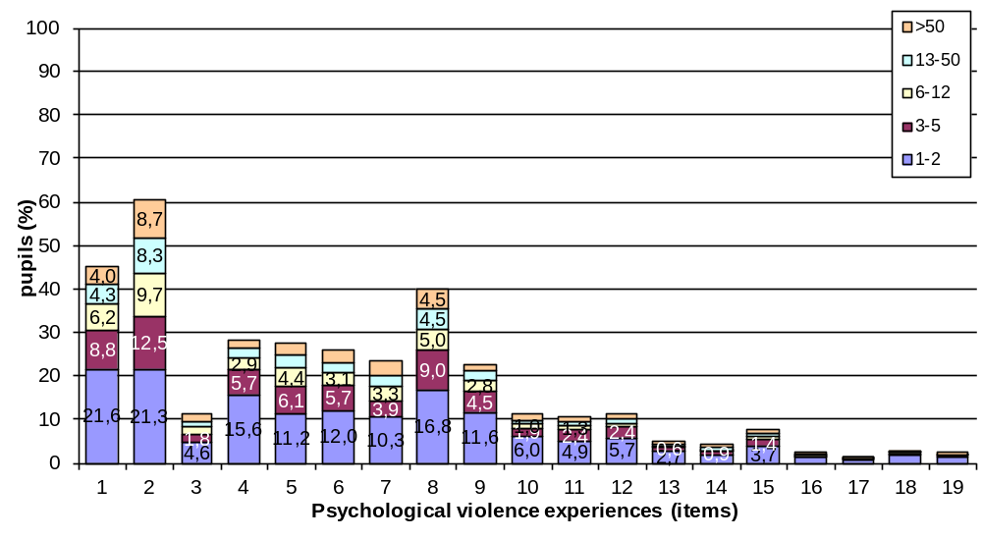

Items*
- Shouted, yelled, or screamed at you very loud and aggressively?
- Insulted you by calling you dumb, lazy or other names like that?
- Cursed you?
- Refused to speak to you (ignored you)?
- Blamed you for his/her bad mood?
- Read your diary, your SMS or e-mail messages without your permission?
- Went through your bag, drawers, pockets etc. without your permission?
- Compared you to other children in a way that you felt humiliated?
- Ashamed or embarrassed you intentionally in front of other people in a way that made you feel very bad or humiliated?
- Said that they wished you were dead or had never been born?
- Threatened to leave you or abandon you?
- Threatened to kick you out of house or send you away?
- Locked you out of the home?
- Threatened to invoke ghosts or evil spirits, or harmful people against you?
- Threatened to hurt or kill you?
- Did not get enough to eat (went hungry) and/or drink (were thirsty) even though there was enough for everyone, as a means of punishment?
- Have to wear clothes that were dirty, torn, or inappropriate for the season, as a means of punishment?
- Locked you up in a small place or in a dark room?
- Threatened you with a knife or a gun?

Scale
- 1-2 (once or twice a year)
- 3-5 (several times a year)
- 6-12 (monthly or bimonthly)
- 13-50 (several times a month)
- more than 50 (once a week or more often)

* Items in bold had been excluded from the short-version of the ICAST-CH completed by the 11 y-o grade’s pupils

Figure 1.5. Distribution of pupils’ exposure to 16/15* different experiences of physical violence, by experience (item) and frequency they experienced it during the past year (incidence)

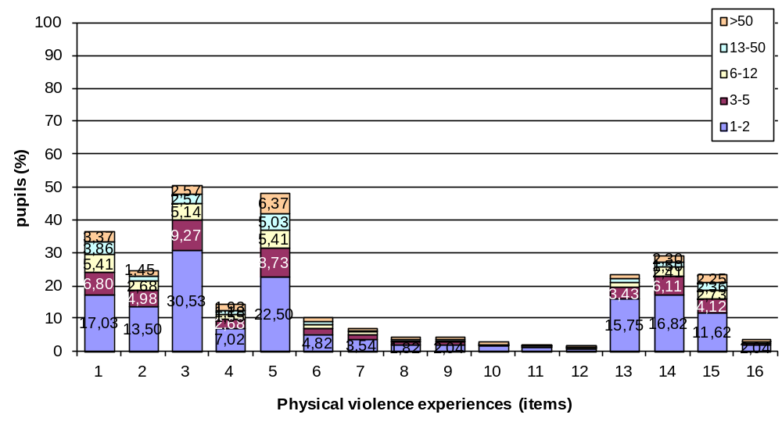

Items*
- Pushed or kicked you?
- Grabbed you by your clothes or some part of your body and shook you?
- Slapped you?
- Hit you on head with knuckle or back of the hand?
- Spanked you on the bottom with bare hand?
- Hit you on the buttocks with an object such as a stick, broom, cane, or belt?
- Hit you elsewhere (not buttocks) with an object such as a stick, broom, cane, or belt?
- Hit you over and over again with object or fist (“beat-up”)?
- Choked you or smothered you (prevent breathing by use of a hand or pillow) or squeezed your neck with hands (or something else)?
- Intentionally burned or scalded you?
- Put chilli pepper, hot pepper, or spicy food in your mouth (to cause pain)?
- Tied you up or tied you to something using a rope or a chain?
- Roughly twisted your ear?
- Pulled your hair?
- Pinched you roughly?
- Forced you to hold a position that caused pain or humiliated you as a means of punishment?

Scale
- 1-2 (once or twice a year)
- 3-5 (several times a year)
- 6-12 (monthly or bimonthly)
- 13-50 (several times a month)
- more than 50 (once a week or more often)

* The item in bold had been excluded from the short-version of the ICAST-CH completed by the 11 y-o grade’s pupils

Figure 1.6. Distribution of pupils’ exposure to 6/5* different experiences of sexual violence, by experience (item) and frequency they experienced it during the past year (incidence)
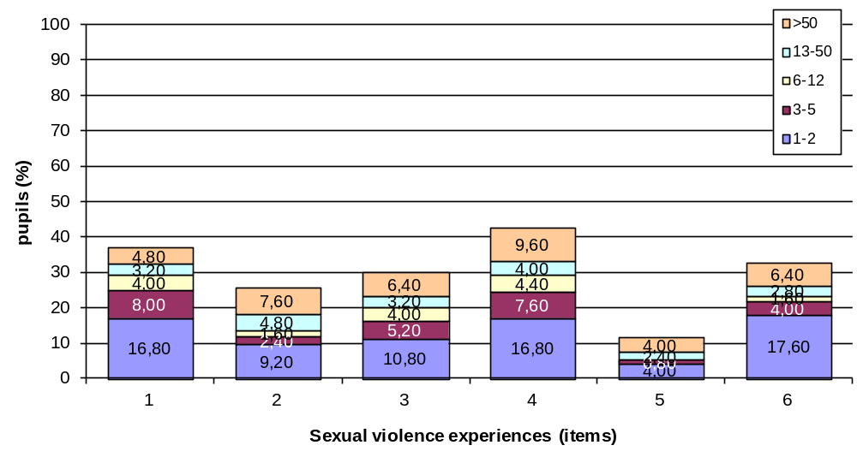
Items*
- Made you upset by speaking to you in a sexual way or writing sexual things about you?
- Made you watch a sex video or look at sexual pictures in a magazine or computer when you did not want to?
- Made you look at their private parts or wanted to look at yours?
- Touched your private parts in a sexual way, or made you touch theirs?
- Made a sex video or took photographs of you alone, or with other people, doing sexual things?
- Tried to have sex with you when you did not want them to?

Scale
- 1-2 (once or twice a year)
- 3-5 (several times a year)
- 6-12 (monthly or bimonthly)
- 13-50 (several times a month)
- more than 50 (once a week or more often)

* The item in bold had been excluded from the short-version of the ICAST-CH completed by the 11 y-o grade’s pupils

Figure 1.7. Distribution of pupils’ exposure to 3 different feelings of neglect, by feeling (item) and frequency they experienced it during the past year (incidence)

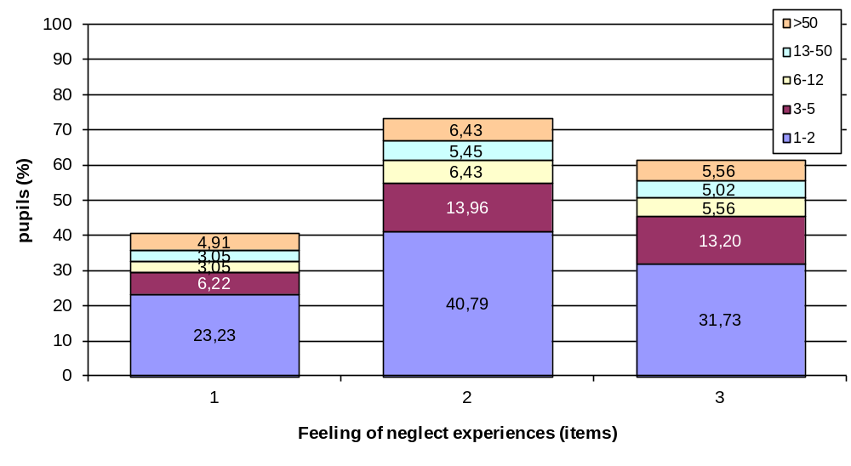
Items
- You did not feel cared for?
- Felt that you were not important?
- Felt that there was never anyone looking after you, supporting you, helping you when you most needed it?

Figure 1.8. Distribution of pupils’ exposure to 7/6* different experiences of positive & non violent parenting, by experience (item) and frequency they experienced it during the past year (incidence)

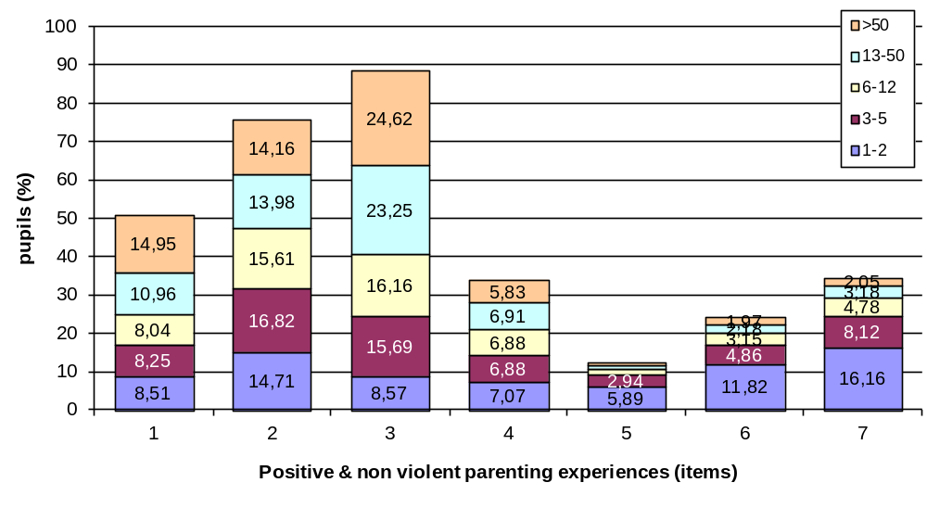
Items*
- Told you to start or stop doing something (e.g. start doing your homework or stop watching TV)?
- Explained you why something you did was wrong?
- Gave you an award for behaving well?
- Gave you something else to do in order to distract your attention (e.g. to tell you do something in order to stop you watching TV)?
- Took away your pocket money or other privileges?
- Forbade you something that you liked?
- Forbade you to go out?

Scale
- 1-2 (once or twice a year)
- 3-5 (several times a year)
- 6-12 (monthly or bimonthly)
- 13-50 (several times a month)
- more than 50 (once a week or more often)

* Items in bold had been excluded from the short-version of the ICAST-CH completed by the 11 y-o grade’s pupils

Appendix 2 Other results, not presented in the report

Figure 2.1. Prevalence and incidence rates of pupils’ exposure to violent behaviors by grade group. (Only the scales for which the analyses revealed a significant main effect of grade group are presented here).

All Significant main effects of grade group
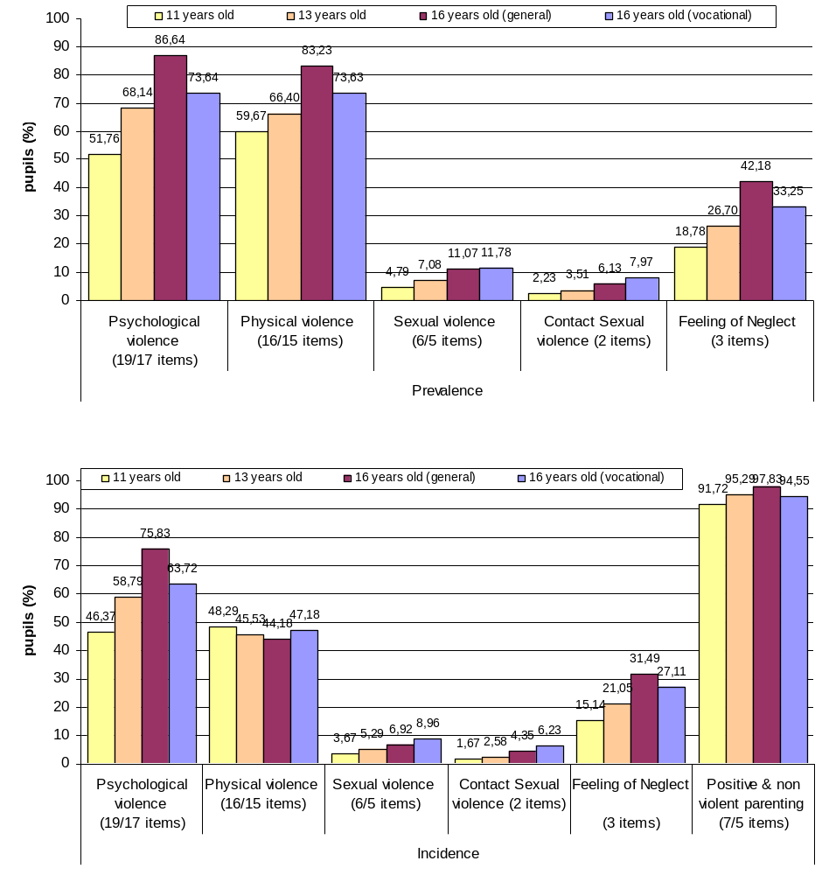

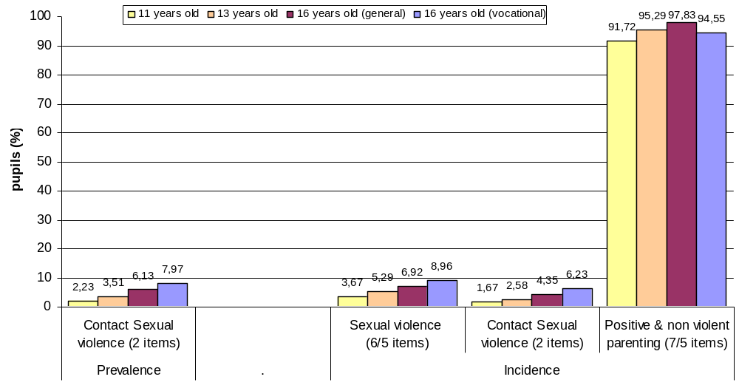

Figure 2.2. Prevalence of psychological violence, by number of different behaviors experienced by children in urban and nonurban sample
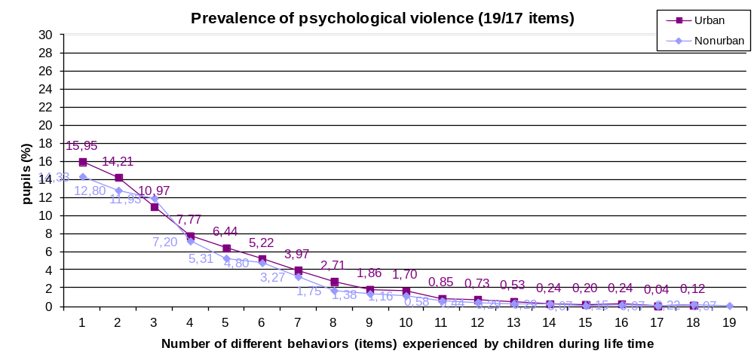

Figure 2.3. Prevalence of physical violence, by number of different behaviors experienced by children in urban and nonurban sample

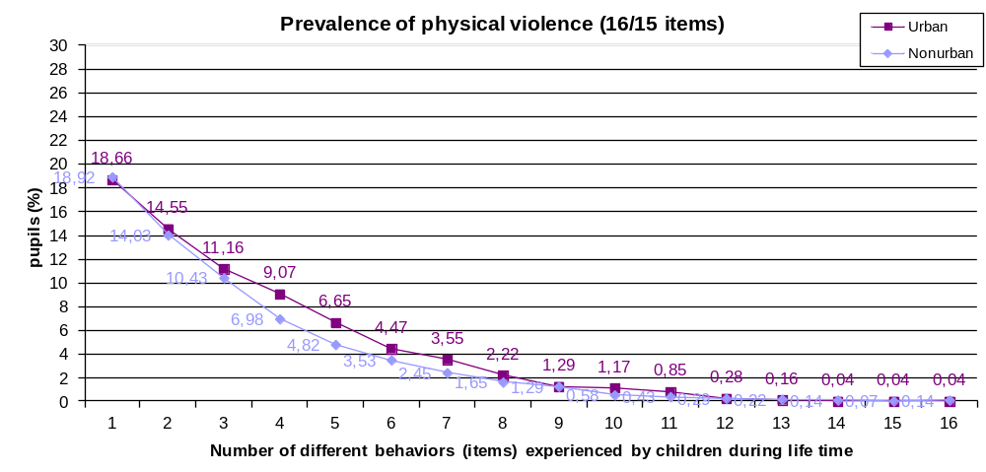

Figure 2.4. Incidence of psychological violence, by number of different behaviors experienced by children in urban and nonurban sample

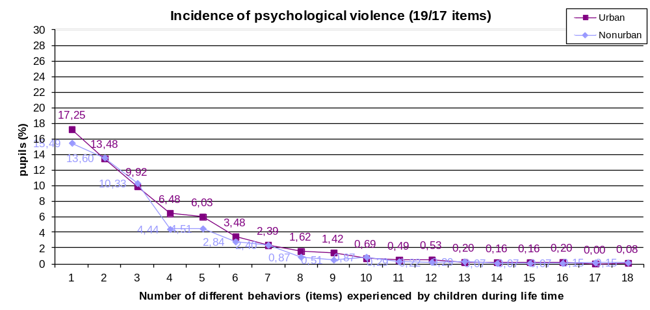

Figure 2.5. Incidence of physical violence with respect to number of different behaviors suffered by gender and geographical region
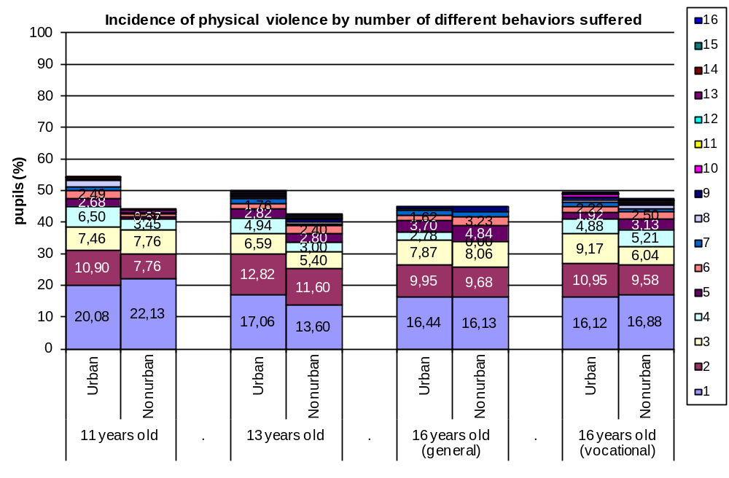

Figure 2.6. Prevalence of positive and non violent parenting with respect to number of different behaviors experienced Interaction by urbanicity and grade
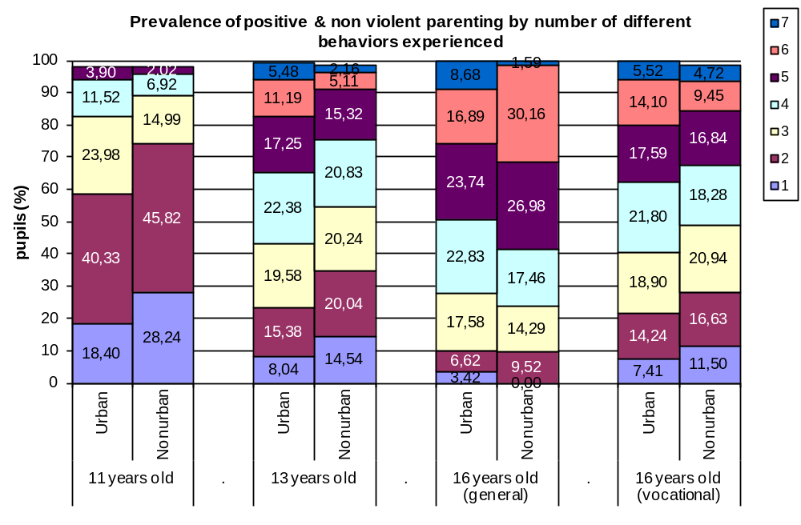

Figure 2.7. Incidence of positive and non violent parenting with respect to number of different behaviors experienced by urbanicity and grade

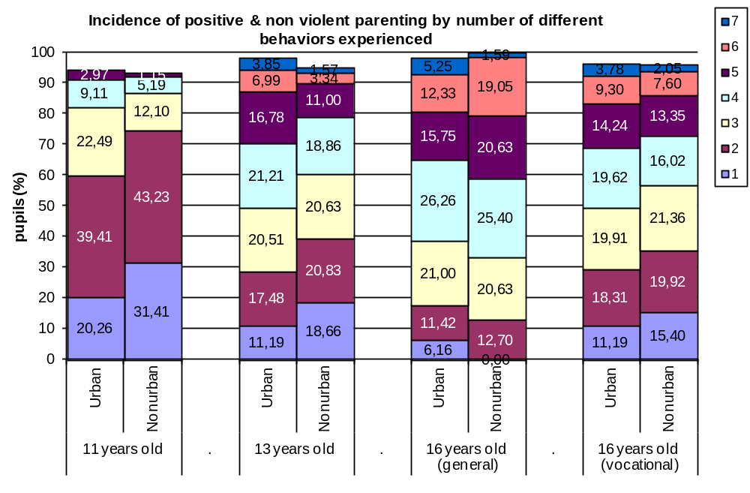

Figure 2.8. Prevalence of positive and non violent parenting with respect to number of different behaviors experienced by geographical region and grade

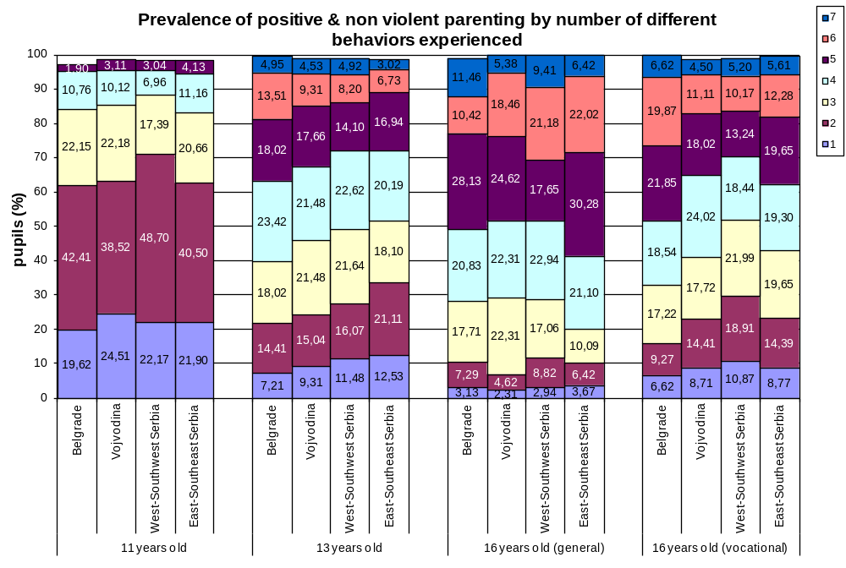

Figure 2.9. Incidence of positive and non violent parenting with respect to number of different behaviors experienced by geographical region and grade

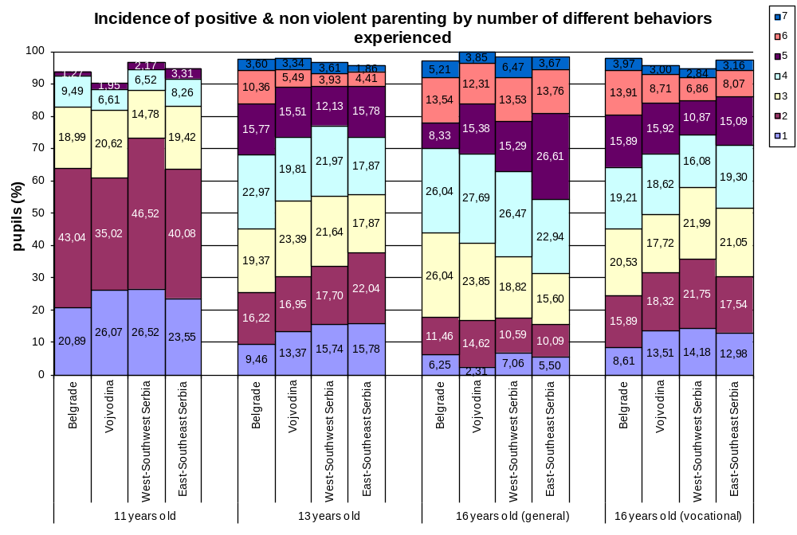

Grant Agreement No: HEALTH-F2-2009-223478.
Pupils registered to school
Child’s gender and age is missing from both ICAST-P and –CH; there is a discrepancy between ICAST-P and –CH in regards to the child’s gender or age (by 2 or more years); the scales’ questions (18_A - 46) answered exclusively by use of the options "Never in my life" or "Don't want to answer".
Parents addressed in order to complete the ICAST-P: of pupils who have completed the ICAST-CH and had no problem to give their parent the ICAST-P, as well as parents who had refused their child’s participation but they agreed to complete the questionnaires themselves.
Child’s gender and age is missing from both ICAST-P and –CH; there is a discrepancy between ICAST-P and –CH in regards to the child’s gender or age (by 2 or more years); the scales’ questions (8 - 42_A) answered exclusively by use of the option "Never in my life" or exlusively by use of the option "Don't want to answer".
Categorization is presented in a separate study of Croatian BECAN team (Rajter, Rimac, Ajdukovic, Delale, 2012).

